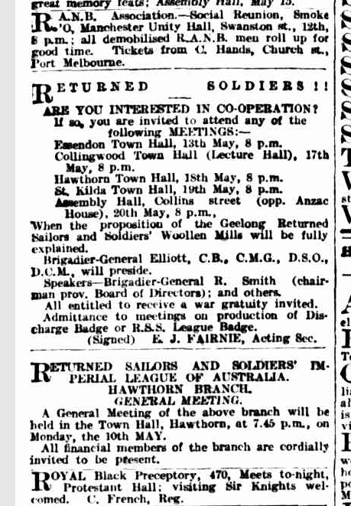

https://trove.nla.gov.au/newspaper/article/1700127#

