THE NAVAL ASSOCIATION OF AUSTRALIA
NATIONAL COUNCIL

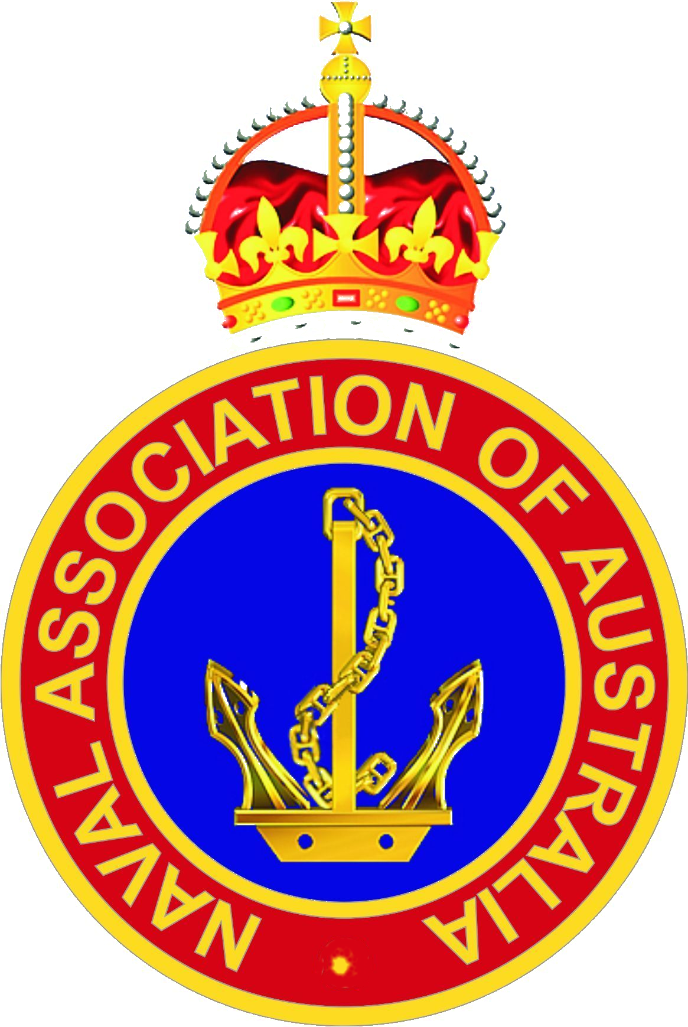

RISK MANAGEMENT

CONTINUED COMPLIANCE TO THE NAVAL ASSOCIATION OF AUSTRALIA CONSTITUTION AND RULES

(This Plan is based on the International Organisation for Standardisation (ISO) 31000:2018 - Risk Management, the comprehensive principles and guidelines that assists organisations with risk analysis and risk assessments)

May 2022

Prepared: R Pettis Approved: D Manolas

Date: 23 June 2022

CONTENTS PAGE

- Introduction

- Context

3.0 Definitions

4.0 Stakeholders

5.0 Events

6.0 Risk Assessment Register

7.0 Risk Templates

Appendix 1 Event Management Risk Assessment

Appendix 2 Risk Assessment Matrix

Appendix 3 Financial Risk Assessment Template

Appendix 4 Basic Risk Assessment

1.0 Introduction

This document is for use by NAA people who create and protect value in the NAA by managing risks, making decisions, setting, and achieving objectives and improving performance.

Managing risk is iterative and assists organisations in setting strategy, achieving objectives and informed decisions. Managing risk is based on principles, framework, and process.

The 31000 standard innovations in several areas in that it:
- Provides a definition of risk as the effect of uncertainty on the possibility of achieving objectives, highlighting the importance of
defining objectives before attempting to control risks and emphasising the role of uncertainty.
- Introduces the notion of risk appetite, or the level of risk the organisation accepts to take on in return for expected value
- Defines a risk management framework with different organisational procedures, roles, and responsibilities in the management of risks
- Outlines a management philosophy where risk Management is seen as an integral part of strategic decision-making and the
- management of change

The Full and Continued compliance of the National Council of the Naval Association of Australia (NAA) to the values and objectives of its Constitution and Rules is key to the successful and sustained maintenance of the operations into the second century of its existence. The development of a clear and transparent Risk Management Strategy and Plan allows the National Council to confidently navigate the NAA through its many challenges to maintain and sustain the governance structure of the organisation. The detailed Work Health and Safety Risk Management Policy Statement declares:

Naval Association of Australia (NAA) incorporates risk management into business activities to proactively manage threats (hazards), risk and opportunities, to improve decision making to support the achievement of objectives and outcomes. This policy establishes the process for the management of work health and safety risks in the NAA and should be read as the guidance to further develop the NAAs commitment to Risk Management. The Work Health and Safety Risk Management Policy Statement is available on the NAA National Website.

2.0 Context

The context within which strategy and plan has been developed, is to enable the National Council to effectively, efficiently, and ethically manage and conduct the business of a National Ex Service Organisation to support veterans and conduct NAA business without risk and as far as is reasonably practicable (SFARP).

The NAA is a federation consisting of a National Council, State or Section Councils and their Sub-sections. The federation is geographically dislocated across Australian States and Territories, manned by elected unpaid volunteers - stakeholders, some who has physical disabilities and or limitations, other health issues, who conduct NAA business without the benefit of a formalised training package and with reduced competency, especially in the early stages of their office bearer tenure, often under stress and delayed by communication challenges and a resistance to change by an ageing member base.

Elected individuals – stakeholders, conduct NAA business of completing administration, providing advice in the DVA welfare and claims space, delivering support, across the three levels of the organisation often in their own domicile, in a risk source such as the home-office, as the NAA workplace, without the benefits of identifying risk, analysis of the risk, evaluation of the risk, treatment of the risk, continued monitoring and review, and or the understanding of consequence, likelihood and controls, for up to forty hours per week without supervision, to achieve NAA objectives in accordance with the NAA Constitution and By-laws. NAA business may be completed during normal business hours but more often NAA work is completed outside of normal business hours. Fundraising is conducted by many Sub-sections via a partnership with Bunnings. The fundraising activity is manned by NAA financial members who are insured under NAA insurance arrangements. Bunnings Work Health and Safety requirements manage the hazards and risks associated with the workflow process.

Available resources are in the most part privately owned IT equipment and privately purchased resources however, some NAA sections and Sub-sections have local arrangements that provide a dedicated working environment and supported other office consumables for elected volunteers to conduct NAA business.

Background/Scope

The National Council provides the framework through the Constitution and By-Laws to effectively lead, manage, and allow the NAA to function at 3 key levels. These are:

- National Council
- State Sections
- State Sub-sections.

The Association is managed as a Federation of States, with each State having its constituent parts assembled as its Sub-sections. The role of the National Council is to provide the governance overlay, providing the resources, skills, education, and knowledge to the Organisation whilst still allowing the individual States to make their own decisions and manage their people and resources.

The purpose of this Work Health Strategy and Risk Management Policy and plans is to provide the NAA with the necessary protection from financial and/or reputational damage which may occur as the result of both external and internal organisational decisions which have impacted the direction, reputation or financial status of the NAA at all levels. Understanding consequence, likelihood and controls, identifying, analysing, treating, monitoring and reviewing potential hazards and potential risk is provided in the file Work Health Safety Risk Management Policy NAA V1.00.

The NAA is now 102 years old and has functioned as the principal naval Ex-Service Organisation in Australia for most of that time. It sits at the table with the Australian Government, the Department of Veteran Affairs and Returned Services League of Australia and has a significant public profile. Damage to that reputation would be catastrophic across many areas of the NAA operations. Consequently, the NAA has developed a comprehensive Risk Management Plan, outlined in this policy.

Organisational Details

National Council, Naval Association of Australia
Key National Office Bearers: National President
National Vice Presidents (2)
National Secretary
National Treasurer
National Membership Registrar
National Asst. Secretary
President, Queensland Section
President, NSW Section
President, ACT Section
President, Vic. Section
President, Tas. Section
President, SA Section
President, WA Section.

Contact Details: National Secretary
(m) 0419 898 427
Email: nationalsecretary@navalassoc.org.au

3.0 Definitions

Risk – The effect of uncertainty on objectives. An effect is a deviation from the expected. The effect can be positive, negative or both and can address, create, or result in opportunities and threats. Objectives can have different aspects and categories and can be applied at different levels. Risk is usually expressed in terms of risk resources, potential events, their consequences, and their likelihood.

Risk Management – Coordinated activities to direct and control an organisation regarding risk.

Stakeholder – Person or organisation that can affect by or perceive themselves to be affected by a decision or activity.

Risk Source – Element that alone or in combination has the potential to give rise to risk.

Event – Occurrence or change of a set of circumstances. An event can have one or more occurrences and can have several causes and consequences. An event can be expected that does not happen or something that is not expected that does happen.

Risk Identification – Identifying what could prevent achievement of objectives.

Risk Analysis – Understanding the resources and causes of the identified risks; studying probabilities and consequences given existing controls, to identify the level of residual risk.

Risk Evaluation – Comparing risk analysis results with risk criteria to determine whether the residual risk is tolerable.

Risk Treatment –The process of selecting and implementing measures to reduce risk. Methods include risk avoidance, risk modification (reducing the probability of the unwanted event or mitigating the consequences) and risk transfer.

Establishing the Context – Defining the scope for the risk management process, defining the objectives, and establishing the risk evaluation criteria. The context comprises both external elements (regulatory environment, market conditions, external stakeholders’ expectations) and internal elements (NAA organisational governance, culture, standards and rules, capabilities, existing contracts, worker expectations and information systems).

Monitoring and Review – Measuring risk management performance against indicators that are periodically reviewed for appropriateness. The review involves checking for deviations from the risk management plan, checking whether the risk management framework, policy and plan remain appropriate given the organisations external and internal context, reporting on risk, progress with the risk management plan and how well the risk management policy is being followed, the reviewing and effectiveness of the risk management framework.

Communication and Consultation – This helps understand stakeholders’ interest and concerns, to check that the risk management process is focusing on the correct elements and explains the rationale for decisions and for treatment options.

Consequence – An outcome of an event affecting objectives. A consequence can be certain or uncertain and can have positive or negative direct or indirect effects on objectives. Consequences can be expressed qualitatively or quantitatively. Any consequences can be escalated through cascading and cumulative effects.

Likelihood – The chance of something happening.

Control – A measure that maintains and or modifies risk. Controls include, but are not limited to, any process, policy, device, practice, or other conditions and or actions that maintain and or modify risk.

4.0 Stakeholders

Input to this Plan has been provided by the National Council members and their State Sections. The draft was circulated as part of the Agenda for the National Council meeting of 23 June 2022. The agenda was circulated 2 months prior to the meeting for input from all stakeholders.

5.0 Events

The following broad events have been identified that may hamper the effective functioning of the Naval Association of Australia across all 3 sectors – National, State, and local Sub-sections:

Health and Safety, Financial Impact, Business Interruption, Reputation, Objectives, Environmental, and Regulatory.

6.0 Risk Assessment Register

A Risk Assessment Register acknowledging the broad events and the descriptors listed at 7.0 is provided at file NAA Hazard Risk Assessment Register V1.00.

