Editor: Tony (Doc) Holliday Email: tonyholliday13@gmail.com Mobile: 0403026916

Volume: 1 August 2018 Issue: 2

A few notifications came in requesting the font size be increased as it was difficult to read. I did notice that but font 9 on Lens program appears to be different to font size on mine so I will increase the font to 11.

Please allow me to submit a correction, on page 6 it was stated that the launch date of HMAS Adelaide (11) was 1978 it should have read 1980.

Greenbank Sub-Section Events: August / September 2018

Tuesday 07 August 1030-1200 Normal Daytime Meeting RSL Rooms (lunch after)
Saturday 18 August 1000-1200 Vietnam Veterans Service Long Tan Day
Wednesday 29 August 1000 Executive Meeting RSL Rooms

Saturday 01 September 100-1400 Merchant Mariners Service
Tuesday 04 September 1930 Normal Meeting RSL Rooms
Wednesday 26 September 1000 Executive Meeting RSL Rooms

Sausage Sizzle dates:

Friday 24 August 0600-1600 Bunnings Browns Plains
Friday 14 September 0600-1600 Bunnings Browns Plains

ADMIRALS

Royal Australian Navy: Admirals : Rear Admiral Thomas
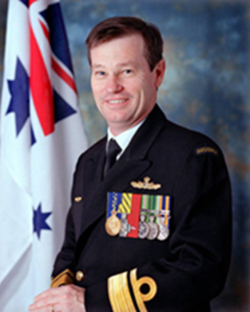
Rear Admiral Davyd Rhys Thomas AO, CSC RAN was born and raised in Newcastle New South Wales 2 May 1956 and joined the Navy in 1974. A graduate of the RAN College he has served as a Seaman Officer in a wide variety of platforms, including patrol boats, Guided Missile Destroyers, Destroyer Escorts and Guided Missile Frigates. After gaining a Bridge Watch keeping Certificate in 1978, he served as Executive Officer of HMAS Aware, a Darwin based patrol boat. Thomas was promoted to lieutenant in 1979, during which time he commenced his warfare training, and served on HMAS Brisbane. A short stint on the staff at the RAN Apprentice Training Establishment, prior to professional warfare specialist training in the United Kingdom, in 1983.
As a Principal Warfare Officer (PWO), he specialised in above water warfare. Upon his return to Australia, Thomas served as the Operations Officer on HMAS Vampire, and later on HMAS Perth as Gunnery Officer. He then completed the RAN Staff Course in 1987, and was subsequently employed as the Surface Weapons Trials Officer at the RAN's Test and Evaluation Centre in Sydney. Thomas was then posted as Executive Officer of HMAS Adelaide, and participated in the first RAN contingent to the Persian Gulf in 1990, as part of Operation Desert Shield; he was promoted to commander in December 1990. He then served in Western Australia as the Operations Officer at Fleet Base West. In September 1994, Thomas assumed command of HMAS Darwin, based on the West Coast. In the Australia Day Honour's List of 1997, Thomas was awarded the Conspicuous Service Cross and was promoted to captain in July of the same year. March 1999 saw him posted as Director of Naval Officers' Postings, until assuming command of HMAS Newcastle in March 2001. As the Commanding Officer of Newcastle during Operation Slipper in the Persian Gulf, Thomas conducted maritime interdiction in support of coalition forces enforcing United Nations sanctions against Iraq. For this he was awarded a Commendation for Distinguished Service in June 2003. He was promoted to the rank of commodore and made a Member of the Order of Australia (AM) in mid-2002 for "exceptional service to the Royal Australian Navy". He later assumed the position of Commodore Flotillas and Commander Deployable Joint Force Headquarters (Maritime) in February 2004. Thomas was promoted to Rear Admiral and appointed to the position of Maritime Commander Australia (MCAUST) in July 2005; in 2007 this position was renamed Commander Australian Fleet (COMAUSFLT). Admiral Thomas is a graduate of the US Naval Command College and has completed a Master’s of Science (Management) at Salve Regina University, Newport Rode Island USA. On 3 August 2007, Thomas assumed command of the Australian Defence College, which on 14 January 2008 became Joint Education, Training and Warfare (JETW) Command (which encompasses the Australian Defence College Headquarters, the Australian Defence Force Academy, the Australian Command and Staff College, the Centre for Defence and Strategic Studies and the ADF Warfare Centre). Thomas assumed the duties of Deputy Chief of Navy (DCN) on 6 June 2008. In the Australia Day Honours List of 2009, Thomas was appointed an Officer of the Order of Australia (AO) for his service as Commodore Flotillas, Maritime Commander Australia, Commander Australian Fleet and Commander, Australian Defence College. He relinquished the post of DCN on 18 February 2011 to Rear Admiral Trevor Jones. Thomas transferred to Naval Reserve in September 2011, as a Rear Admiral RAN.
In 2012, to strengthen its defence business development activities and capabilities, Austral appointed former Deputy Chief of the Royal Australian Navy, RADM Davyd Thomas, AO, CSC, and RANR to Vice President - Defence.

THE GREAT WHITE FLEET

On 20 August 1908 well over half a million Sydneysiders turned out to watch the arrival of the United States (US) Navy’s ‘Great White Fleet’. For a city population of around 600,000 this was no mean achievement. The largest gathering yet seen in Australia, it far exceeded the numbers that had celebrated the foundation of the Commonwealth just seven years before. Indeed, the warm reception accorded the crews of the 16 white-painted battleships during ‘Fleet Week’, was generally regarded as the most overwhelming of any of the ports visited during the 14 month and 45,000 mile global circumnavigation. The NSW Government declared two public holidays, business came to a standstill and the unbroken succession of civic events and all-pervading carnival spirit encountered in Sydney (followed by Melbourne and Albany) severely tested the endurance of the American sailors. More than a few decided to take their chances and stay behind when the fleet sailed! One man undoubtedly well pleased with the visit’s success was Australia’s then Prime Minister, Alfred Deakin, who had not only initiated the invitation to US President Theodore Roosevelt, but had persisted in the face of resistance from both the British Admiralty and the Foreign Office. By making his initial request directly to American diplomats rather than through imperial authorities Deakin had defied protocol, but he was also taking one of the first steps in asserting Australia’s post-colonial independence. His motives for doing so were complex. He was, after all, a strong advocate for the British Empire and Australia’s place within it, but he also wished to send a clear message to Whitehall that Australians were unhappy with Britain’s apparent strategic neglect. The security of the nascent Commonwealth might still ultimately depend on the Royal Navy’s global reach, but the ships of the small, rarely seen and somewhat obsolescent Imperial Squadron based in Sydney did not inspire confidence. As an officer in the US flagship, observed during the visit: ‘These vessels were, with the exception of the Powerful [the British flagship], small and unimportant …Among British Officers this is known as the Society Station and by tacit consent little work is done’. Equally galling to local opinion, the passage of the unpopular Naval Agreement Act, 1903 had meant that although Australia contributed £200,000 per annum for its upkeep, the Squadron could be withdrawn in times of danger to fulfil imperial priorities. To many commentators this simply represented taxation without representation, but for those looking deeper the implications were rather more disturbing. During even a transitory enemy cruiser raid, Australian commerce might face the choice of being driven into harbour or destroyed, while local ports could readily be threatened and held to ransom.
Feeling both isolated and vulnerable, it was easy for the small Australian population to believe that Britain was ignoring its antipodean responsibilities. The 1902 Anglo-Japanese Alliance (renewed in 1905), which had allowed the Royal Navy to reduce its Pacific presence, did little to alleviate these fears. Remote from the British Empire’s European centre, Australians had no confidence that their interests, and in particular their determination to prevent Asiatic settlement, would be accommodated in imperial foreign policy. Japan’s evident desire for territorial expansion, its decisive naval victory over the Russians at Tsushima in 1905, and its natural expectation of equal treatment for its citizens all seemed to reinforce the need for Australia to explore alternative security strategies. Staunchly Anglophile, Deakin was not necessarily seeking to establish direct defence ties with the United States, but more than a few elements in Australian society were prepared to see in America the obvious replacement for Britain’s waning regional power. A new and evidently growing presence in the Pacific, the United States possessed a similar cultural heritage and traditions, and as even Deakin took care to note in his letter of invitation: ‘No other Federation in the world possesses so many features [in common with] the United States as does the Commonwealth of Australia’. Attitudes towards Asiatic, and more particularly hostility towards Japan, seemed likewise to be shared, particularly after a rise in Japanese immigration to the US West coast sparked riots in California and the passing of discriminatory legislation.
President Roosevelt had initiated the deployment of the US Atlantic Fleet to the Pacific — the first such movement of great battleships — to test his Navy’s professionalism, arouse popular interest in and enthusiasm for the navy, and demonstrate that the United States had arrived as a world power.

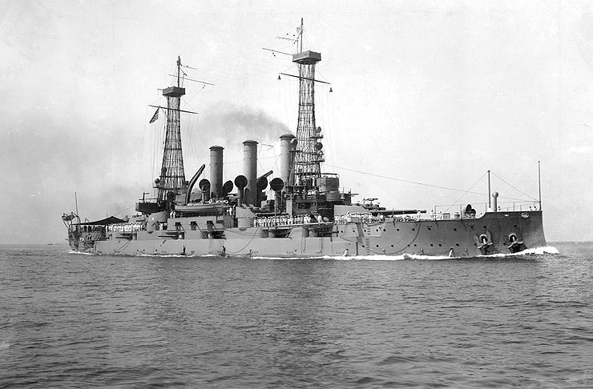
USS Connecticut. Great White Fleet Flagship

Wanting foreign nations to accept that the fleet should from time to time gather in one ocean just as much as it should in another, Roosevelt claimed publicly that the cruise was not directed against Japanese interests. Nevertheless, for most Australians the visit became an unmistakable expression of Anglo-Saxon solidarity; an ‘essentially peaceful’ mission, but simultaneously ‘an armed assertion that the White Race will not surrender its supremacy on any of the world’s seas’. Unsurprisingly, the epithet ‘Great White Fleet’ only came into popular usage during the visit to Australia, and referred as much to race as it did to paint schemes. No British battleship, let alone a modern fleet, had ever entered Australasian waters. So with the arrival of the American vessels locals were treated to the greatest display of sea power they had even seen. While the public admired the spectacle’s grandeur, for those interested in defence and naval affairs it was an inspiration. This too was a part of Deakin’s plan, for although he was a firm believer in Australia’s maritime destiny, where defence was concerned national priorities still tended towards the completion of land rather than maritime protection.
------------------------------------------------------------------------------------------------------------------------------------------
NAVAL DISASTERS - HTMS SRI AYUDHYA

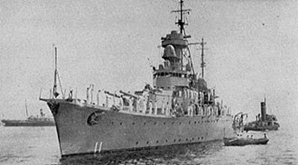

Thailand Navy
Name | HTMS Sri Ayudlya | Name Sake | Kingdom of Ayuthaya
Builder | Kawasaki, Kobe, Japan | Laid down | 1936
Launched | 31 July 1937 | Acquired | 16 June1938
Commissioned | 19 July 1938 | Struck
Class Type: Thunbori | Coastal Defence Ship | Displacement | 2,350 Metric Tons
Length | 253 ft (77M) | Beam | 44 ft (13.4m)
Draft | 14 ft (4.2m) | Propulsion | 2 MAN Diesels
Speed | 15.8 Knots (29.3 Km/h) | Compliment | 234 Officers and men
Armament | 4 x 8 in Guns  4 x 3 in Guns  4 x 20mm Guns

HTMS Sri Ayudhya was a coastal defence ship of the Royal Thai Navy. It was in service from 1938 to 1951, being active during the Franco-Thai war in which its sister ship HTMS Thonburi was heavily damaged in the Battle of Ko Chang. Sri Ayudhya later served as flagship of the navy until it was sunk as a result of fighting in the Manhattan Rebellion. In the 1930s the Royal Siamese Navy pursued plans to upgrade and expand its limited forces. This was approved by parliament in 1935, and 18 million baht was allocated for the procurement of new equipment. In December 1935, the navy contracted the Japanese Kawasaki Shipbuilding Corporation of Kobe to build two coastal defence ships for 5.727 million baht.
Sri Ayudhya was delivered on 16 June 1938 and commissioned on 19 July; its sister ship Thonburi followed in October that year. When the Franco-Thai war broke out in late 1940, the navy assigned Sri Ayudhya and Thonburi to the First Squadron, tasked with patrolling the eastern waters against potential French attacks. On the night of 14 January, the group led by Thonburi set sail from Sattahip Naval Base to relieve Sri Ayudhya and its convoy, which had been stationed at the island of Ko Chang in Trat Province. They rendezvoused the following morning, and the Sri Ayudhya group returned to Sattahip. Two days later, at dawn on 17 January, Thonburi and other ships in the group were engaged by French naval forces in what became the Battle of Ko Chang. Sri Ayudhya was sent to assist in the battle, but only arrived in the afternoon after hostilities had ceased. However, some French reports erroneously noted that Sri Ayudhya was damaged by a torpedo during the battle.
Sri Ayudhya didn't see action after World War II, although it became regarded as the flagship of the navy. It served as a royal transport vessel for Kings Ananda Mahidol and Bhumibol Adulyadej during the final legs of their respective return trips from Switzerland in 1938 and 1950. On 29 June 1951, in a coup attempt known as the Manhattan Rebellion, a group of junior naval officers held Prime Minister Plaek Pibulsonggram (Phibun) at gunpoint during a boat-transfer ceremony at Ratchaworadit Pier on the Chao Phraya River in Bangkok. Phibun was taken aboard the Sri Ayudhya and held hostage. General stations were called, and the ship began to make way downstream towards the Naval Ordnance Department in Bang Na. However, the coup plotters failed to secure the opening of the Memorial Bridge, and the ship thus could not continue. Fighting quickly ensued, and the naval units that sided with the rebels became heavily outnumbered by the army, police and air forces, which were loyal to the government. Fighting subsided during the night but resumed and intensified early the next morning. Sri Ayudhya joined the fight, but its engines were soon disabled and the ship became dead in the water in front of Wichaiprasit Fort. It was heavily fired upon from the eastern bank by guns and mortars, and, by afternoon, was also bombarded by AT-6 trainer planes. Heavy fires broke out, and the order was given to abandon ship. Phibun had to swim ashore along with the sailors, but was uninjured. The fires continued throughout the night and into the next day, when fighting ceased. The heavily damaged Sri Ayudhya finally sank in the night of 1 July 1951. The wreck of Sri Ayudhya was later salvaged for scrap, as it had become a navigational hazard. The ship was officially struck from the naval register on 8 October 1959 in Ministerial Order 350/21315.

Editors Request:
Articles for the newsletter can be handed in at meetings, or by email: articles may be edited to fit the newsletter.

The contents of this edition of the newsletter have been obtained from information provided from Len Kingston-Kerr whom I thank greatly, various publication publications, History of the RAN and NAA information emailed in.

Royal Australian Navy Ship History

HMAS HOBART (1) D63

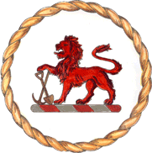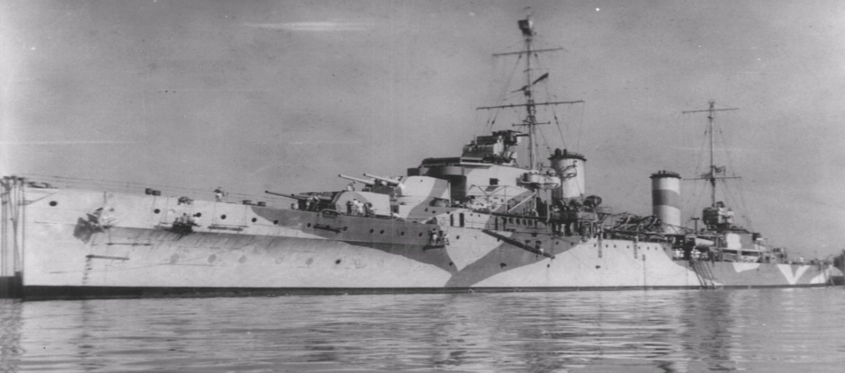

Class | Modified Leander | Type | Light Cruiser4
Builder | HM Dockyard Devonport | Laid down | 15 August 1934
Launched | 9 October 1934 | Commissioned | 20 December 1938
De-commissioned | 20 December 1947 | Displacement | 7,105 tons
Length | 563 ft 3 in | Beam | 56 ft 8in
Draught | 15 ft 8in | Speed | 32.5 knots
Horsepower | 72,000
Armament | 8 x 6in guns | 8 x 4in guns | 4 x 3pounder guns
Torpedoes | 8 x 21in

HMS Apollo and her sister ships Phaeton and Amphion were modified Leander class light cruisers.
Apollo commissioned on 13 January 1936 and served on the North American and West Indies Station from 1936 to 1938. At Devonport on 6 October 1938, she was due to transfer to the Royal Australian Navy as HMAS Hobart but, owing to the mobilisation of the British Fleet on 28 September 1938 during the Munich Crisis she commissioned on that date under the command of Captain RR Stewart RN. She was manned by the former crew of the seaplane carrier HMAS Albatross which had transferred to the Royal Navy in part payment for Apollo. The renaming ceremony was performed by Mrs Bruce, wife of
the High Commissioner for Australia in London.
Hobart sailed from Portsmouth on 28 October, one month after commissioning, and arrived in Australia at the end of 1938 in time for Christmas. On arrival Captain Stewart was interviewed by the press, remarking:

‘Hobart has been a really happy ship. I have been greatly impressed by the men. They are better specimens physically than the average English sailor and they are very intelligent.’

On 6 February 1939 Hobart sailed from Sydney for her first port visit to her namesake city, Hobart, the capital of Tasmania.

She arrived on 17 February and four days later had the distinction of fulfilling the role as the flagship of
the 101st Hobart Regatta.

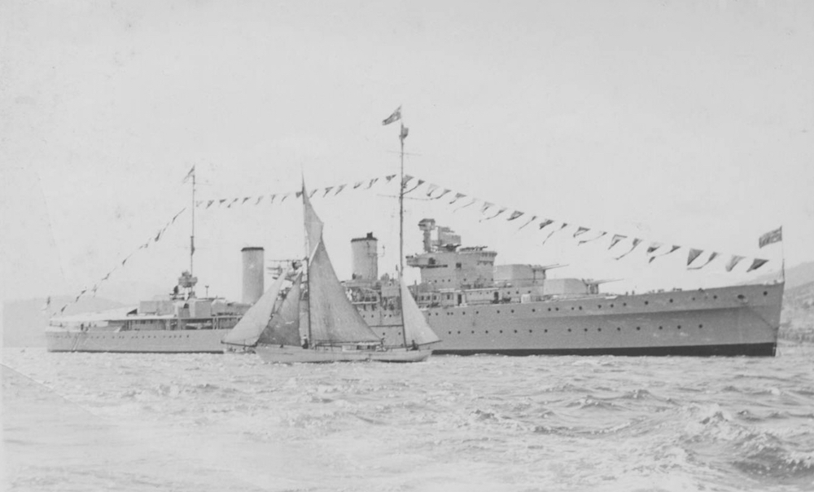

The next six months were spent working up and exercising off the eastern seaboard and visiting several south Pacific nations. On 28 August Captain Stewart was relieved by Captain HH Howden, OBE, RAN.
On Sunday 3 September 1939, Australia found herself at war with Germany. Hobart was on patrol in Bass Strait when news of the war reached her and she was subsequently ordered to Port Melbourne. There she undertook a series of exercises in Port Phillip before proceeding to her home port of Sydney.

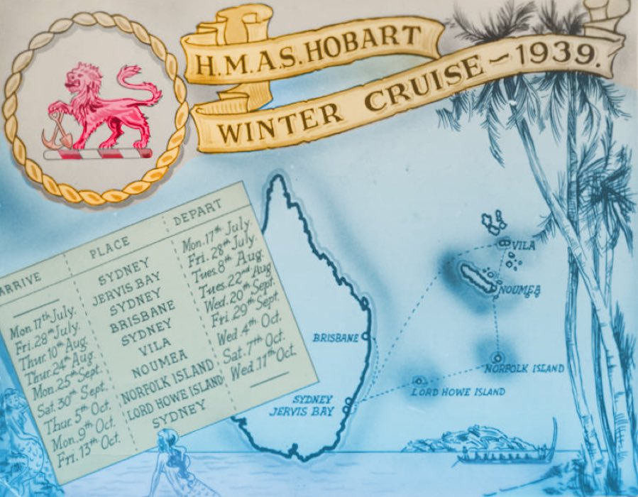

On 14 October 1939 Hobart sailed for service on the East Indies Station stopping enroute at Darwin and Singapore where she arrived on 26 October. Two days later she sailed and rendezvoused with the Royal Navy cruiser HMS Birmingham to patrol the west coast of Sumatra and the Sunda Strait. During this period Hobart's Walrus amphibian aircraft was used extensively for aerial reconnaissance work before meeting with accident during a night landing. The damaged aircraft was recovered with great difficulty and Hobart returned to Singapore in company with Birmingham on 5 November.

On 8 November Hobart joined the aircraft carrier HMS Eagle and the destroyer HMS Wescott as part of the escort for a west bound convoy to Colombo. On 2 December 1939 Hobart escorted the troop ship Akbar from Bombay to waters of Aden where she arrived on 6 December. There she picked up the Ettrick for the return voyage to Bombay, however, enroute one of Hobart's petty officers became seriously ill requiring an urgent operation. Consequently Hobart left Ettrick and proceeded to Bombay at full speed. Notwithstanding the mercy dash Petty Officer Barker died in hospital the day after arriving.
Hobart sailed from Bombay on 10 December to escort an important convoy to Aden remaining with it until 15 December at which time she shaped a course for Colombo with orders to escort a convoy of French colonial troops through the Malacca Strait. Sailing on 23 December she spent her first Christmas of the war at sea.

On Christmas Day a festive meal was provided and the messes were decorated. Captain Howden had thoughtfully bought 100 gallons of beer in Colombo to provide Christmas cheer for his crew - this was typical of him.

The ensuing months were spent escorting troop convoys in the Bay of Bengal and the Arabian Sea during which time she variously visited Colombo, Bombay, Aden, Trincomalee and Chakdina

During this period Hobart paid courtesy visits to the Kamaran Islands, Hodeida (Yemen) and Mocha in the Red Sea. The visit to Hodeida saw Hobart anchor outside the three mile limit as Yemen was a neutral country. A 21 gun salute was fired in honour of the Prince of Yemen, Prince Seif Allslam Al Hussein, who returned the honour with a visit to the ship and gifts of goats and eggs which were carried on board by his colourful bodyguard.

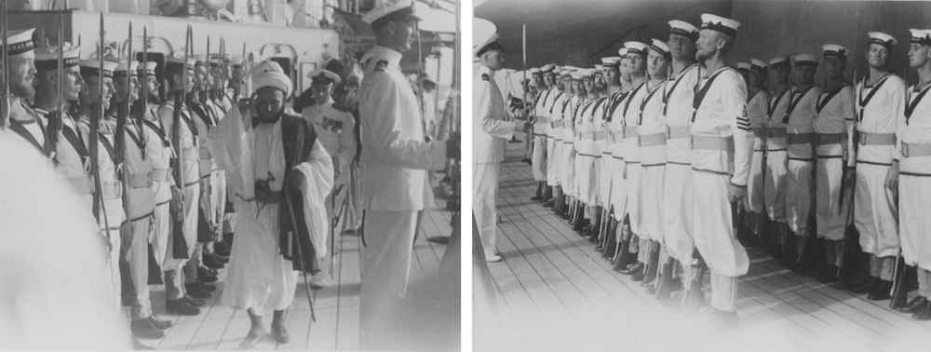

Hobart was at Aden when Italy entered the war on 10 June 1940 and her first shots against an enemy were fired two days later when her anti-aircraft guns opened fire on three Italian aircraft during a raid on Aden. Seven days later Hobart returned the compliment when her Walrus aircraft was flown off, carrying out a bombing attack on the Italian wireless station on Centre Peak Island in the Red Sea. There was no opposition and the target was reported as being severely damaged.
Routine patrols and sweeps followed throughout June during which the Walrus gathered useful intelligence during a number of aerial reconnaissance flights. At the end of the month Hobart embarked officers and men of the 2nd Punjabi Regiment in Aden to convey them to Berbera, Somaliland. During the voyage there were some 1300 men on board the cruiser and her upper decks were packed with troops. The soldiers disembarked the following day.

The Allies grip on Somaliland was tenuous and the land position deteriorated rapidly following the collapse of France. With the loss of Djibuti in French Somaliland, Berbera was the only port available to the British for supplying the Allied forces ashore.
On 1 August 1940 Hobart arrived in Berbera, British Somaliland, escorting and landing further reinforcements. She remained there assisting in a general disembarkation while providing protection against any possible attack from the sea. The British however, were heavily outnumbered by three Italian columns advancing overland. On 15 August a general evacuation of the territory from Berbera was ordered.
Hobart assumed the role as the operational headquarters throughout the evacuation and alongside the crews of other ships, her personnel performed a variety of tasks. Shipwrights and joiners constructed a pontoon that complemented inadequate existing piers, one of wood and the other of stone, while her communications division provided ship to shore communications. A sea transport officer, beach and pier master were also appointed from among her officers while ratings provided security platoons to maintain order in the town throughout the evacuation. Hobart's boats crews continuously ferried troops back and forth while others were provided as crews for the tugs Queen and Zeila.
During the evacuation, the harbour area suffered a number of enemy air attacks while Hobart's Walrus took the fight to the enemy attacking the Italian headquarters at Zeila. After the bombs had been dropped, the Walrus machine gunner, from a height of 250 feet, silenced two enemy machine gun posts, drove a lorry off the road and into a ditch and scored a number of hits on Italian staff cars.

Hobart also landed a quick-firing 3-pounder Hotchkiss gun for service with the Army as an anti-tank gun. A volunteer crew of three seamen from Hobart accompanied the gun: Petty Officer Hugh Jones, Able Seaman Jock Hurren and Able Seaman Hugh Sweeney. They later took part in fighting a rear-guard action until over run. The three seamen were later reported ‘missing, believed killed’ but resurfaced unharmed when the British captured Massawa from the Italians in April 1941. All three were subsequently mentioned in dispatches.

The main lift of troops took place under cover of darkness and the skill and devotion of the men engaged in ferrying the exhausted soldiers was not lost on Captain Howden who later reported:

A temporary sick bay was set up on the starboard shelter deck where many of the sick and wounded who had reached the beach were taken. Hobart's medical staff worked around the clock ministering to soldiers from five different nations.

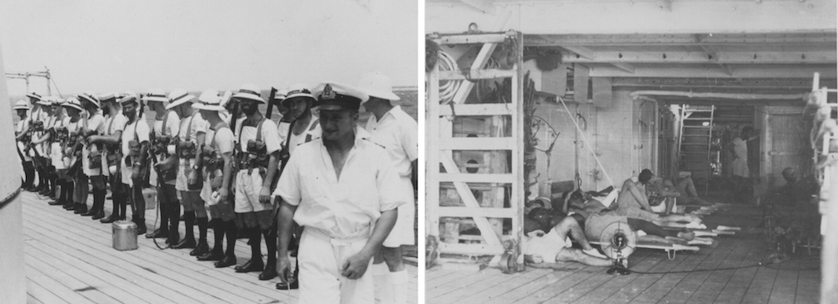

Demolition parties from the cruiser destroyed everything of value to the enemy before Berbera was finally abandoned Hobart's boats were the last ashore on the final day of the evacuation picking up stragglers. At 07:45 on Monday 19 August 1940, Hobart commenced bombarding Berbera. The bombardment rounded off the work of the demolition parties and an hour later, her task completed, the ship proceeded to Aden leaving British Somaliland under the temporary control of the Italians.

On arrival at Aden later the same day the GOC Somali force and his staff were landed and all wounded were discharged ashore with the exception of two severe cases who were detained in Hobart for treatment until 22 and 26 August respectively. On 22 August an advance party of the 2nd Battalion, the Black Watch Regiment, was embarked the remaining joining the following day. Altogether some 20 officers and 661 other ranks were embarked after which the ship put to sea bound for Suez. Enroute a boxing match between members of Hobart’s crew and the Black Watch was held on the upper deck, which proved a distraction from the events of the previous few weeks.

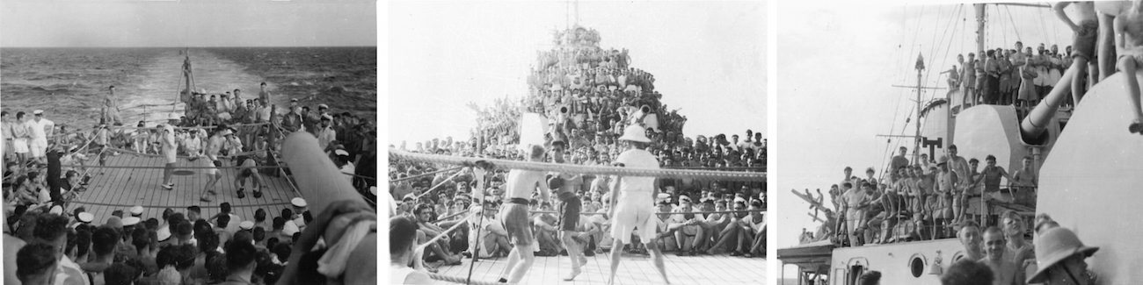

Suez was reached at 07:45 on 26 August and the troops disembarked. Two days later Hobart departed Suez bound for Aden. On the morning of 30 August Hobart came under a determined aerial attack from an Italian SM81 Savoia bomber. The aircraft commenced its bombing run flying a steady course in spite of heavy anti-aircraft fire from the ship. Bombs fell nearby but none hit. Two hours later three more Italian aircraft attacked but again no hits were made.
Hobart continued escort and patrol duties as a unit of the Red Sea Force until October 1940 when it was arranged between the Commander-in-Chief East Indies and the Australian Commonwealth Naval Board that she would return to Australian waters. Following a brief refit at Colombo, Hobart reached Fremantle on 28 December 1940 and arrived back in Sydney on 3 January 1941 where she became the Flagship of Rear Admiral JG Crace, Commanding the Australian Squadron.

-----------------------------------------------------------------------------------------------------------------------------------------

Continued next issue:

Have a laugh

Many years ago, I married a widow out of love, who had an 18-year-old daughter.
After the wedding, my father, a widower, came to visit a number of times, and he fell in love with my
step-daughter. My father eventually married her without my authorisation.
As a result, my step-daughter legally became my step-mother and my father became my son-in-
grandchild because I am the husband of my step-daughter's mother.
This boy is also my brother, as the son of my father.
As you can see, my wife became a grandmother, because she is the mother of my father’s wife. Therefore, it appears that I am also my wife's grandchild.
A short time after these events, my wife gave birth to a son, who became my father's brother-in-law, the step-son of my father's wife, and my uncle. My son is also my step-mother's brother, and through my step-mother, my wife has become a grandmother and I have become my own grandfather. In light of the above mentioned, I would like to know the following:
Does my son, who is also my uncle, my father's son-in-law, and my step-mother's brother fulfil the requirements for receiving childcare benefits?

That's Golf!!
Two golfers are waiting their turn on the tee when a naked woman runs across the fairway and into the woods.
Two men in white coats and another guy carrying two buckets of sand are chasing her, and a little old man is bringing up the rear.
One of the golfers grabs the old man and asks, "What's going on?"
The old guy says, "She's a nymphomaniac from the asylum, she keeps trying to escape, and we attendants are trying to catch her."
The golfer asks, "What about the guy with the buckets of sand?"
The old man says, "That's his handicap. He caught her last time."

The Collar
A priest was invited to attend a house party.
Naturally, he was properly dressed and wearing his Priest's Collar.
A little boy kept staring at him the entire evening.
Finally, the priest asked the little boy what he was staring at.
The little boy pointed to the priest's neck.
When the priest finally realized what the boy was pointing at, he asked the boy;
"Do you know why I am wearing that?"
The boy nodded his head yes, and replied,
"It kills fleas and ticks for up to three months".

The Worker

The Canada Department of Employment believed a boat owner wasn't paying
proper wages to his help.
An agent was sent to the fishing village of Burin to investigate the boat owner.
Government Agent: "I need a list of your employees and how much you pay them".
Boat Owner: "Well, there's Clarence, my hired hand. He's been with me for 3 years.
I pay him $200 a week plus free room and board.
Then there's the mentally challenged guy.
He works about 18 hours every day and does about 90% of the work around here.
He makes about $10 per week, and pays his own room and board.
I buy him a bottle of Lamb's rum and a dozen Labatt Lite Beers every Saturday night so he
can cope with life.
Also, he gets to sleep with my wife occasionally".
Government Agent: "That's the guy I want to talk to - the mentally challenged one".
Boat Owner: "That'll be me. What'd you want to know?"

