Once Navy, Always Navy

20 April 2024
2023 ANNUAL REPORT

Naval Association of Australia, Victorian Section Incorporated

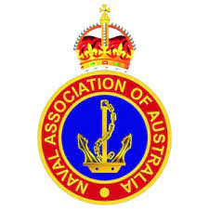

Foreword

I am delighted to present this edition of the Naval Association of Australian, Victorian Section Annual Report, my second report as the Section Chair but, the first in this fashion.

This project, the Victorian Section, is close to my heart as I believe education, transparency, and consultation makes an important contribution to strategy, policy development and decision-making. Managing the business-as-usual activities of the Victorian Section is hard work, can be very frustrating at times, even disappointing but rewarding non-the-less.
The NAA Victorian Section Report, our annual analysis of the Victorian Section, maps the size and scope of the section, illustrating the contribution of Naval Association of Australia, Victorian Section volunteers and their commitment to the Navy veteran and their family. In our one hundred and third year, it was timely for us to review our purpose, in consultation with key stakeholders and accept every opportunity to evolve and grow. We must adapt our approach to adhere to the NAAs objectives and to finesse our approach in consultation with you the stakeholders.
As philanthropy is part of the current national conversation, Australian Charities Not-for-Profit Commission (ACNC) data confirms not only that philanthropists are significant in number, nearly one fifth of registered charities are grant makers, but these philanthropists also play a very significant role in funding charities Not-for-Profit organisations regulated by the ACNC. Data also shows that $13.4 billion of charity revenue is made up of donations and bequests, and charities distributed $9.7 billion in grants and donations.
While challenges for the Victorian Section continues, such as increased costs of delivery resulting from inflation, lower revenue from donations, lower revenue from annual membership fees, higher costs to maintain assets, and the lack of donations, and increases in fuel and associated subsistence travel costs, the Victorian Section has not been able to break into the pool of philanthropists. Two Section members undertook training provided by a Registered Training Authority, to understand the necessary critical underpinning knowledge to write successful grant applications and new knowledge to enable growth in the donation field.

The NAA Victorian Section and its Sub-sections rely on volunteers continue to underpin the work of our sector and operate with no paid staff. There is data, available in the marketplace, to confirm the widely observed decline in Australian volunteering, with volunteer numbers dropping. Our regulators recognise the NAA Victorian Section as a small Not-for-Profit with revenue of under $250,000 and are in the one third of all charities that operate on less than $50,000 annual revenue with no paid staff.
I invite you to read the report for a picture of the Victorian Section.

Our mission

Deliver the best quality services to Victorian ex-navy veterans and generate positive meaningful change.

Our vision

To deliver an optimistic environment, to Victorian Naval Association members and partners, through unwavering support and to inspire current and future Sub-section members through positive change that enriches and contributes to member's health and well-being.

Our history

The Naval Association of Australia promotes mate ship, community spirit, Australia, and the Royal Australian Navy. It began life in 1920 as the Ex-Naval men’s Association and in 1960 changed its name to The Naval Association of Australia.

CONTENTS

Our mission | Page 2
Our vision | Page 2
Our history | Page 2
Section 1 – An overview of the NAA Victorian Section
About us | Page 7
Our people | Pages 8 & 9
Our supporters | Page 10-12
Section 2 – Governance
Structure & management | Pages 15 & 16
Chairperson’s report | Pages 17-19
Our Objectives and Activities | Page 21
Section 3 – Our Finances
Treasurer’s report | Page 22
Auditor’s statement | [page no]
Financial statements | [page no]
Section 4 – Our other important information | [page no]
Acknowledgements | [page no]
How you can help | [page no]
Looking to the future | [page no]
Contact us | [page no]

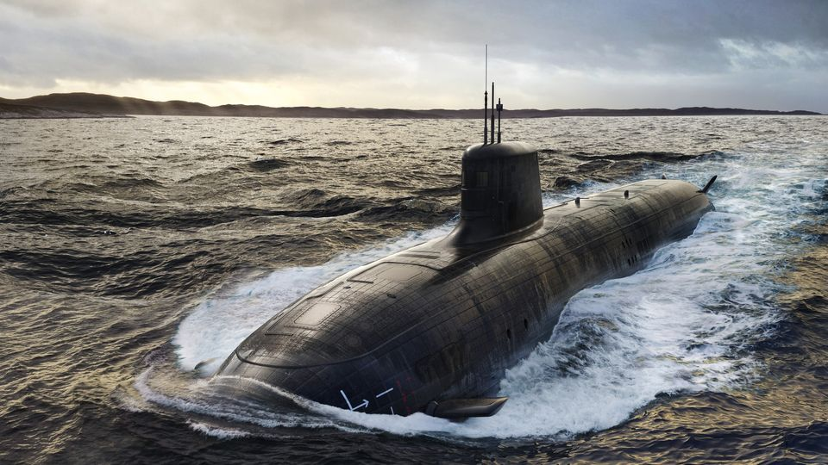

SECTION 1 | AN OVERVIEW OF NAA Victorian Section Incorporated (Vic – V00)

ABOUT US

The Naval Association of Australia (NAA) was established in 1920. Our aim is to be a dynamic and contemporary organisation supporting the Navy fraternity in a wide range of different ways with Mateship at the core of our ethos.
The Victorian Section is a member of the NAA Federation. Membership in the Victorian Section numbers around 260 financial members with Club members and Life members across ten Sub-sections. The Victorian Sub-sections plan their individual activities around five objectives that underpin our mission, and these are:
- Care (welfare) for the diverse and crucial support of Navy and ex-Navy men and women,
- Commemoration by maintaining the legacy of past service and sacrifice.
- Cadets (ANC) by assisting youths to become better citizens through support to the ANC.
- Camaraderie to meet and socialise with like-minded Navy and ex-Navy men and women.
- Community (Engagement) How we interact with and support our local communities.
The five objectives underpinning our values point to the significance of membership. Compensation, rehabilitation, and wellbeing entitlements provided to Navy and ex-Navy men and women today is the result of decades of dedicated work by NAA members. The NAA is the only national organisation with the sole purpose of looking after the interests of serving Navy and ex-Navy men and women.
We believe that Once Navy, Always Navy.

OUR PEOPLE

Patron
Governor of Victoria

Section Board
Section Executive
Name | Position | Dates acted  (if not for whole year)
Graham G. Thomas | Section Chair | 2023
Lee (Dutchy) Andrews | Vice President | 2023
Ron Evans | Vice President | 2023
Graham Don, OAM | Chief Finance Officer | 2023
Ange Kenos | Secretary | June 2023
Joy Emmett | Committee | 2023
Sean Derrick | Committee | 2023
Section Councillors
Gary Cleary | Dandenong | 2023
Mick Clifford | Southwestern | 2023
Russell Pettis, AM | Footscray | 2023
Wendy Sedgwick | Frankston | 2023
Ian Kellett/Bill Matthews | Sunraysia | 2023
Joy Emmett | Box Hill | 2023
Peter Tanner, AM | Geelong | 2023
Ron Evans | Melbourne | 2023
Peter Tunnage | East Gippsland | 2023
Graham Thomas | J.S. Dickson | 2023

Sub-section Delegates

 |  | 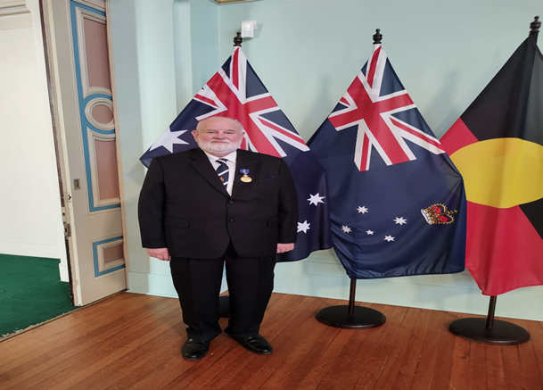
Gary Cleary  Dandenong  Dandenong Delegate | Mick Clifford  South-western | Russell Pettis, AM  Footscray  Footscray Delegate | Wendy Sedgwick  Frankston  Frankston Delegate | Bill Matthews  Sunraysia
Joy Emmett  Box Hill | Peter Tanner, AM  Geelong | Ron Evans  Melbourne | Peter Tunnage  East Gippsland

 |  |  | 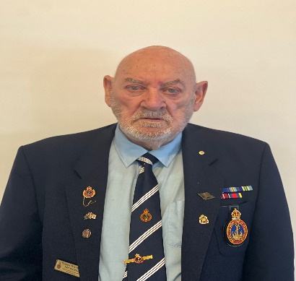
Lee Andrews VP | Ron Evans VP | Ange Kenos Secretary | Graham Don, OAM Chief Finance Officer | Joy Emmett Committee

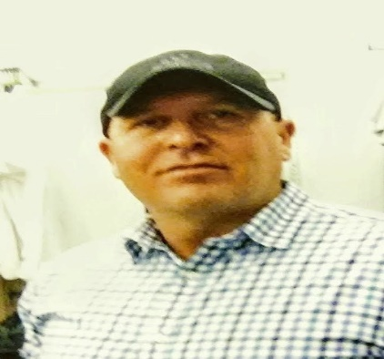 | 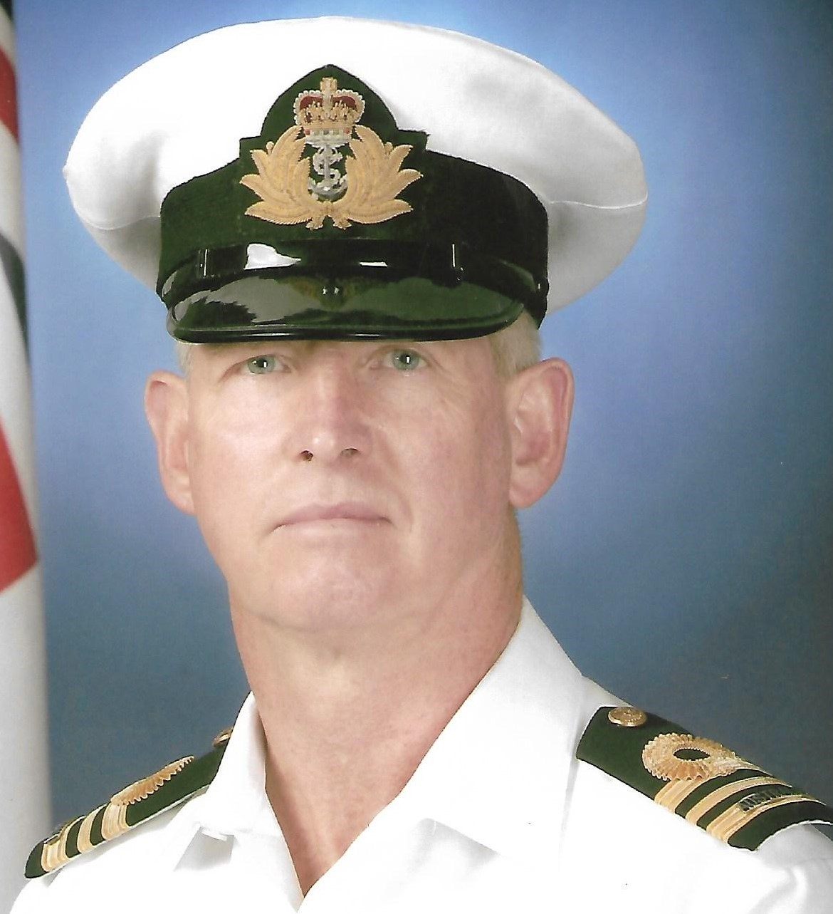
Sean Derrick Committee | Graham Thomas  Chair

VICTORIAN SECTION LIFE MEMBERS

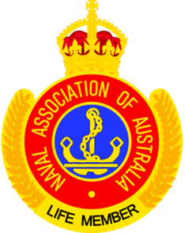

In Recognition
Life Membership may be awarded to a member who:
(a) hold a Certificate of Merit, and
(b) has been a valued and worthy member, and
(c) has rendered exceptional service.
Exceptional service is defined as individual acts and/or performance of duties above and beyond that which would normally be expected from a member of the Association resulting in benefit to the Association, for periods totalling not less than10 years.
Dandenong: R. J. Kennedy; G. McLeod; Norman Hansen JP.
Footscray: R. Pettis, AM
Frankston: J.V. Eriksson; R.N. Surridge; S.J. Goldsmith; G. Savage; L. J. Andrews.
Geelong: P. Faulkhead; L.N. Williams.
J.S. Dickson: F. Kofoed; G. Don, OAM
Box Hill: R. Gill, OAM
Melbourne: R.A. Rowe.
Southwestern: Mervyn Hampson

OUR SUPPORTERS

Patron: Governor of Victoria

Her Excellency, the Honourable Margaret Gardner, Governor of Victoria AC

Margaret Elaine Gardner AC is an Australian academic, economist and university executive serving as the 30th and current governor of Victoria since August 2023. She was previously the vice-chancellor of Monash University from 2014 to 2023 and the president and vice-chancellor of RMIT University from 2005 to 2014.
Eminent academic and university sector leader, Professor Margaret Gardner AC, will be appointed the 30th Governor of Victoria. The term of the current Governor, Her Excellency the Honourable Linda Dessau AC CVO, will expire on Friday, 30 June 2023. Professor Gardner will commence a five-year term as Governor on Wednesday, 9 August 2023, after she concludes in her current role with Monash University. A prominent and well-respected academic with a background in economics, industrial relations and organisational management, Professor Gardner has had a distinguished career in Australia’s university sector and abroad.
As the first woman to lead Monash University, Professor Gardner has served as President and Vice Chancellor since 2014. She previously served as President and Vice Chancellor at RMIT University between 2005 and 2014 and has also held executive leadership and senior academic positions at the University of Queensland and Griffith University. Professor Gardner was a Fulbright Postdoctoral Fellow spending time at the Massachusetts Institute of Technology, Cornell University, and the University of California, Berkeley. In 2018, she was elected a Fellow of the Academy of the Social Sciences in Australia.
In 2007, Professor Gardner was made an Officer of the Order of Australia in recognition of her service to tertiary education – particularly in the areas of gender equity and university governance – and to industrial relations. In 2020, she was appointed a Companion of the Order of Australia for her eminent service to tertiary education through leadership and innovation in teaching and learning, research, and financial sustainability.
Professor Gardner was Chair of the Group of Eight Universities in Australia from 2020 until 2023 and Chair of Universities Australia from 2017 to 2019. She has also been a member of a range of boards and committees including Infrastructure Victoria, Museums Victoria, the Australia and New Zealand School of Government, the Australian-American Fulbright Commission, the ANZAC Centenary Advisory Board and the Australian Technology Network

Office of the Premier of Victoria

SHRINE OF REMEMBRANCE

Victoria's national memorial honouring the service and sacrifice of Australians in war and peacekeeping.

Senior Naval Officer Victoria

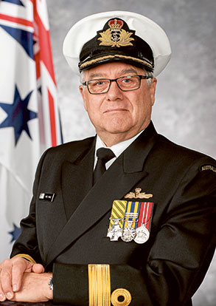

CDRE Greg Yorke, RAN AM, CSC

HMAS CERBERUS

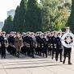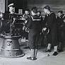

Frankston Naval Memorial Club

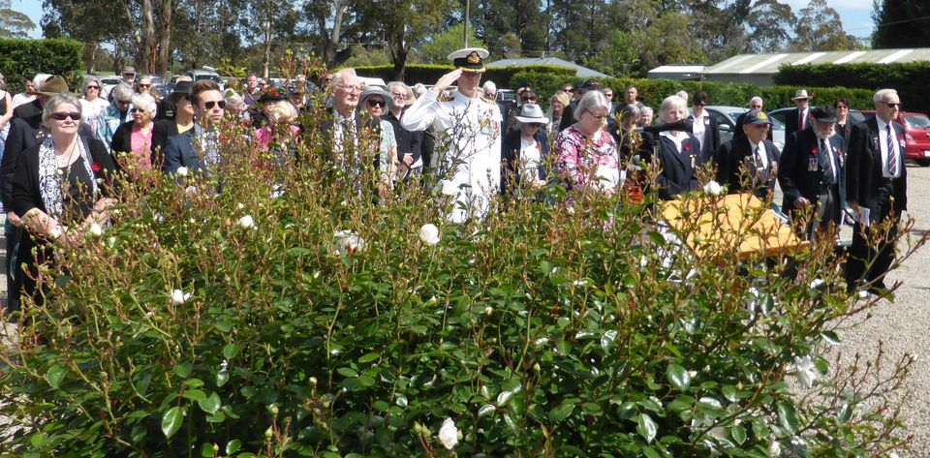

Melbourne Commemorative Committee

Office Choice Bairnsdale

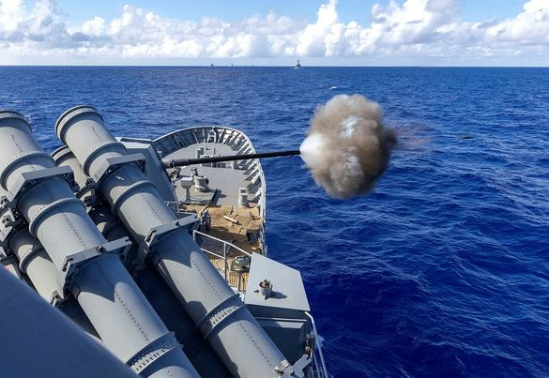

SECTION 2 | GOVERNANCE

STRUCTURE & MANAGEMENT

The Naval Association of Australia, Victorian Section Incorporated, is registered with the Australian Charities and Not-for-profits Commission (ACNC) and regulated by Consumer Affairs – Victoria.
All Not-for-profit organisations need to have a governing document, and the NAA has its Constitution and By-laws augmented by Section Regulations and Sub-section Guidelines. These documents set out the NAAs powers, objects, and processes moreover, the Constitution, by-laws, Regulations and Guidelines contains the rules that define how the NAA, at all levels, is governed moreover, the Section’s Mission Statement, available on the Victorian Section webpage sets out our purpose.
For registration as a Not-for-Profit with the ACNC, the ACNC looks to the NAAs Constitution to determine if the Victorian Section meets the eligibility criteria for charity registration. Fortunately, the NAA Constitution meets the ACNC requirements by providing the following:
- not-for-profit character.
- has charitable purposes for the public benefit.
- information about Responsible People, including:
  - their powers,
  - how they are appointed,
  - the number of Responsible People the charity should have,
  - information about any specific roles (such as chair or treasurer) that need to be filled.
- how to become a member, as well as the rights and obligations of members.
- how meetings are called and held.
- how authority is delegated to the Responsible People.
- the process for winding up.
Of critical importance is that the NAAs Constitution accurately reflects how the NAA, and the Victorian Section operate. If the NAA Constitution isn’t followed, the Victorian Section will not be able to rely on Constitution when needed.
The people responsible for running the Victorian Section, including making decisions, managing finances, overseeing operations, and ensuring the Victorian Section, is working towards achieving its charitable purposes.
Under Governance Standard 5, Not-for-Profits must take reasonable steps to ensure their Responsible People are complying with their duties to:
- to act with reasonable care and diligence
- to act honestly and fairly in the best interests of the Victorian Section and for its purposes
- not to misuse their position or information they gain as a Responsible Person
- to disclose conflicts of interest
- to ensure that the financial affairs of the Victorian Section are managed responsibly, and
- not to allow the Victorian Section to operate while insolvent.

Current Responsible Persons
Contact Responsible Person Position Start Date End Date Status

Lee Andrews Responsible Person Vice President 25 Feb 2022 Active
Ron Evans Responsible Person Vice President 25 Feb 2022 Active
Ange Kenos Responsible Person Secretary 22Jul 2023 Active
Graham Thomas Responsible Person Chair 19 Mar 2022 Active
The Victorian Section has ongoing obligations to the ACNC to remain registered. These obligations are to:
- retain their NFP status by maintaining entitlement to registration.
- notify the ACNC of changes.
- keep records.
- report annually in the Annual Information Statement.
- comply with the Governance Standards and External Conduct Standards.
Our details as recorded on the ACNC register:
ABN: 86973753106
Address: 36 Barretts Rd, Langwarrin South, VIC, 3911, Australia
Email: vicsecretary@navalassoc.org.au
Address For Service email: vicsecretary@navalassoc.org.au
Website: navalassoc.org.au
Phone: 0431709105
Charity Size: Small
Who the charity helps: Veterans and/or their families. Youth - 15 to under 25
Last reported: 23 May 2023
Next report due: 1 February 2024
Financial year end: 30/06
Summary of activities. Provide care to RAN veterans in need. Commemorate events of significance on the Naval calendar. Support the Australian Navy Cadets, in Victoria. Provide opportunities for RAN veterans to mix with likeminded people. Community Engagement.
Subtypes are: Another purpose beneficial to the community, advancing the security or safety of Australia or the Australian public, advancing social or public welfare, advancing public debate (promoting or opposing a change to any matter established by law, policy or practice in the Commonwealth, a state, territory, or another country).
Where the charity operates. States: Victoria
Financial overview. Financial information from the latest AIS. Insert the information here!
Charity name: Naval Association Of Australia Victoria Section Inc
Australian Business Number (ABN): 86973753106

Information about your charity
Charity Details
Your charity’s website address: https://navalassoc.org.au
Your charity’s Address for Service: vicsecretary@navalassoc.org.au

Reporting details
Is your charity an incorporated association? Yes
Incorporated in: Victoria A0047633A
r territory Incorporated Association number

Does your charity intend to fundraise in the next reporting period? Yes
State or territory Fundraising licence number
Your charity’s size for the 2022 reporting period:
Small, Annual revenue less than $500,000 (small charity)
OFFICIAL
OFFICIAL
Charity Programs
Operations
Did your charity operate in the 2022 reporting period? Yes

Description of how your charity’s programs helped achieve your purpose:

Provided care to RAN veterans in need.
Commemorated events of significance on the Naval calendar.
Supported the Australian Navy Cadets, in Victoria.
Provided opportunities for RAN veterans to mix with likeminded people.

Programs

Program information
Program 1
Name: Australian Navy Cadet Units
Classification: Leadership development
Beneficiaries: 'Youth - 15 to under 25';
Location(s): Melbourne Central, Melbourne VIC, Australia; Mildura VIC, Australia; Port Fairy VIC, Australia.
Website:

Program information
Program 2
Name: Commemorations
Classification: Commemorations
Beneficiaries: 'Veterans and/or their families';
Location(s): Melbourne Central, Melbourne VIC, Australia; Online
OFFICIAL
OFFICIAL
People, finance, and reporting
Human Resources
Full time employees: 0
Part time employees: 0
Casual employees: 0
Full time equivalent staff: 0
Volunteers: 14

Financial Report Details

Charity reporting period: 01/07- 30/06
Are you reporting for a period longer or shorter than 12 months? Yes
Enter your reporting period below:
From: 01/01/2022
To: 31/12/2022
Financial reporting:
Did your charity use cash or accrual accounting? Cash
Financial Report:
Uploaded financial report: Report_ Finance 01 Jan - 31 Dec 2022.pdf

Income and Expenses
Revenue
Revenue from government (including grants): $ .00
Donations and bequests: $ .00
Revenue from providing goods or services: $8,626.00
ICIAL
OFFICIAL
Revenue from investments: $1.00
Other revenue/receipts: $ .00
Total revenue/receipts: $8,627.00
Other income: $ .00
Total income/receipts: $8,627.00

Expenses
Employee expenses: $ .00
Grants and donations made for use in Australia: $665.00
Grants and donations made for use outside Australia: $ .00
Other payments/expenses: $6,623.00
Total expenses:/payments $7,288.00
Net surplus/(deficit): $1,339.00

Balance Sheet
Assets
Total assets: $62,251.00
Liabilities
Total liabilities: $ .00
Net assets/liabilities: $62,251.00
Provide a short written description of your assets and liabilities: Naval
Association of Australia, Victorian Section Investment Account and Patriotic Welfare Fund
OFFICIAL
State and Territory Reporting
VIC
Charity AGM date: 06/05/2023

Any resolutions passed at AGM concerning the financial statements? Yes

What were the resolutions? The Auditor's report provided the following:
'I have examined the banking and associated documentation provided to me in respect of the
Naval Association of Australia, Victorian Section Inc and in my opinion having regard to
the income and expenditure disclosed in those accounts, they are a true and fair
representation of the Victorian Section's operations for the year ending 2022.'
The auditor CMDR John Moller was appointed the Section's Auditor for 2023.

Number of members at end of financial year: 457
Value of mortgages/securities/charges: $ .00
Has the charity managed a trust in current financial year? No
OFFICIAL
OFFICIAL
Responsible People
Changes to existing Responsible People
Family name Given name Current position or End
Andrews Lee Vice-president
Evans Ron Vice-president
Thomas Graham President

New Responsible People
name Given name Current position Start date
FICIAL
OFFICIAL
Declaration
Title: Mr
Given name: Graham
Family name: Thomas
Primary phone number: 0431709105
Secondary phone number:
Email address: grahamthomas176@gmail.com
Position held: President
The declaration relevant to you: Authorised person
Revenue
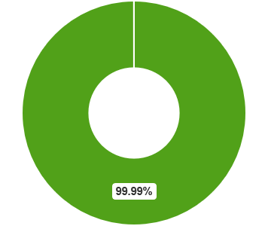
Total revenue: $8,627.00
Revenue from Goods or Services – 99.99%
Expenses. Total expenses: $7,288.00
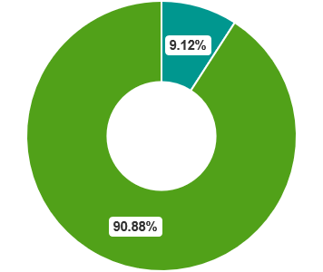
Grants and donations made for use in Australia – 9.12%
All other expenses – 90.88%

Other obligations
In addition to the ACNC, the Victorian Section is registered with the Australian Taxation Office for tax concessions. The Section has opted not to use this option.

CHAIRPERSON’S REPORT

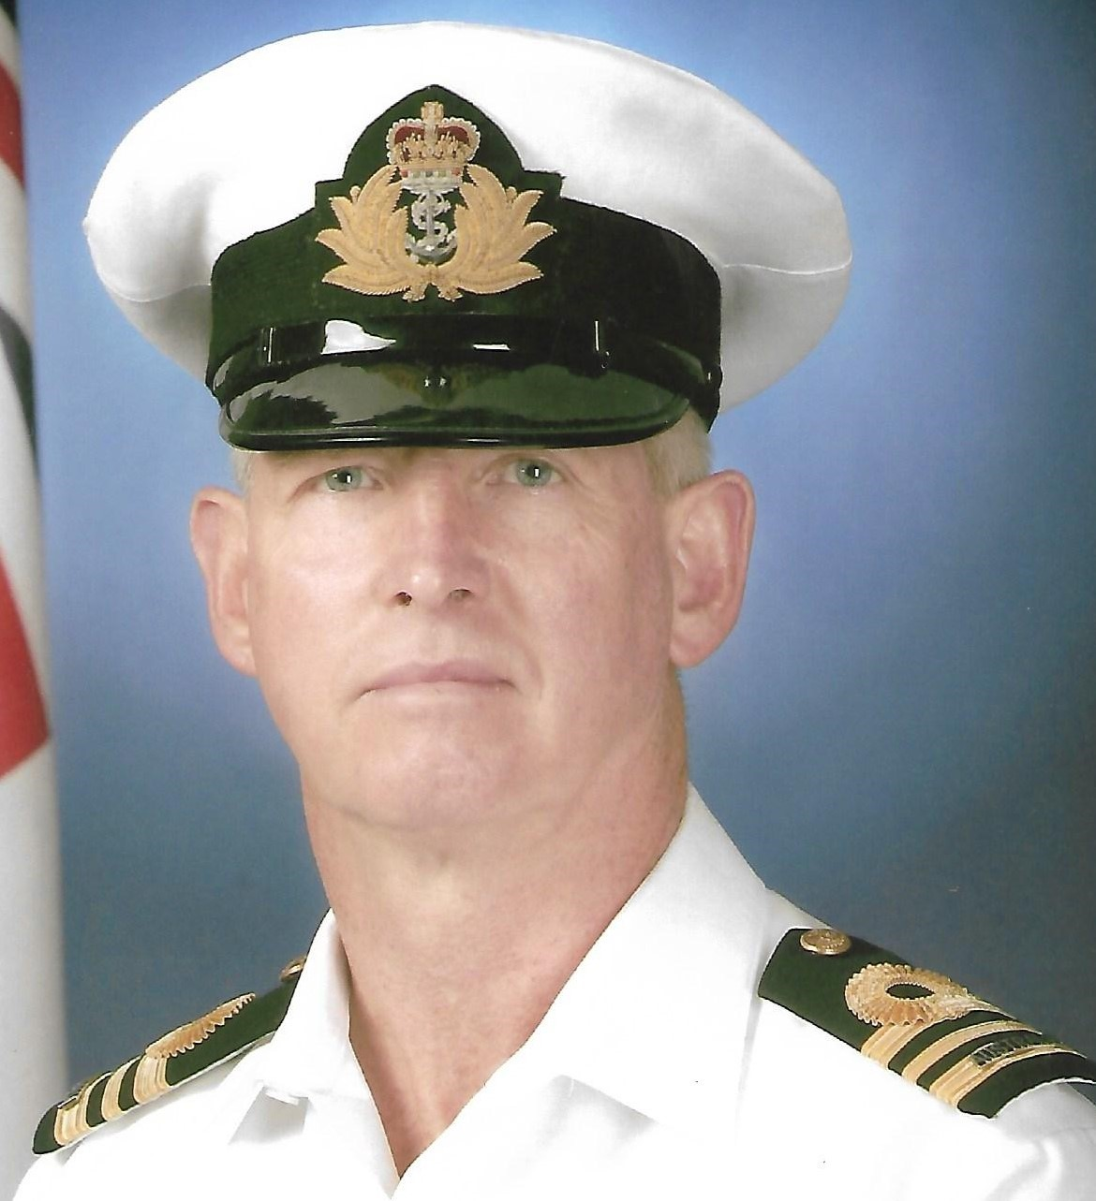

Graham G. Thomas

This report will cover, in as much detail as possible, the achievements of 2023 and celebrate those who were recognised.
2023 resonates with me as a year of challenge, of change, and opportunity. There was much to be done during 2023, enabled by the resolutions made at the Victorian Section's Council Meeting and the Annual General Meeting. 2023 was a year of implementation and progress. The Section Council set out to achieve goals ratified by Section Council that were believed to add value and a fill knowledge gap while providing consistency of information and process, in fields such as:
- Welfare Frequently Asked Questions (FAQ),
- Develop a Sub-section New Member Checklist,
- Create a Bereavement Package,
- Conduct an Executive Forum,
- Provide First Aid Training Update,
- Develop a handy billy for the management of Memorabilia and Honour Boards,
- ANC Award Sponsorship

The Section Council is pleased to report that these goals and the associated Performance Indicators demonstrate the goals have been achieved to an acceptable standard.

My personal goals were to:

Address and correct the legacy issues, de-registration with the ACNC as a double defaulter, the lack of annual taxation returns for several years, impacting the Victorian Section not just on business-as-usual activities but to restore damage to the Victorian Section’s brand.

Drive innovation and the use of technology across the Section and its Sub-sections, encountering some resistance along the journey. As the education base develops at Sub-section level, across available ICT technology, resistance to change will be less obvious.

Grow and develop individuals, using the method known and used by Navy, as mentoring. This aspect of personal development is critical to our current and future situations. The challenge is to recruit new blood, fresh eyes, and new ideas to the Section Executive by identifying prospective high achievers to the roles of Section Chair, Section Vice-President, Section Secretary, Section Chief Finance Officer, and Committee Members. The importance of Succession Planning cannot be understated, and mentoring is a critical lever to successfully recruiting new blood.

Challenge the NAA institution regarding processes and administration. Much has been done in the administration space at Section level by making documents and information visible. There are risks associated with the approach, but these are mitigated by internal checks and balances. The 2023 arrangement for distributing information from the National Council to Sub-sections through the Sections is cumbersome and time consuming and not sustainable. A NAA Working Group is working hard in the background to redesign the NAA website, the method used to distribute information and file documents. An off-the-shelf product known as SharePoint will play a significant role in significantly enhancing how the National Council, the Sections and Sub-sections do business and communicate across all NAA levels.

Fill administrative gaps, for example, developing Section Regulations, available on the Section webpage, ACNC compliance requirements, available on the Section webpage, Work Health Safety Policy, and handy billy, again available on the Section webpage, where and when identified.

Highlight the need to recognise the tireless effort of Sub-section volunteers using the online NAA tools and the Australian Honours and Award System. Russell Pettis, the former National Secretary, was listed among the many Kings’ Birthday Honours list, while Lee Andrews, Mervyn Hampson were made a Life Members, Gary Cleary was among many who received a Certificate of Merit and Frank Kofoed was awarded a sixty-year Long Service Certificate. There are many unrecognised NAA people who do excellent work unselfishly and tirelessly still to be recognised. My thanks go to the people who took the time to put pen to paper and nominate people for not just the NAA awards but also for the formal Australian honours.

Stimulate a coordinated effort involving the Victorian Section and Sub-sections in determining annual goals and goals of future years. The intention is to formulate plans for 2024, 2025 and 2026, set goals and attribute resources to those goals, to identify the hazards, to understand the risks, and to apply mitigation controls that might result in a less than desirable outcome.

Further expand my personal knowledge in the corporate and governance spaces. Understanding the actual compliance requirements was not an easy task but the new challenge is to sustain the reporting effort over future years to not make the same mistakes that led to de-registration.

These personal aims will remain a feature of my role as the Chair.

One of the most satisfying outcomes has been the frank and fearless discussion surrounding issues and incidents, forwarded by the NAA National Council, to its Sections for comment and considered decision. The
Victorian Section has made a significant contribution to these discussions and the NAA position. My personal position, on some matters, was different to Sub-sections positions but one had to recognise the NAA is about NAA members and what they desired not my personal view.

Dwindling membership, caused by an ageing demographic, continues to challenge the Section and Sub-sections in every way possible. A small membership base hinders our business-as-usual activities and responsibilities, and the fear is that a reducing membership base will continue to be an issue unless the Sub-section aggressively recruit what is known as the Contemporary veteran to the NAA. So herein lies the challenge for every member of the NAA in Victoria: Recruit a new member to the Sub-section every six months.

During August 2023 Sub-sections were asked to provide input to the Section Goals/Objectives they viewed as important for 2024, 2025 and 2026. Based on Sub-section input, late in 2023 the Executive undertook a review of the Victorian Section’s Business Plan. The review was necessary as the Section’s Goals/Objective changed, as directed by Sub-section input, as did the hazards, the risks, and the mitigation strategies. But first, why review the Section’s business plan? The answer, a business plan:
- Formalises ideas.
- Structures priorities.
- Tests a project's viability.
- Demonstrate to funders and partners, for example, Scouts Victoria, that we know what we are doing. (If the Section does acquire funders).
- Helps identify responsibilities.
- Helps us to work together with partners, such as Scouts Victoria.
- Helps ask the right questions AND provides some of the answers.
- Identifies areas where there is a need to find out more.
- Provides a map to guide progress and stops getting sidetracked.
Our business plan is prepared, under the direction of the CFO, by the finance Steering Committee with the assistance of the Council delegates.

What are the components of our business plan? Our business plan included the following elements:

Mission statement/goals/objective. All the elements that aren't about money are carried over from our strategic plan. They don't change; what happens now is that we must realistically assess how much worth other people/organisations have for the NAA Victorian Section. Here is an example:

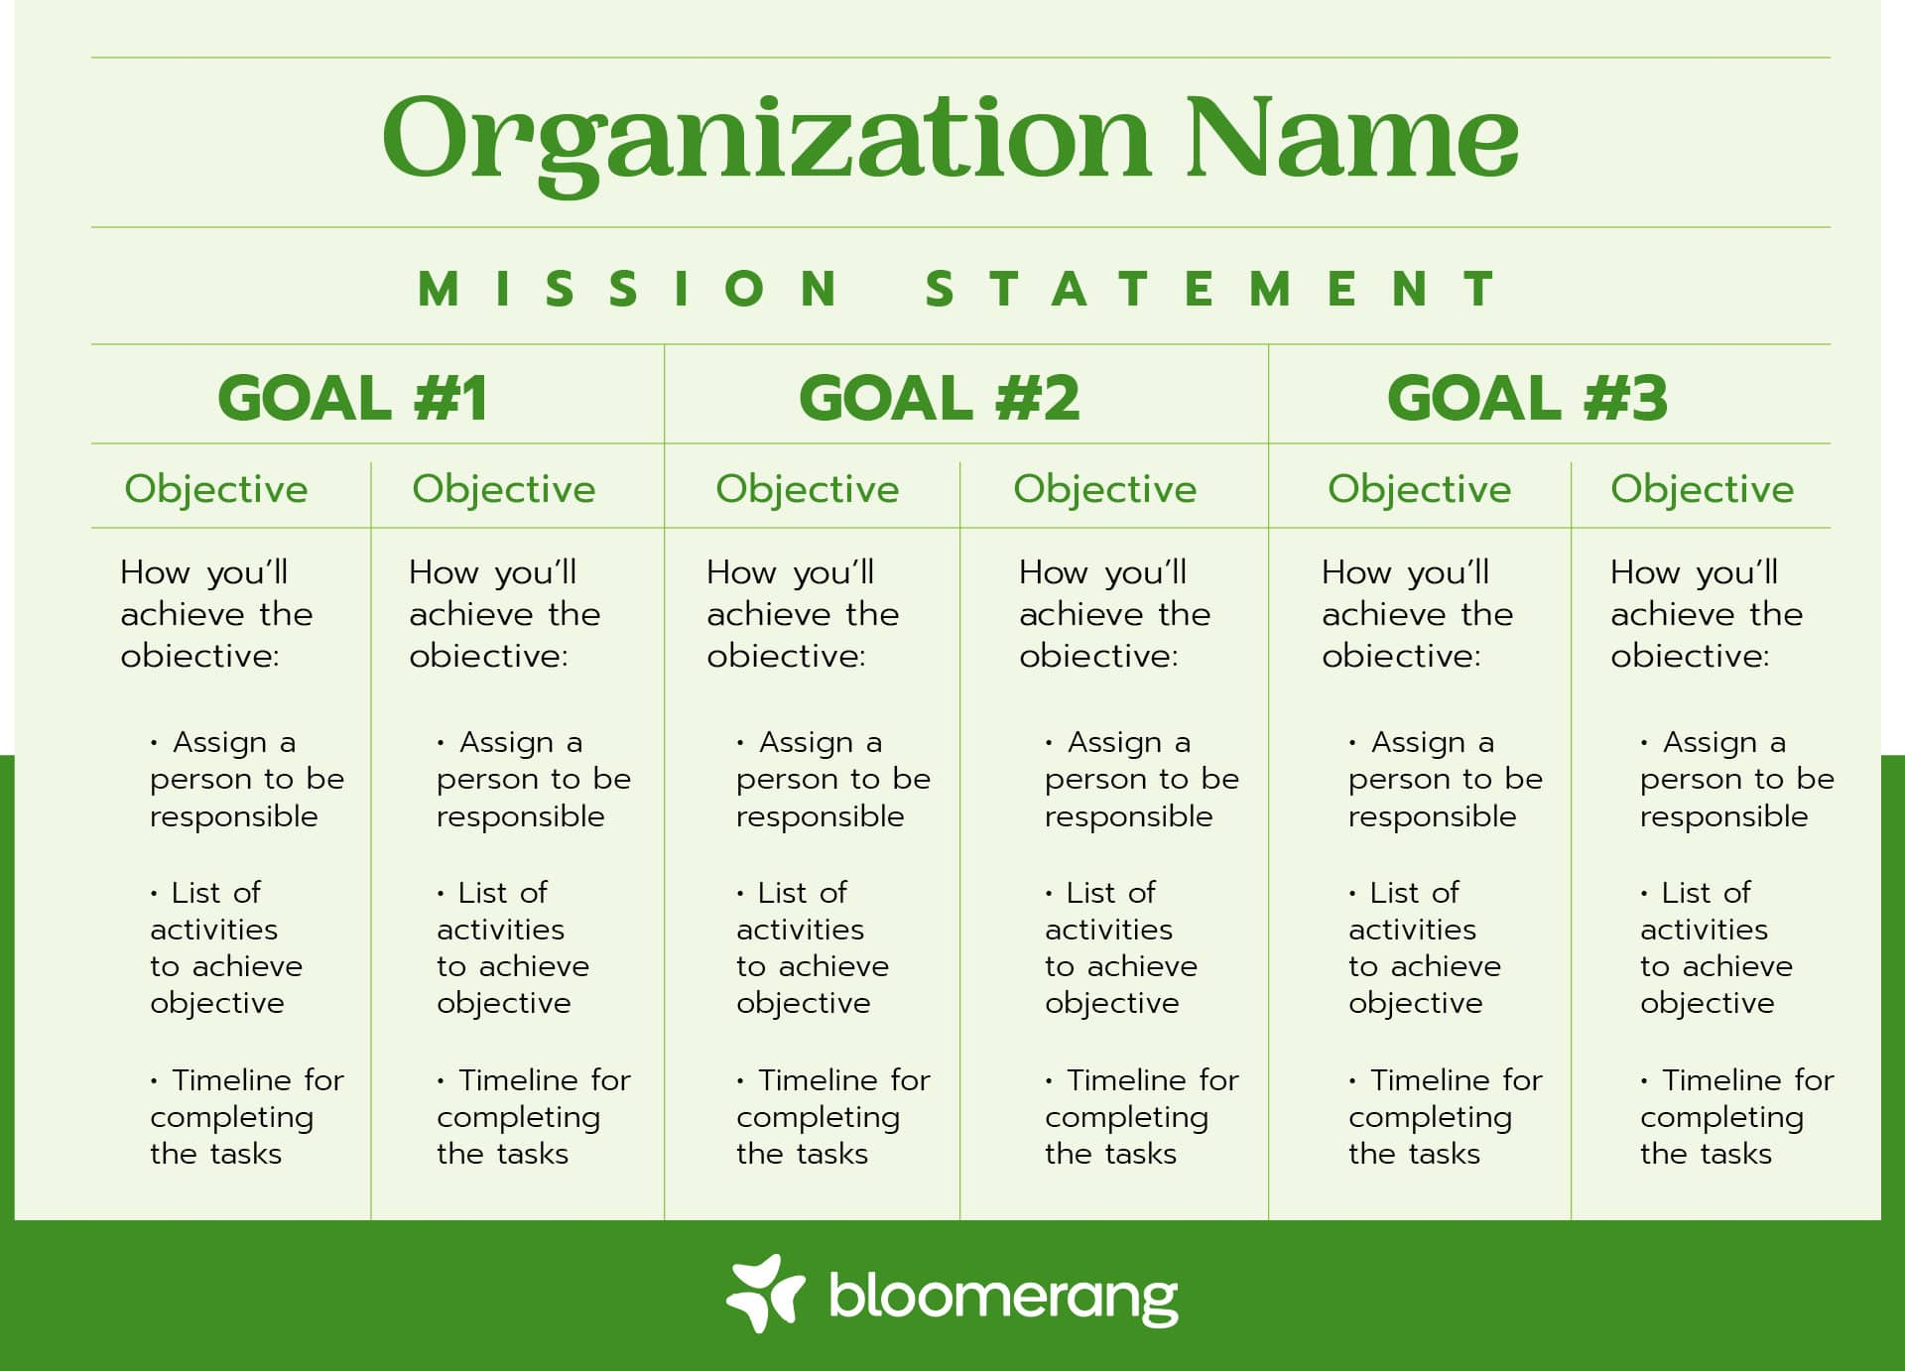

The situation reports. The Situation Report (SITREP) template is a form of status reporting that provides decision-makers and readers a quick understanding of the current situation. It provides a clear, concise understanding of the situation—focusing on meaning or context, in addition to the facts.

Sitrep no. (version no.)

Date of issue

Time period covered by the SITREP (optional if not issue daily or similar)

1.0 Situation to date (what has happened)

• A brief summary of “start-up details” – date, place, time, who

• Summary of overall situation to date

• Ensure old information is deleted, and do not just add new/additional info

2.0 Actions to date (what has been done)

• Brief reporting of actions completed to date

• Table format may be used for repeat actions and/or progressive totals, or similar is given, e.g.,

destructions statistics, no’s of properties visited

3.0 Actions to be completed (what will be done)

• Brief reporting of scheduled/planned actions – typically for the period covered by the SITREP

• As above, a table may be used for repeat actions

• Where the operation expects to be by the next SITREP

4.0 Issue(s)

• Present a brief description of the issue(s) that are known/reasonably expected to arise before the next

SITREP is issued, e.g., a shortage of a given resource, a significant OH&S issue

• Acknowledge of significant achievements, failures, etc. can be given here.

The Situation Report feeds in the results of, our strengths, our weaknesses, our opportunities, and our threats (SWOT) analysis. In short, a SWOT analysis asks for a list (and analyses) of the following:
- What’s working for the Victorian Section (strengths)
- What’s not working for the Victorian Section (weaknesses)
- The external factors the Victorian Section could capitalize on (opportunities)
- The external factors that could harm the Victorian Section (threats)
It’s a simple brainstorming exercise that helps you uncover strategic ways to improve. The Situation Report (SITREP) template is a form of status reporting that provides decision-makers and readers a quick understanding of the current situation. It provides a clear, concise understanding of the situation—focusing on meaning or context, in addition to the facts.

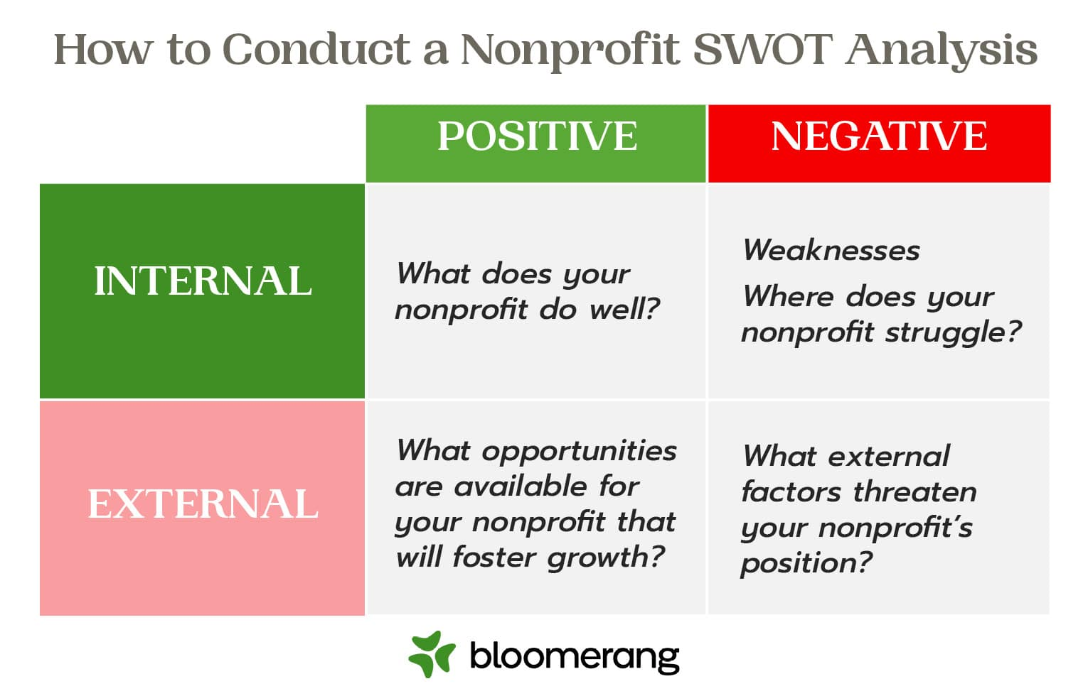

Plans
Each plan attempts to express in concrete terms:
- The outcomes that must be achieved,
- The steps that will be needed to get there,
- The schedule for these to be done,
- The people who will need to do them, and
- What they will cost.

Resources analysis (including human resources plan). Our resources - in particular, given that we rely heavily on volunteers, our human resources - are going to depend largely on how well we market the Victorian Section, and how well we market our organisation, is going to depend partly on how much volunteer labour we must call on. Our resources plan covers both human resources (with a note of the systems and policies in place as support) and material resources (buildings, equipment, transport). As above, the plan should result in measurable performance indicators.

Operational plan. The operational plan covers our delivery of services, for Care, Camaraderie, Commemoration, the ANC, and Community Engagement. To complete this task, ask these questions:

What do we do? How do we do it? Again, the plan should result in performance indicators.

Financial Plan - The budget. The heart of the Section’s business plan is the Section budget. Everything else in the financial plan is there either to feed assumptions into the budget or explain the conclusions that emerge from the budget. Our budget should include:

Income
- Membership fees
- Fundraising/donations
- Special event income
- Sponsorship
- Bank Interest received
- Grants
- Other income

Expenditure
- Personnel
- Public Liability Insurance (PLI)
- Bank charges
- Fundraising/event expenses
- Supplies
- Office equipment
- Stationery
- Travel costs
- Subscriptions/affiliation fees
- Evaluation
- Miscellaneous expenses/sundries
Include the previous year's actual figures and next year's projected figures. Key assumptions should be flagged as footnotes and referred to the situation analysis.
The budget is its own performance indicator.

Evaluation plan
We need to be able to report both on financial soundness and on mission outcomes. Evaluation needs to be built into the structure of the Section - and needs to be carefully costed into the budget.

Timelines
Our Corporate Plan should be for three or five years, with yearly reviews. The business plan should be re-done each year, with six-monthly reviews, and should be re-done when contemplating significant new options or threats, for example, when applying for new grants.
General.
The Victorian Section has aligned with Scouts Victoria to secure much needed funding to support the Section’s business-as-usual activities. Scouts Victoria conduct a monster raffle, approved by Victorian Regulators, hoping to sell around 75,000, two-dollar raffle tickets per raffle. The benefit of the Victorian Section aligning with Scouts Victoria is that for every two-dollar raffle ticket sold, against the Victorian Section link the Victorian Section receives $1.50 return at the end of the raffle. Our thanks must go to Joy Emmett, one of two Section Committee people. Joy has a history with Scouts Victoria and through her tireless efforts the Victorian Section will benefit into the future.

Graham G. Thomas
Lieutenant Commander RAN, (Rtd)
Chair, Victorian Section, Naval Association of Australia

Open Day HMAS CERBERUS

19 March 2023

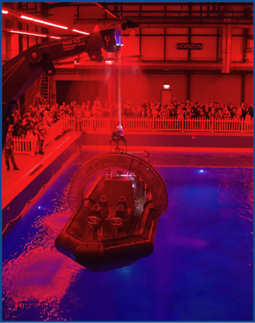

Above - Maritime Skills Training Simulator - Survival At Sea

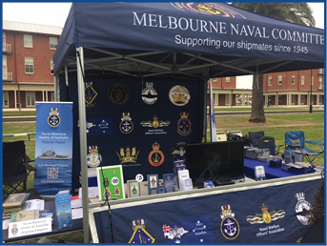

Ex-service Organisation Marque

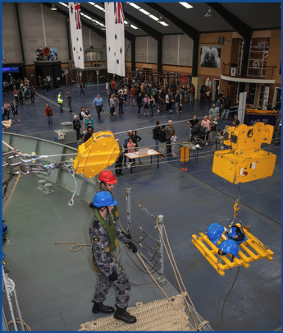

Above Heavy Jackstay Simulator – Seamanship School

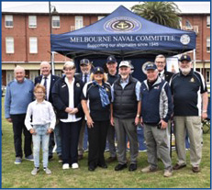

OUR OBJECTIVES AND ACTIVITIES

During 2023

- Create a Welfare Frequently Asked Questions portfolio (FAQ). Available on the Victorian Section Web Portal.
- Develop a Sub-section New Member Checklist. Available on the Victorian Section Web Portal.
- Create a common Bereavement Package. Available on the Victorian Section Web Portal.
- Deliver First Aid Training Update (Under Development by Southwestern Sub-section)
- Create a Memorabilia and Honour Boards. Available on the Victorian Section Web Portal.
- Grant Writing Toolbox: Best Practice Tracker, Strategic Grants Project Information Template, Strategic Grants Writing Checklist, Strategic Grants Workshop Background.

For 2024

- Plan and manage an Executive Forum for Secretaries, for Treasurers, and Presidents and other interested individuals. The program will include morning stand easy, luncheon and afternoon stand easy.
- Initiate Succession Planning to the Victorian Executive. The Victorian Executive Succession Plan was approved by the Section Council in September 2023. The URL is: https://navalassoc.org.au/sections/vic-v00
This AGM will elect a person to the VP Bravo position, and a person to the Secretary for a three-year term of office.
- Conduct a review of ANC Award Sponsorship
- Conduct a Recruiting Drive
- Forward a motion to National Council regarding the Membership By-law
- Distribute the Challenge Coin to Sub-sections
- Implement the Section’s Corporate Plan for 2024, 2025 and 2026
- Revamp the Section web portal
- Routinely review the Section WHS policy, risks, and mitigations
- Review the Section’s Regulations
- Submit the Section’s Annual Information Statement (AIS) to the Australian Charities Not-for-profit Commission (ACNC)
- Submit the Section AIS to Consumer Affairs-Victoria
- Roll out First Aid training across interested Sub-sections
- Procure and issue an AED to interested Sub-sections
- Attend Commemoration Services conducted by the Shrine of Remembrance, Melbourne
- Represent the Section Council at the HMAS SYDNEY II, HSK KORMORAN Commemorative Service conducted by the German Navy in Laboe during November 2024

SECTION 3 | OUR FINANCES

CHIEF FINANCE OFFICER’S REPORT

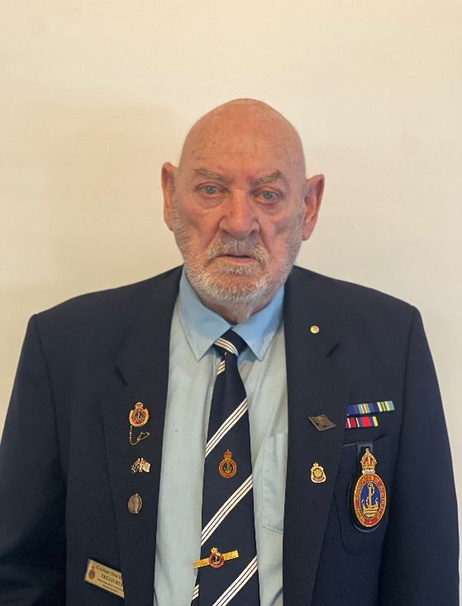
Graham Don, AOM

Victorian Section Annual Finance Report for 2023

The Victorian Section Chief Finance Officer (CFO), Graham Don, OAM, will speak in detail to the Victorian Section NAA Balance Sheet for the period 2023. On completion of the CFOs reading, the Auditor’s Report of the 2023 Victorian Section Financial Operations, the report enclosures will be handed to the Section Secretary for inclusion in the Annual General Meeting Minutes.

Financial Summary (Sourced from the Auditor’s Report):

Total cash and deposits on 31 December 2023: $25 945.17

Funds available on 31 December 2023: $11 627.57

Term Deposit on 21 December 2023: $58 241.06

Patriotic Welfare Fund on 01 December 2023: $ 2 198.69

Total: $72 067.26

Graham Don, AOM
Victorian Section Chief Finance Officer

HONORARY AUDITOR’S REPORT

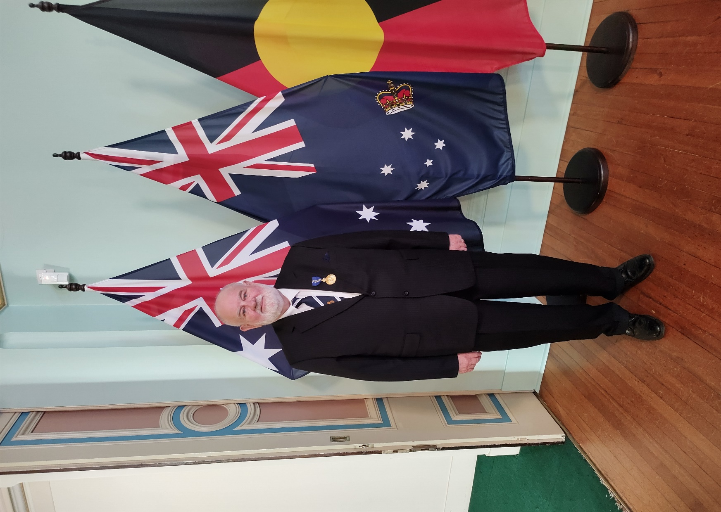

Mr. Russell W. Pettis, AM FAIM

Honorary Auditor’s Report for 2023

Mr. Russell W. Pettis, AM FAIM was appointed as the Victorian Section Honorary Auditor, given the appointed Auditor, CMDR John Moller, RAN (Rtd) was gravely ill and could not undertake the audit.

The financial audit is dated 21 January 2024 and addressed to the Victorian Section President and Members of the Victorian Section, Naval Association of Australia (NAA). The financial audit provided an Auditor’s Report of the 2023 Victorian Section Financial Operations, accompanied by the report enclosures and Bank Statements for the audit period, a Victorian Section NAA Balance Sheet for 2023, notes, information, and conclusions.

A direct transcription of the Honorary Auditor’s Report is:

‘I have examined the banking and associated documentation provided to me in respect of the Naval Association of Australia, Victorian Section Inc., and in my opinion, having regard to the income and Expenditure disclosed in those accounts, they are a true and fair representation of the Victorian Section’s operations for the year ending 31 December 2023’.

Original Signed By

Russell W. Pettis, AM FAIM

Honorary Auditor

24 January 2024

The original Honorary Auditor’s Report and declaration will be passed to the Victorian Section Secretary for inclusion in the Annual General Meeting minutes.

On behalf of the Victorian Section, NAA Executive, Council, and members I thank Mr. Pettis for his contribution.

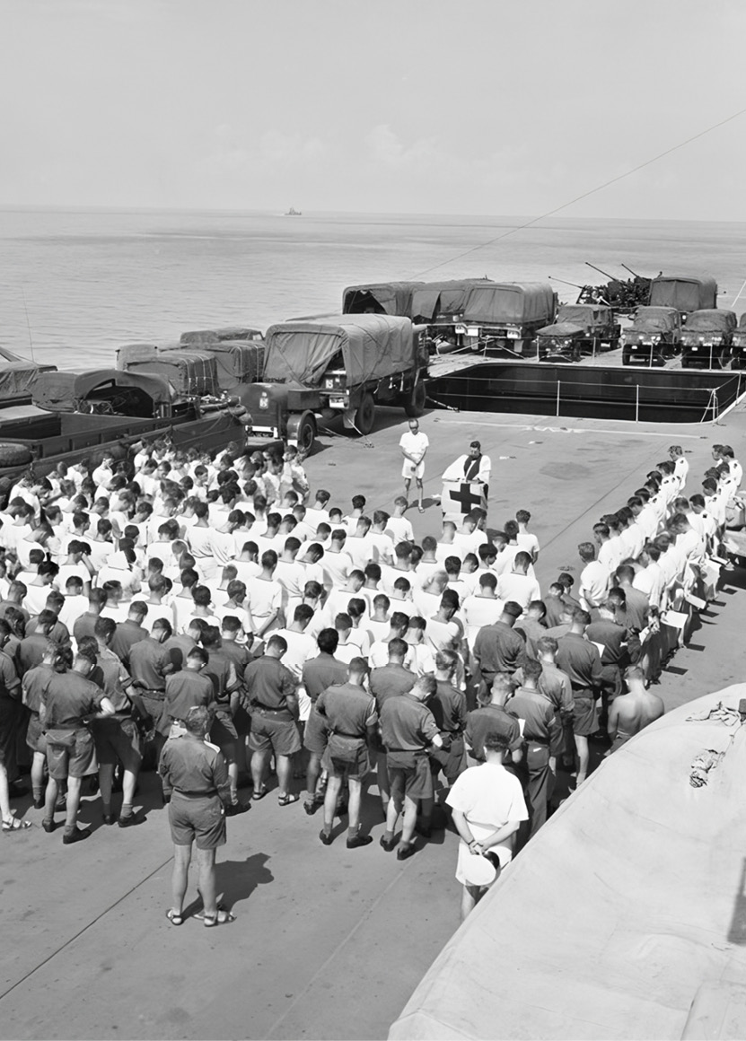

The Vung Tau Ferry – HMAS SYDNEY at sea.

SECTION 4 | OUR OTHER IMPORTANT INFORMATION

ACKNOWLEDGMENTS & THANK YOU

Donors
Box Hill Sub-section
Graham Thomas
Anonymous

Grants and funding
Melbourne Naval Committee

Corporate & community partners
Scouts Victoria

HOW YOU CAN HELP

Become a member of your Sub-section Executive Committee. Use your managerial skills, your time management skills, your people skills, your literacy skills and more.

Volunteer your time, support an event or fundraising activity. Volunteer your time, your skills and knowledge in support of your Sub-section fundraising events. Fundraising is often the way Sub-sections augment their income from annual membership fees, to deliver Sub-section activities.

Donate to your Sub-section.

Leave a bequest. Consider leaving a bequest to your Sub-section or the Section.

LOOKING TO THE FUTURE

Continue the coordinated effort involving the Victorian Section and Sub-sections in determining annual goals and goals of future years.

Formulate plans for 2024, 2025 and 2026,
Set goals and attribute resources to those goals,
Identify the hazards, to understand the risks, and to apply mitigation controls that might result in a less than desirable outcome.

CONTACT US

Victorian Section is headquartered at the Frankston Naval Memorial Club
36 Barretts Road Langwarrin South, Victoria
Section Secretary: vicsecretary@navalassoc.org.au General Mail: Victorian Section Secretary, 6 Coghlan Street, NIDDRIE VIC 3042
Sub-section Capitation Reports to the Victorian Section, send to: Victorian Section Treasurer, 4 Gayle Court, Clayton South Vic. 3169

(Heading) Help and Feedback
HELP DESK: 0431 709 105
Feedback Line. (email): graham.thomas@navalassoc.org.au
Suggestion Box: graham.thomas@navalassoc.org.au
URL: https://navalassoc.org.au/sections/vic-v00

