NAVAL ASSOCIATION OF AUSTRALIA (NAA) WORK HEALTH AND SAFETY (WHS) HANDY BILLY
FOR USE BY NAA PEOPLE

Introduction

NAA has developed a WHS enclosure to this handy billy to assist NAA people with the identification, management, and control of WHS risks and hazards associated with NAA real estate as a workplace, finance, IT, information, and security. The Log is enclosure 1 to this document.

Context. The NAA, established in 1920, is a dynamic and contemporary organisation supporting the Navy fraternity in a wide range of different ways with Mateship at the core of our ethos. The NAA is the only national organisation with the sole purpose of looking after the interests of serving Navy and ex-Navy men and women. The NAA is a Federation with Sections across all States and Territories, with the exception being Northern Territory. Each Section may have a number of Sub-sections consisting of currently serving members, separated members and veteran family members. The membership cohort is aged and given the attitude of the contemporary veteran, recruitment of new younger members is a challenge and a significant risk to the NAA. Membership is often achieved via word of mouth. Office accommodation, for responsible persons, to conduct NAA business as usual is not ordinarily available, hence many responsible persons work from a home office with established lines of communication via, usually email, and other readily available technology and platforms such as Zoom using privately owned IT equipment with minimum security infrastructure, mechanisms for backup and storage of and for NAA intellectual property. This reliance on private equipment is because the NAA does not access to a server or storage infrastructure, for example, SharePoint as the repository for NAA documents. Sub-section meeting spaces and appropriate spaces for social gatherings, with the exception of a few Sub-sections with club rooms, rely on third parties such as RSL, ANZAC House and in some cases private homes.

Care is one of the NAA pillars however, there is no structure around how care is delivered let alone assessed for effectiveness and quality of the service to the veteran and or family. Hospital visitations, by NAA people, for hospitalised veterans, is neither well structured or organised across the federation. Closely associated with visitations is Advocacy. DVA has made the delivery and assessment for welfare and claims advocate training problematic. The new training delivery is cumbersome and lengthy. Many advocates under the old training regime have not aligned with the new training package leaving the NAA in a position where trained and competent welfare and claim advocates are too few for the demand. NAA members are reliant on paid DVA advocates for services.

The NAA works within several Regulatory structures at State and Federal levels including the ATO across several departments, the Australian Charities Not-for-Profit Commission, Consumer Affairs while complying with the Registration requirements.

The aim of this handy billy and the enclosure is to address the issues raised in the context while providing an easy reference for day-to-day business.

Do you have a Duty of Care as the Person Conducting a Business or Undertaking (PCBU)? Answer: Yes.

What do you as a PCBU do to deliver on your duty of care? Answer: Identify, eliminate, and manage WHS related risk. Read on.

Eliminating risks to health and safety, implement control measures in accordance with the hierarchy of control measures. This is key.

What is ‘reasonably practicable’ in ensuring health and safety? Answer: What is reasonably practicable is an objective test. This means a duty holder must meet the standard of behaviour expected of a reasonable person in the duty holder's position and who is required to comply with the same duty.

You have a Duty to Consult, Co-operate and Co-ordinate (CCC) Answer: Definitely. Your duty is to consult with NAA workers/volunteers and if applicable their representatives.

How do you use the NAA Risk Assessment and Hazard Risk Assessment Register? Read on and don’t be daunted.

The NAA Risk Assessment and Hazard Risk Assessment Register – enclosure 1, should be developed prior to the commencement of any NAA business or undertaking and updated regularly. Note: The NAA Risk Assessment and Hazard Risk Assessment Register – enclosure 1, is to be saved in a WHS file, at National, Section and Sub-section level, and reviewed and updated as required.

Highly recommended that the NAA Risk Assessment and Hazard Risk Assessment Register – enclosure 1, is routinely discussed and any necessary amendments made (including revised control measures) at each Sub-section, Section or National Council planning meeting.

The revised NAA Risk Assessment and Hazard Risk Assessment Register – enclosure 1, should be issued by the PCBU and any other PCBU owing WHS duties concerning the matters. The NAA Risk Assessment and Hazard Risk Assessment Register – enclosure 1, is developed to the point where most common hazards are identified. Enclosure 1 provides a ready reckoner for Likelihood and Consequence Descriptors, Likelihood and Consequence Chart. Separate worksheets for IT, Home Office, Workstation Setup, Event Management, Financial Risk, and Security Risk, Welfare – Care, and a Risk Register of risks across all worksheets are provided. These worksheets are your base line Risk Assessment and mitigation documents. Additionally, a consolidated Risk Register, brings all your identified hazards, identified risks and mitigations into a single document. When a new hazard and associated risks are identified the relevant work sheet is amended and the Risk Register adjusted.
- The worksheets in enclosure 1 have been preloaded with information derived from the:
Health and Safety Work Hazard Types recognised Hazard Sources and Potential Harm – The table above refers.
Work Health and Safety Risk Management Procedure 03 - Hierarchy of Control measures at figure 1.
Work Health and Safety Risk Management Procedure 04 – Work Health and Safety Risk Matrix defining the Level of risk from Likelihood x Consequence.
Further reading is available below.
Work Health and Safety Risk Management Procedure 03 - Hierarchy of Controls
10. This procedure provides information on the application of the hierarchy of controls (see Figure 1).
11. Risk control is taking action to eliminate work health and safety risks, and if that is not possible, taking action to minimise those risks so far as is reasonably practicable (SFARP).
12. A control measure, in relation to a risk to health and safety, means a measure to eliminate or minimise the risk. The hierarchy of control measures are:
Eliminate – the most effective control measure involves elimination of the hazard. Eliminating the hazard will also eliminate any risks associated with the hazard. Eliminating hazards is often more cost effective and practical to achieve at the design or planning stage of a platform, product, process, or activity.
Substitute – involves replacing the hazard with a hazard that has a lower level of risk (for example, substituting a solvent-based paint with a water-based product).
Isolate - involves isolating the hazard by physically separating the source of harm from people by using distance or barriers (for example, installing guarding on machinery or barriers to prevent access).
Engineering – are controls that are physical in nature, such as a mechanical device or process (for example, mechanical isolation - mechanical lockouts or tag-outs or software systems that provide redundancies).
Administrative – are work methods or procedures that are designed to minimise exposure to a hazard (for example, procedures on how to operate machinery safely, limiting the exposure time to a hazardous task, use of safety signs to warn people of a hazard).
Personal Protective Equipment (PPE) – personal protective equipment limits the exposure to harmful effects of a hazard (for example, gloves, respirators, glasses, coveralls, hearing protection, hard hats).

The hierarchy of control measures to be applied in determining the management or risks is to accord with figure 1 below.
Hierarchy of Control Measures

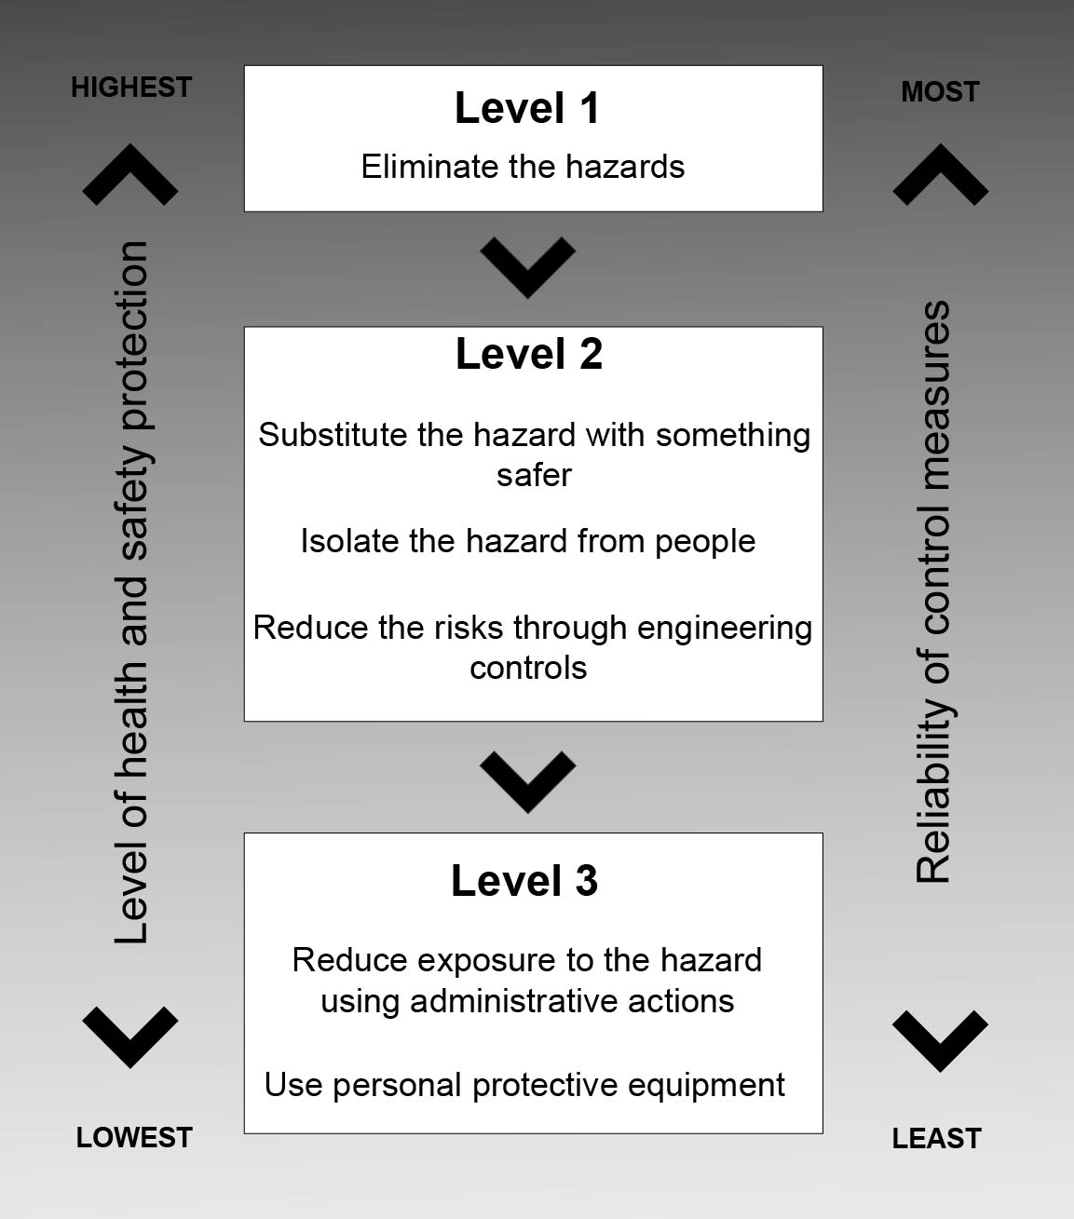

Figure 1. Hierarchy of Controls

You must keep records that demonstrate a risk management approach has been applied to the project and or event and the identification of hazards and risk. Records to be kept include the following:

Hazards that were identified, risks assessed, and control measures chosen (including worksheets or assessment tools used in addition to the Log).

Records of consultation, co-operation and co-ordination with concurrent duty holders, and consultation with others and their representatives.

How and when control measures were implemented, monitored, and reviewed (in addition to the Log).

Any relevant training records.
Use of the matrix
- When conducting risk assessments, the emphasis must be on the identification and implementation of reasonable and effective Mitigations/treatments/risk controls as this may inform decision making in relation to the appropriate allocation and use of resources. It may also inform the assignment of appropriate risk controls that contribute to effective risk management.
- Separate Risk Assessment templates and Risk Register are provided to support your individual circumstances. These separate risk assessment templates are generic in nature but, many hazards and risks will be common throughout the NAA. Use the handy billy as a handy reference point and use the templates to build your individual Risk Profile.

Enclosure:
- NAA Risk Assessment and Hazard Risk Assessment Register

