|  |
| --- |
| Saclip_image001  **GREENBANK NAA NEWSLETTER**  **GREY FUNNEL DITS**  *Disclaimer: The material contained in this publication is in the nature of entertainment for the members. Contributions are acknowledged, with thanks, from service organisations. The editor expressly Disclaims all and any liability to any person, whether an association member or not. Views expressed may not necessary be those held by the Executive or the members.*  flag  A close up of a sign  Description generated with very high confidence |

*Editor: Tony Holliday* [*tonyholliday13@gmail.com*](mailto:tonyholliday13@gmaiul.com) *0403026916*

*S***eries No. 4 Date: Issued October 2021 No .10**

**GREENBNANK NAVAL ASSOCIATION Subsection**

**Events: October and November 2021**

Tuesday 05 October 1930-2100 Normal Meeting RSL Rooms

Wednesday 27 October 1000-1030 Executive Meeting RSL Rooms

Tuesday 09 November 1930-2100 Normal Meeting RSL Rooms

Thursday 11 November TBA Remembrance Day

Wednesday 24 November 1000-1030 Executive Meeting RSL Rooms

Saturday 27 November 1830-2330 Annual Dinner/Christmas function Glenn Hotel

**Jack’s Memorial Commemoration at 1100 Thursday 28 October 2021**

**RANCBA:**

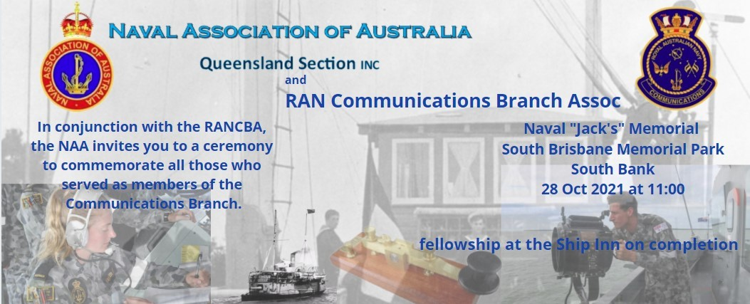

**ROYAL AUSTRALIAN NAVY – PERSONALITY**

**RADM Wendy Anne Malcolm:**

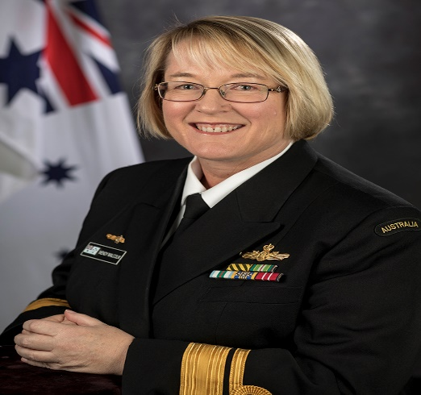Born and bred in Victoria Wendy Malcolm joined the Royal Australian Navy in 1987, graduating as a Midshipman from the Australian Defence Force Academy in 1989 having completed a Bachelor of Science majoring in Physics.

She trained as a Supply Officer (Maritime Logistics Officer) at HMAS *Cerberus* in 1990 and saw service ashore and at sea. During the period 1995-1998 Wendy was involved with setting up the in-service support for the Anzac Class frigates through the Anzac Class Logistics Office within Naval Support Command. Lieutenant Commander Malcolm served as the supply officer in the guided missile frigate HMAS *Newcastle* during 1998-2000 including operational service in East Timor as part of Operation WARDEN.

She was posted to the Directorate of Naval Officers Postings from February 2000 to December 2001 and during this period completed a Masters in Commercial Law. A challenging and rewarding posting in the then-Defence Materiel Organisation followed as the Project Manager for the Evolved Sea Sparrow Missile Project during the period of this weapons introduction into service.

Wendy was promoted Captain in 2010 and appointed as the Director Anzac Systems Program Office. In this capacity, she was responsible for maintenance, logistics support and in-service engineering for the RAN’s eight Anzac Class frigates and their shore support facilities in Fleet Base East (Sydney) and Fleet Base West (Rockingham). Wendy was awarded a Conspicuous Service Medal (CSM) in the 2015 Australia Day Honours List "for meritorious devotion to duty as the Anzac System Program Office Director".

She left the Navy in 2015 to take up a position with Saab Australia as the transition manager for the new support enterprise for the Anzac Class ships, before returning to Navy in late 2017. Wendy was promoted Commodore on 23 October 2017 and appointed as Director General Specialist Ships with responsibility for sustainment of Armidale Class patrol boats, Pacific patrol boats, hydrographic vessels, mine-hunters and mine warfare and diving systems.

Promoted Rear Admiral on 7 December 2018 she assumed the role of head Maritime Systems within the Capability Acquisition and Sustainment Group (CASG).

**\*\*\*\*\*\*\*\*\*\*\*\*\*\*\*\*\*\*\*\*\*\*\*\*\*\*\*\*\*\*\*\*\*\*\*\*\*\*\*\*\*\*\***

**ROYAL AUSTRALIAN NAVY – ADMIRALS**

**RADM Frans Karel de Laat**

**Frans Karel de Laat**, known as Karel, was born on 23 December 1949 in Rotterdam, The Netherlands. He migrated to Queensland, Australia with his family in June 1953 and subsequently became an Australian citizen in March 1962. He was interested in a military career from a young age, joining the Australian Army Cadets at age 14 and ultimately became a company commander in his final year of high school and was awarded prizes for being the most efficient cadet and having the most efficient platoon.

Upon leaving school he commenced studying psychology at the University of Queensland and also joined the Citizens Military Forces (Army Reserve) serving in 21 Psychology Unit, as a psychological assessor, during 1967-1969. He was awarded a Commonwealth scholarship to complete his Bachelor of Arts; having completed the majority of his studies on a part-time basis while working in the Australian Public Service. He subsequently completed a Bachelor of Art (University of Queensland) in 1971 and a Diploma in Psychology (University of Queensland) in 1973.

After completing his Diploma in Psychology, de Laat qualified as a psychologist while employed by the University of Queensland in a training role and became a Member of the Australian Psychological Society. While working at the University he was appointed as a part-time consultant psychologist to the Royal Australian Navy (RAN) as part of its Queensland recruiting team, serving in this role as a civilian during 1976 - 1978. In 1978, the RAN established a reserve psychological branch and a special list of psychology officers. On 20 November 1978, de Laat was appointed as a Lieutenant in the Royal Australian Naval Reserve (RANR) in support of the Brisbane Port Division and the RAN recruiting team.

From 1978 to 1990 he was attached to the Brisbane Port Division of the RANR based at HMAS *Moreton* and also completing short term postings to Navy Office, Canberra and in support of other bases including HMA Ships *Cairns* and *Encounter*. His initial duties were in his psychology specialisation, but after promotion to Lieutenant Commander, in 1986, he was appointed as a head of department and in charge of recruiting, recruit training, psychology and public relations (for the Brisbane based landing craft HMAS *Labuan*. He also continued his academic career obtaining a Master of Letters from the University of New England (Armidale, NSW) in 1979.

After a restructure of the RANR and the closure of the Brisbane Port Division, Lieutenant Commander de Laat served in the Directorate of Naval Psychology, based in Canberra, and consulted to the Directorate of Naval Officers Postings (DNOP) from 1991 to 1995. As a consultant, he coordinated the RAN Officer Career Management Survey and provided strategic planning advice to DNOP for which he was awarded an Australia Day Medallion. He was promoted Commander on 1 July 1995 and subsequently served as the national Senior Naval Reserve Psychologist during 1995-1996.

In 1997, Commander de Laat was appointed Director Reserve Utilisation Policy and chair of the Force Mix Review Board Working Group. As such, he was tasked with developing a structure that would optimise the contribution that the RANR made to the RAN and enhance the overall effectiveness of the 'Total Force' Navy. As part of this process he advocated the utilisation of reserve force members on a 'part-time' basis in essential roles that made them an integral part of the command structure.

On 30 April 1998, de Laat was promoted Captain and appointed as Director General Reserves - Navy (DGRES-N), chair of the Force Mix Review Board and principal reserve advisor to Chief of Navy. During his seven year tenure as DGRES-N he established a comprehensive command structure to progress the introduction of the 'Total Force' and increase the contribution of the RANR to the day to day operations of the Navy. As an ancillary function, he established and managed the Chief of Navy Corporate Consultative Program facilitating senior naval officer engagement with Australian industry and commerce. In addition he committed to do professional work in Navy Office, including working with personnel on board HMA Ships *Sydney* and *Tobruk*. He was promoted Commodore on 22 May 2001 and was awarded a Conspicuous Service Cross (CSC) in the 2004 Queen's Birthday Honours List "for outstanding achievement, fine leadership and tireless dedication as Director General Reserves-Navy".

After completing his tenure as DGRES-N, Commodore de Laat was appointed to establish and manage the RAN Community Engagement Strategy. From 2005-2006 he was tasked with raising awareness of the role of the RAN. This was done through a range of events that allowed members of the public to engage with Navy members and learn about day to day activities undertaken by the RAN as well as gaining a better understanding of naval careers.

In 2007, he was appointed as the inaugural Director General Australian Navy Cadets. After completing a comprehensive study ('ANC 2010') he restructured the Australian Naval Cadets into flotillas, rather than as stand-alone units, to facilitate both joint activities and better use of resources for sea training. On 17 December 2007, de Laat was promoted Rear Admiral and appointed as Head Cadet Policy and chair of the Cadet Policy Committee in charge of coordinating the delivery of Australian Defence Force cadet programs by the single service cadet commands in Navy, Army and Air Force.

>Rear Admiral Karel de Laat, CSC, RFD, RAN retired from the RAN on 30 June 2009 after more than 30 years of service. After retiring he completed his doctorate in naval history at the University of New South Wales, Canberra, in 2013. His thesis was 'Seamanship and citizenship: a history of the Australian naval and sea cadet movement, 1863-1952'. He continues to consult in organisational psychology and pursues his interests in writing, mentoring and public speaking. On 18 January 2017 the King of the Netherlands appointed him Honorary Consul for Queensland.

**\*\*\*\*\*\*\*\*\*\*\*\*\*\*\*\*\*\*\*\*\*\*\*\*\*\*\*\*\*\*\*\*\*\*\*\*\*\*\***

**NAVAL DISASTER**

**HMS Repulse:**

At the beginning of the Second World War, *Repulse* was part of the Battlecruiser Squadron of the [Home Fleet](https://en.wikipedia.org/wiki/Home_Fleet). She patrolled off the Norwegian coast and in the North Sea in search of German ships, as well as to enforce the blockade for the first couple months of the war. Early in the war, the aft triple 4-inch gun mount was replaced with an 8-barrel 2-pounder mount. In late October, she was transferred to [Halifax](https://en.wikipedia.org/wiki/Halifax_Regional_Municipality) with the aircraft carrier [*Furious*](https://en.wikipedia.org/wiki/HMS_Furious_(47)) to protect convoys and search for German raiders. *Repulse* and *Furious* sortied from Halifax on 23 November in search of the [German battleship *Scharnhorst*](https://en.wikipedia.org/wiki/German_battleship_Scharnhorst) after it had sunk the [armed merchant cruiser](https://en.wikipedia.org/wiki/Armed_merchant_cruiser) [*Rawalpindi*](https://en.wikipedia.org/wiki/HMS_Rawalpindi), but *Repulse* was damaged by heavy seas in a storm and was forced to return to port. *Repulse* escorted the convoy bringing most of the [1st Canadian Infantry Division](https://en.wikipedia.org/wiki/1st_Canadian_Infantry_Division) to Britain from 10 to 23 December 1939 and was reassigned to the Home Fleet. In February 1940, she accompanied the aircraft carrier [*Ark Royal*](https://en.wikipedia.org/wiki/HMS_Ark_Royal_(91)) on a fruitless search for six German [blockade runners](https://en.wikipedia.org/wiki/Blockade_runner) that had broken out of [Vigo](https://en.wikipedia.org/wiki/Vigo), Spain.

Repulse was assigned to support Allied operations during the [Norwegian Campaign](https://en.wikipedia.org/wiki/Norwegian_Campaign) in April–June 1940. On 7 April, *Repulse*, along with the bulk of the Home Fleet, was ordered to sea to intercept what was thought to be another attempt to break-out into the North Atlantic. The ship was detached the following day to search for a German ship reported by the destroyer [*Glowworm*](https://en.wikipedia.org/wiki/HMS_Glowworm_(H92)), but the destroyer had been sunk by the [German cruiser *Admiral Hipper*](https://en.wikipedia.org/wiki/German_cruiser_Admiral_Hipper) before *Repulse* arrived and she was ordered to rendezvous with her sister *Renown* south of the [Lofoten Islands](https://en.wikipedia.org/wiki/Lofoten_Islands), off the Norwegian coast. On 12 April, *Repulse* was ordered to return to [Scapa Flow](https://en.wikipedia.org/wiki/Scapa_Flow) to refuel and she escorted a troop convoy upon her return. In early June the ship was sent to the North Atlantic to search for German raiders and played no part in the evacuation of Norway.

Accompanied by *Renown* and the 1st Cruiser Squadron, *Repulse* attempted to intercept the German battleship [*Gneisenau*](https://en.wikipedia.org/wiki/German_battleship_Gneisenau) as it sailed from [Trondheim](https://en.wikipedia.org/wiki/Trondheim) to Germany in July. Until May 1941, the ship escorted convoys and unsuccessfully searched for German ships. On 22 May, *Repulse* was diverted from escorting Convoy WS8B to assist in the search for the German battleship [*Bismarck*](https://en.wikipedia.org/wiki/German_battleship_Bismarck), but she had to break off the search early on 25 May as she was running low on fuel. The ship was refitted from June–August and received eight [Oerlikon 20-millimetre (0.79 in)](https://en.wikipedia.org/wiki/Oerlikon_20_mm_cannon) [autocannon](https://en.wikipedia.org/wiki/Autocannon) as well as a [Type 284](https://en.wikipedia.org/wiki/List_of_World_War_II_British_naval_radar#Type_284) surface gunnery [radar](https://en.wikipedia.org/wiki/Radar). *Repulse* escorted a troop convoy around the [Cape of Good Hope](https://en.wikipedia.org/wiki/Cape_of_Good_Hope) from August to October and was transferred to [East Indies Command](https://en.wikipedia.org/w/index.php?title=East_Indies_Command&action=edit&redlink=1).

In late 1941 [Winston Churchill](https://en.wikipedia.org/wiki/Winston_Churchill) decided to send a small group of fast capital ships, along with one modern aircraft carrier to Singapore, to deter expected Japanese aggression. In November, *Repulse* which was in the Indian Ocean was ordered to [Colombo](https://en.wikipedia.org/wiki/Colombo), [Ceylon](https://en.wikipedia.org/wiki/Ceylon) to rendezvous with the new battleship [*Prince of Wales*](https://en.wikipedia.org/wiki/HMS_Prince_of_Wales_(53)). The carrier [*Indomitable*](https://en.wikipedia.org/wiki/HMS_Indomitable_(92)), which was assigned to join them, was delayed when she ran aground in the Caribbean. *Prince of Wales* and *Repulse* and their escorting destroyers comprised [Force Z](https://en.wikipedia.org/wiki/Force_Z), which arrived in Singapore on 2 December 1941. On the evening of 8 December, Force Z departed for an attempt to destroy Japanese troop convoys and protect the army's seaward flanks from Japanese landings in their rear.

Force Z was spotted during the afternoon of 9 December by the [Japanese submarine *I-65*](https://en.wikipedia.org/wiki/Japanese_submarine_I-65), and [floatplanes](https://en.wikipedia.org/wiki/Floatplane) from several Japanese cruisers spotted the British ships later that afternoon and shadowed them until dark. [Admiral](https://en.wikipedia.org/wiki/Admiral) Sir [Tom Phillips](https://en.wikipedia.org/wiki/Tom_Phillips_(Royal_Navy_officer)) decided to cancel the operation as the Japanese were now alerted. Force Z turned back during the evening, after having tried to deceive the Japanese that they were heading to [Singora](https://en.wikipedia.org/wiki/Singora). At 00:50 on 10 December, Admiral Philips received a signal of enemy landings at [Kuantan](https://en.wikipedia.org/wiki/Kuantan) and correspondingly altered course so that he would arrive shortly after dawn.[[](https://en.wikipedia.org/wiki/HMS_Repulse_(1916)#cite_note-38)The crew of [*I-58*](https://en.wikipedia.org/wiki/Japanese_submarine_I-58_(1925)) spotted Force Z at 02:20, reported their position, and fired five torpedoes, all of which missed. Based on this report the Japanese launched 11 reconnaissance aircraft before dawn to locate Force Z. Several hours later 86 bombers from the 22nd Air Flotilla based in [Saigon](https://en.wikipedia.org/wiki/Saigon) were launched carrying bombs or torpedoes. The crew of a [Mitsubishi G3M](https://en.wikipedia.org/wiki/Mitsubishi_G3M) reconnaissance bomber spotted the British at 10:15 and radioed in several reports. The pilot was ordered to maintain contact and to broadcast a directional signal that the other Japanese bombers could follow.

The first attack began at 11:13 when 250 kilograms (551 lb) bombs were dropped from eight G3Ms from an altitude of 11,500 feet (3,505 m). The battlecruiser was [straddled](https://en.wiktionary.org/wiki/straddle) by two bombs, then hit by a third which penetrated through the hangar to explode on the armoured deck below. This inflicted a number of casualties and damaged the ship's [Supermarine Walrus](https://en.wikipedia.org/wiki/Supermarine_Walrus) seaplane, which was then pushed over the side to remove a fire hazard. Anti-aircraft fire damaged five of the Japanese bombers, two so badly that they immediately returned to Saigon. In the ensuing attacks, *Repulse* was skilfully handled by her captain, [Bill Tennant](https://en.wikipedia.org/wiki/William_Tennant_(Royal_Navy_officer)), who managed to avoid 19 torpedoes as well as the remaining bombs from the G3Ms. However, *Repulse* was then caught by a synchronised pincer attack by 17 [Mitsubishi G4M](https://en.wikipedia.org/wiki/Mitsubishi_G4M) torpedo bombers and hit by four or five torpedoes in rapid succession. The gunners on the *Repulse* shot down two planes and heavily damaged eight more, but the torpedo damage proved fatal. At 12:23, *Repulse* listed severely to port and quickly [capsized](https://en.wikipedia.org/wiki/Capsizing) with the loss of 508 officers and men. The destroyers [*Electra*](https://en.wikipedia.org/wiki/HMS_Electra_(H27)) and [*Vampire*](https://en.wikipedia.org/wiki/HMAS_Vampire_(D68)) rescued the survivors, including Captain Tennant.

**\*\*\*\*\*\*\*\*\*\*\*\*\*\*\*\*\*\*\*\*\*\*\*\*\*\*\*\*\*\*\*\*\*\*\*\*\*\*\*\*\*\*\*\*\*\*\*\***

**HAVE A LAUGH**

A guy spots a sign outside a house that reads “Talking Dog for Sale.” Intrigued, he walks in.

“So what have you done with your life?” he asks the dog.

“I’ve led a very full life,” says the dog. “I lived in the Alps rescuing avalanche victims. Then I served my country in Iraq. And now I spend my days reading to the residents of a retirement home.”

The guy is flabbergasted. He asks the dog’s owner, “Why on earth would you want to get rid of an incredible dog like that?”

The owner says, “Because he’s a liar! He never did any of that!”

\*\*\*\*\*\*\*\*\*\*\*\*\*\*\*\*\*\*\*\*\*\*\*\*\*\*\*\*\*\*

In surgery for a heart attack, a middle-aged woman has a vision of God by her bedside. “Will I die?” she asks.

God says, “No. You have 30 more years to live.”

With 30 years to look forward to, she decides to make the best of it. So since she’s in the hospital, she gets breast implants, liposuction, a tummy tuck, hair transplants, and collagen injections in her lips. She looks great! The day she’s discharged, she exits the hospital with a swagger, crosses the street, and is immediately hit by an ambulance and killed. Up in heaven, she sees God. “You said I had 30 more years to live,” she complains.

“That’s true,” says God.

“So what happened?” she asks.

God shrugs. “I didn’t recognize you.”

**\*\*\*\*\*\*\*\*\*\*\*\*\*\*\*\*\*\*\*\*\*\*\*\*\*\*\*\*\*\*\*\***

A park ranger is giving some ramblers a warning about bears, “Brown bears are usually harmless. They avoid contact with humans, so we suggest you attach small bells to your rucksacks and give the bears time to get out of your way. However, grizzly bears are extremely dangerous. If you see any grizzly-bear droppings leave the area immediately.”

“So how do we know if they’re grizzly bear droppings?” asks one of the ramblers.

“It’s easy,” replies the ranger. “They’re full of small bells.”

\*\*\*\*\*\*\*\*\*\*\*\*\*\*\*\*\*\*\*\*\*\*\*\*\*\*\*

**ROYAL AUSTRALIAN NAVY – Ship History**

**HMAS Brisbane (ll) Cont.:**

A number of Brisbane's on-board systems were upgraded. Besides satellite communications equipment and electro-optical surveillance systems, these improvements included new electronic warfare equipment; better chaff decoy rounds; radar absorbent material (RAM) panels to reduce the ship's radar cross section; and extra firefighting and damage control equipment. To improve efficiency of boarding operations the old sea boats were replaced with two new rigid hull inflatable boats (RHIBs) which were to prove their worth during subsequent boarding operations in the Gulf. The most prominent structural change was the installation by dockyard workers of a pair of Phalanx Close-in-Weapons Systems (CIWS) for greater protection against missile attack.

On 15 October Brisbane, in company with Sydney, sailed for a tailored two-week pre-deployment workup before both ships departed for the Middle East on 12 November under the auspices of Operation DAMASK II. A number of VIPs farewelled the ship's company including Prime Minister Bob Hawke, AC, MP, and the Premier of New South Wales, Nick Greiner, MLA.

On 30 November, just before entering the Middle East Area of Operations (MEAO), the ships were advised that the United Nations Security Council had adopted Resolution 678 authorising the use of force against Iraq unless it withdrew from Kuwait by 15 January 1991. On 3 December, Prime Minister Hawke announced that Australian units were allowed to pass through the Strait of Hormuz and enter the Arabian Gulf. Brisbane and Sydney were to form part of the largest grouping of warships seen since the end of World War II. The multi-national coalition included some 90 warships, more than 100 logistic, amphibious and smaller craft, and 800 aircraft from 15 nations.

*L-R HMA Ships Brisbane (ll), Adelaide (ll), Success (ll), Darwin and Sydney (iv) – Operation Damask December 1990.*

Brisbane and Sydney arrived in the MEAO, via Fremantle and Diego Garcia, on 3 December 1990. They rendezvoused with HMA Ships Success (II), Darwin and Adelaide (II) that morning and conducted a thorough handover after which they commenced Maritime Interception Force (MIF) duties. They sailed through the Strait of Hormuz and entered the Arabian Gulf for the first time on 16 December, Brisbane's 23rd birthday. The two ships conducted patrol operations in the Central Gulf. Brisbane spent Christmas alongside in Bahrain before recommencing patrol duties on 27 December. A scheduled port visit to Dubai was delayed in early January 1991 when, over the course of 36 hours, Brisbane came to the assistance of three separate merchant vessels, one of which, MV Demetra Beauty, claimed to have struck a mine in the Gulf of Oman but refused any assistance which required anyone to board and inspect her hull. Her crew was rescued by the Omani patrol vessel Mussadan and the merchant ship Sumara before Demetra Beauty sank.

The UN deadline of 16 January 1991 passed without incident, but at 2:30am on 17 January Operation DESERT STORM began. Sydney and Brisbane formed part of the air defence screen around Battle Force Zulu which included up to three USN aircraft carriers. These duties continued for the duration of the war with Brisbane operating primarily in the North and Central Arabian Gulf. Additional duties during the course of the war included search and rescue, aircraft control and escort of detached units. US President George Bush announced a cease fire on 28 February 1991, though Brisbane's responsibilities in the Battle Force Zulu screen remained largely unchanged. Brisbane and Sydney proceeded out of the Arabian Gulf for the last time on 22 March and exited the MEAO on 26 March. They arrived back in Sydney, via Singapore, Darwin and Brisbane, on 22 April where they began a well-earned leave and maintenance period. Brisbane was subsequently awarded an Australian Meritorious Unit Citation in recognition of her service during Gulf War I.

Following a period alongside in Sydney, *Brisbane* returned to sea on 26 June resuming the normal program of exercises, training and maintenance. She conducted a successful 'welcome home' visit to Melbourne from 5 to 9 July and the ship's company participated in the Gulf Welcome Home parade in Sydney on 5 August. Later that month she participated in Exercise PITCH BLACK off the Northern Territory before conducting passage exercises with Malaysian and Singaporean ships between Darwin and Cape York in early September.

*Brisbane* departed Darwin, in company with *Sydney*, on 10 September bound for Southeast Asia. The pair separated on 14 September with *Sydney* continuing on to Singapore en route to the Middle East, while *Brisbane* went on to Penang and Phuket before visiting Singapore, where she took part in a multi-national Integrated Air Defence Series (IADS) exercise. She returned to Sydney, via Darwin and Brisbane, on 22 October. A Fleet Concentration Period in November was her last major fleet exercise for the year.

During the early part of 1992 Brisbane underwent an extended maintenance period before participating in another Fleet Concentration Period and Exercise CORAL SEA in April. On 1 May she joined 11 other RAN and USN vessels, led by the 80,000-tonne aircraft carrier USS Independence, in a fleet entry into Sydney Harbour commemorating the 50th anniversary of the Battle of the Coral Sea. She departed later in the day, in company with USS Reuben James, for a four-day visit to Melbourne to participate in further Coral Sea commemorations including a march through the streets of Melbourne concluding with a memorial service at the Shrine of Remembrance. Later that month she conducted trials for the Nulka missile decoy system off Jervis Bay becoming the first ship in the world to fire Nulka on 18 May.

Brisbane visited her namesake city in June, where crew members conducted another working bee at Tufnell House, before continuing northwards to the Shoalwater Bay Training Area to participate in Exercise TASMAN LINK in late June and early July. Upon her return to Sydney, she participated in festivities celebrating Sydney's sesquicentenary with 52 members of the ship's company forming part of the Heritage Guard which marched through the streets of the city on 18 July.

To be Continued:

**ROYAL AUSTRALIAN NAVY – NU Ship 1990+**

**PB HMAS Maryborough (ll)**

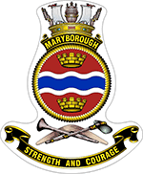

|  |  |  |  |
| --- | --- | --- | --- |
| Class | Armadale | Displacement | 300 tonnes |
| Type | Patrol Boat General | Length | 56.8Mtrs |
| Builder | Austral Ships Fremantle | Beam | 9.7Mtrs |
| Commissioned | 8 December 2007 | Draught | 2.7Mtrs |
| Speed | 25 knots | Crew | 21 |
| Armament | 25mm Rafael M242 Bushmaster  2 x 12.7mm Machine guns  Electronic Countermeasures | Machinery | 2 MTU 4000 16v Diesels |

HMAS *Maryborough* and her 12 sister Armidale Class Patrol Boats and two Cape Class Patrol Boats are Navy's principal contribution to the nation's fisheries protection, immigration, customs and drug law enforcement operations. The vessels work hand-in-hand with other Government agencies as part of the Australian Border Force. In the event of war they would be tasked to control the waters close to the Australian mainland.

Armidale Class Patrol Boats are highly capable and versatile warships which are able to conduct a wide variety of missions and tasks. Most importantly, Patrols Boats are a primary enabler of the Australian Defence Force contribution to Operation SOVEREIGN BORDERS, which is a whole of government effort to protect Australia's borders and offshore interests.

Our operations in association with Border Force, Australian Fisheries and Australian Federal Police protect against unauthorised entry, breaches of customs, immigration and drugs legislation, other illegal activity and in support of law enforcement, preserve the integrity of our national fish-stocks, our marine environment and other natural resources.

When protecting our borders, Patrol Boat crews are typically employed on a range of constabulary duties involving tracking, intercepting, stopping and boarding other vessels, and sometimes arresting their crews and seizing cargo.A picture containing text

HMAS Maryborough has a range of 3000 nautical miles at 12 knots and a maximum speed of about 25 knots. It is equipped with high-definition navigational radar, high and ultra-high frequency communications equipment, gyro compasses and echo sounder. HMAS Maryborough is also fitted with a satellite navigation system that enables the ship's position to be determined with great accuracy.

## **Patrol Boat service**

](http://www.navy.gov.au/sites/default/files/PBG_crest_3.jpg)

The Patrol Boat Group is headquartered in Darwin with vessels home ported in Darwin and Cairns.

Life in Australia's tropical North has many advantages with easy access to Asia for leave, stunning National Parks, including Kakadu and Litchfield, just outside Darwin, a great outdoor lifestyle, camping, fishing, water sports and 4WD opportunities. There are also numerous cultural and artistic events, including festivals. Although in Darwin the cost of living is a little higher than elsewhere in Australia, this is compensated for by District Allowance. There are also travel allowances for RAN members and their dependants.

The region is monsoonal and is characterised by two seasons - a wet season from late December until the end of April, and a dry season from May to December. Temperatures are warm all the year round, but the dry season is cooler at night and much less humid than the wet. The transition between the dry and the wet, between October and December, is a time of increasing humidity and rainfall, and is referred to as the build-up. The cyclone season runs from 1 November to 30 April each year.

## **Family services**

Defence is dedicated to recognising the very important and valuable role of ADF members and their families in the achievement of the Defence mission. While carrying out their daily tasks, whether here in Australia or deployed overseas on operations, our personnel need to be assured that their families are well cared for and have the support they need. For this reason, Defence has tasked [Defence Member and Family Support (DMFS)](https://www.defence.gov.au/members-families/) (formerly Defence Community Organisation - DCO) to support commanders in looking after the welfare of Defence families. DMFS does this by providing a wide range of services that all members and their families can access to help them cope with aspects of the Defence lifestyle.

**\*\*\*\*\*\*\*\*\*\*\*\*\*\*\*\*\*\*\*\*\*\*\*\*\*\*\*\*\*\*\*\*\*\***

**PICTURE FUNNIES**

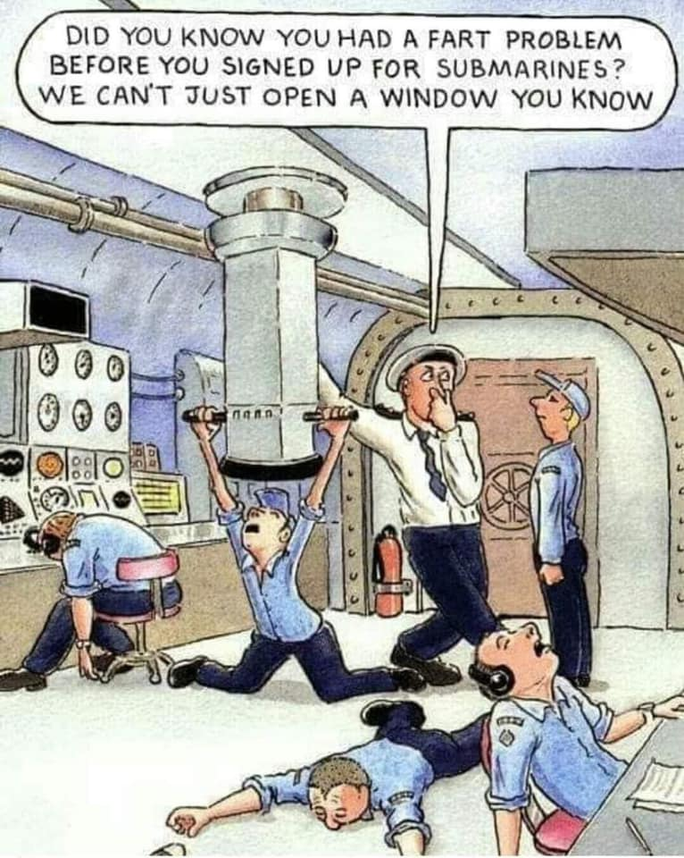

 

 

**RAN – HISTORY, CUSTOMS< TRADITIONS**

**History – Angled Flight Deck**

The angled deck was one of the three improvements to aircraft carrier design conceived by the Royal Navy that made fast-jet operations both possible and safe. The idea of canting or skewing the landing area to port of the ship's centreline had evolved from experiments with a rubber deck and Sea Vampire fighters without undercarriages in HMS *Warrior* in 1948. Although the rubber deck itself proved impractical, the ‘skewed deck’ as it was called at first was seen as a very effective way of making arrested landings safer on existing, relatively small, flight decks.

The generation of jets planned for the 1950s were much heavier than their predecessors, had higher landing speeds and would have needed most of the deck available to complete an arrested landing. The standard technique of centreline landings with a barrier to protect the deck park forward from aircraft that missed the wires was no longer tenable and, with little or no room for the deck park, the number of aircraft that could be operated was small.

Worse still, if the whole deck had to be clear for every landing the number of aircraft operated at any one time would be low and the speed with which they could be recovered would be slow. The angled deck solved this dilemma by providing a landing runway that was longer than the portion of deck aft of the existing barriers. The sum of the lengths of the landing and launch/parking areas was `greater than the length of the ship. Trials were carried out on an angled deck painted on HMS *Triumph,* on USS *Antietam* the first carrier actually fitted with a full angled deck in 1953 and in HMS *Centaur* the first British angled deck carrier in 1954.

[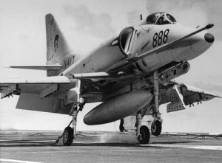](https://www.navy.gov.au/sites/default/files/Angleddeck-2.jpg)

An A-G4 Skyhawk catching arresting wire A Gannet approaches barricade-

emergency arrest

The trials were successful, so successful that every carrier navy moved to copy the idea quickly, led by the USN. Not only did the angled deck provide a longer runway in which the arrester wires could be moved nearer the centre of pitch to make landing easier in bad weather but other advantages soon became apparent. There was no longer a need for a barrier since, with clear deck space ahead of the wires, an aircraft that missed the wires, known as a ‘bolter’, could open the throttle to go round for another circuit.

The area to starboard of the runway gave clear parking space for a number of aircraft, allowing rapid multiple aircraft recoveries and a deck park for refuelling and re-arming.

Although simple in concept, the conversion of existing carriers to have angled decks involved structural alterations, loss of the armament and aerials mounted on the port beam. The arrester wire machinery had to be re-aligned to lie athwart the angled deck. Once the new structure was installed, it provided useful volume for mess decks and machinery.

Three new aircraft carriers joined there respective fleets in 1955 with all three British improvements to carrier flying. They were HMS *Ark Royal* in February, USS *Forrestal* in October and HMAS *Melbourne* (II) in November. The Australian ship was, therefore, one of the most advanced ships of her day despite her small size.

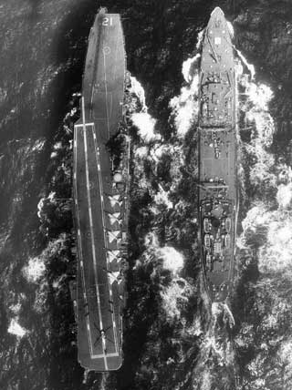 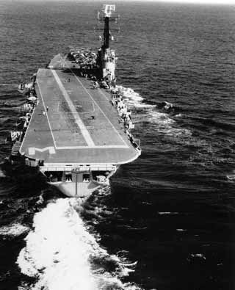

*Pilot’s view of HMAS Melbourne (ll) angled Flight deck HMAS Melbourne (ll) 5.5-degree angled flight deck*

**\*\*\*\*\*\*\*\*\*\*\*\*\*\*\*\*\*\*\*\*\*\*\*\*\*\*\*\*\***