

GREENBANK NAA NEWSLETTER

Grey Funnel Dits

*Disclaimer: The material contained in this publication is in the nature of entertainment for the members. Contributions are acknowledged with thanks from service organisations. The editor disclaims all and any liability to any person, whether an association member or not. Views expressed may not necessary be held by the executive or the members.*

A close up of a sign

Description generated with very high confidence

*Editor: Tony Holliday* [*tonyholliday13@gmail.com*](mailto:tonyholliday13@gmail.com) *0403026916*

*S***eries No. 5 Date: May 2022 No .5**

**GREENBANK NAVAL ASSOCIATION Subsection**

**Events: May2022 and June 2022**

Tuesday 03 May 2022. Normal Meeting 1830 - 1930 RSL Rooms

Wednesday 25 May 2022. Exec Meeting 1000 - 1030 RSL Rooms

Sunday 05 June 2022 Normal Meeting 1030 – 1200 RSL Rooms

Wednesday 29 June 2022 Exec Meeting 1000 - 1030 RSL Rooms

Jack’s Memorial: Thursday 30 June 1100.

**Vietnam Conflict**

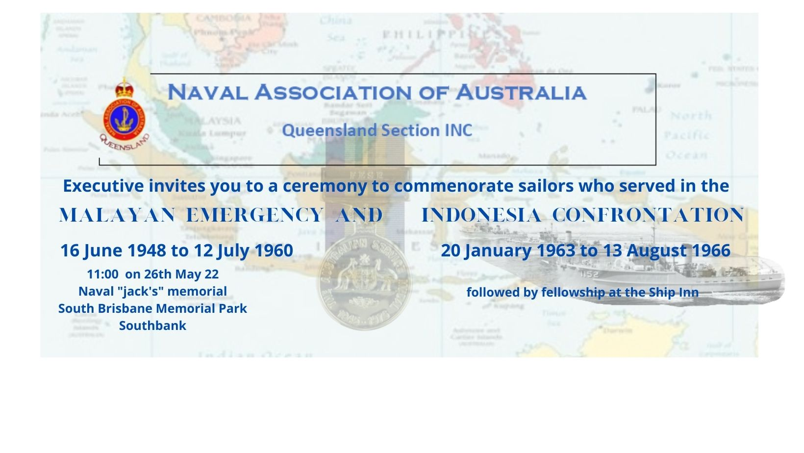

**ROYAL AUSTRALIAN NAVAL Personality**

**LS F B Emms:**

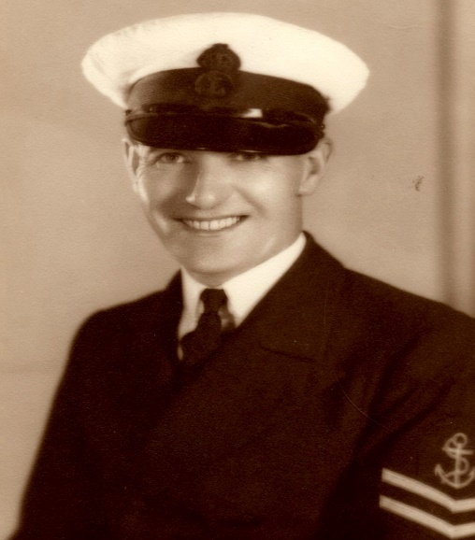**Francis Bassett ‘Dick’ Emms** was born at Launceston, Tasmania on 28 November 1909 and following his schooling was employed in his father’s tailoring shop. He joined the Royal Australian Navy on 14 March 1928 and undertook his initial training as an Ordinary Seaman at HMAS Cerberus. On completion of his training, he joined the heavy cruiser HMAS Canberra in March 1929 and served in her until July 1930. Emms was promoted to Able Seaman in January 1930 and later qualified as a gunnery rating.

Able Seaman Emms then spent much of the next seven years as a member of the Seaman Branch which included postings to Cerberus (1930-31) and the heavy cruiser HMAS Australia (1931-33). In January 1932 he married Sylvia Rosetta Tame in Hobart and they later had a daughter Rae. In 1933 Francis Emms was posted to the depot ship HMAS Penguin and later served in the destroyers HMAS Waterhen (1934) and HMAS Vendetta (1934-35). In April 1935 he joined the old coal burning cruiser HMAS Brisbane which was sent to England for scrapping and her crew then became the commissioning crew for HMAS Sydney (II). Francis Emms then served in Sydney from September 1935 until April 1937.

It was while serving in Sydney, in the Mediterranean, that his eyesight began to deteriorate and rather than leave the Navy he decided to transfer to the Supply Branch as a Cook. In January 1937 he undertook a short cookery course at Cerberus to assess his suitability and on 9 February 1937 he was rerated as a Cook (Officers). He was then posted to the destroyer HMAS Stuart in April 1937 and served in her until June 1938. Francis Emms was promoted to Acting Leading Cook (Officers) in April 1938.Following his service in Stuart he was posted to the sloop HMAS Swan (1938-39) and the depot ship Penguin (1939-40), where he was confirmed in the rank of Leading Cook. He served again briefly in the heavy cruiser Canberra during mid-1940. In September 1940 Francis Emms was posted to the Darwin shore depot HMAS Melville where he was employed as a cook at the base and also in the boom defence vessels which operated the anti-submarine boom net in Darwin Harbour.

On 19 February 1942, Leading Cook Francis Emms was serving onboard the boom defence vessel [HMAS Kara Kara](http://www.navy.gov.au/hmas-kara-kara) when the Japanese conducted their first air raid on Darwin. During this raid dozens of Japanese aircraft attacked ships in the harbour, the RAAF airfield and indiscriminately bombed the city. Eight ships were sunk, dozens of aircraft destroyed and nearly 300 people were killed. During the attack Kara Kara was singled out by several Japanese aircraft that commenced strafing the vessel. Emms manned one the vessels machine guns and returned fire and continued to do so even after he had been seriously wounded. His constant and accurate fire forced the Japanese aircraft to break off their attack and probably saved the lives of several of his shipmates.

Francis Emms was badly wounded as a result of the attack and despite being transferred to the hospital ship Manunda he died later that day and was buried at sea. He was subsequently awarded a posthumous mention in dispatches “For courage and devotion to duty in HMAS Kara Kara during an enemy air raid on Darwin on 19 February 1942”. Many of his shipmates believed he should have been awarded the Victoria Cross.

**Medals and awards include:**

Mention in dispatches

* 1939-45 Star
* Pacific Star
* Defence Medal
* 1939-45 War Medal
* Australian Service Medal 1939-45

**ROYAL AUSTRALIAN NAVAL Admirals**

**RADM. A.M. Carwardine:**

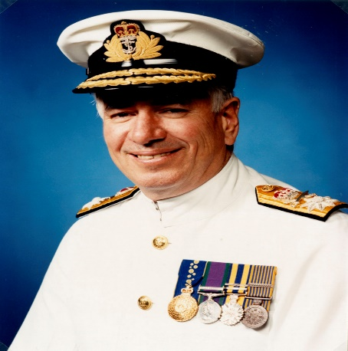**Anthony Michael ‘Jerry’ Carwardine** was born in Stanmore, NSW on 25 March 1938. He was educated at Newington College in Sydney (1947-53) before entering the RAN College in 1954 as a Cadet Midshipman in the Intermediate Entry. He was given the nickname ‘Jerry’ early in his career due to his resemblance to the American actor Jerry Lewis. He graduated from the Naval College in December 1955.

Midshipman Carwardine completed training at the naval air station HMAS *Albatross* and in HMA Ships *Sydney* and *Swan* in early 1956. In April 1956 he proceeded to England for training courses at the Royal Naval College Dartmouth and in the training ship HMS *Carron* (a destroyer converted for navigational training as part of the Dartmouth Training Squadron).

Carwardine was promoted acting Sub Lieutenant in September 1957 and in January 1958 was appointed to the anti-submarine frigate HMAS *Queensborough* for training and watchkeeping duties. During his time on board the frigate operated in Australian and New Zealand waters. He undertook training courses at HMAS *Cerberus* in late 1958 and was appointed to the frigate HMAS *Quiberon* in January 1959. *Quiberon* served in Southeast Asian waters during the early part of 1959 as part of the Far East Strategic Reserve before returning to Australia.

In January 1960, Sub Lieutenant Carwardine was appointed to the RAN’s shore depot in Darwin, HMAS *Melville*, for service in the general-purpose vessel HMAS *Banks* as a Watchkeeping Officer. He was promoted Lieutenant in September 1960. *Banks* was originally fitted out for survey duties and patrol work around Australia and New Guinea and one of her first tasks was to undertake a fisheries surveillance patrol in northern Australian waters.

In April 1961, Lieutenant Carwardine took command of *Banks* for a hydrographic survey of the Adelaide River. *Banks* became the first seagoing ship in more than fifty years to undertake the 50-mile Adelaide River passage. Later that year *Banks* deployed to Java and the Celebes to recover the remains of Allied servicemen on behalf of the Commonwealth War Graves Commission (CWGC). The remains were later reinterred in official CWGC cemeteries. During 1962 *Banks* visited Portuguese East Timor before returning to survey work in northern Australian waters.

In mid-1962 Carwardine travelled to the United Kingdom to undertake the Long Gunnery Course at HMS *Excellent*. After completion of the course, he served in the destroyer HMS *Corunna*, serving in the Mediterranean and Southeast Asian waters; with the latter service being as part of the Commonwealth naval forces patrolling off the Malay Peninsula and Singapore during Confrontation. In late 1965 he served briefly on the staff of the Australian Naval Representative in the United Kingdom (ANRUK) before returning to Australia, in early 1966, and serving in Navy Office for seven months in the Weapons and Electrical Engineering Section.

He was then appointed as Commanding Officer of the minesweeper HMAS *Gull* for the period September 1966-May 1967. During his time in command the ship undertook patrol duties in Southeast Asian waters as part of the Far East Strategic Reserve. Even though the Malayan Emergency and Confrontation had ceased the region was still unstable and the minesweepers operated as patrol vessels with crews rotating in and out as required. *Gull* returned to Australia for a refit in April 1967 and soon after Lieutenant Carwardine was appointed to the destroyer HMAS *Vendetta* as Gunnery Officer.

The destroyer operated mainly in Australian waters during 1967 and then, from March to October 1968, was deployed to Southeast Asia. While serving in *Vendetta* Carwardine was promoted Lieutenant Commander on 1 May 1968. The destroyer commenced a refit in early 1969 and Carwardine took up his second appointment to Navy Office, in February 1969, on the staff of the Director of Surface and Air Weapons (DSAW). In December 1971 he joined the guided missile destroyer HMAS *Brisbane* as the Executive Officer, shortly after the ship had returned from a deployment to Vietnam.

In 1972 *Brisbane* conducted training in Australian waters before deploying for the period August-November, with other RAN units, to Exercise RIMPAC 72 (off Hawaii), Yokosuka (Japan), Exercise SEA SCORPION (a South East Asia Treaty Organization exercise off the Philippines) and Exercise GROUNDWORK, an ANZUK exercise which simulated the opposed passage of a carrier force from Manila to Singapore. Exercise GROUNDWORK finished in early November and Brisbane went on to visit Surabaya (Indonesia) for Exercise CAKRAWALA BARU. The destroyer arrived home in Sydney on 28 November 1972 after a very busy Pacific and Southeast Asian deployment.

In January 1973 Lieutenant Commander Carwardine was appointed as Fleet Gunnery Officer, on the staff of the Flag Officer Commanding the Australian Fleet, and promoted Commander on 30 June 1973.

As Fleet Gunnery Officer he was frequently embarked in the aircraft carrier HMAS *Melbourne* which was the flagship of the RAN. Commander Carwardine was appointed to HMAS *Cerberus* as Officer in Command of the RAN Gunnery School in July 1974. The following year he proceeded to the United States to undertake the US Navy War College course at Newport, Rhode Island (1975-76) and the also attended the US Navy Post Graduate School at Monterey in 1976. Upon returning to Australia, he was appointed in Command of the destroyer escort HMAS *Swan* on 16 September 1976. The ship was then undergoing a major refit at Williamstown Naval Dockyard, Victoria and this was not completed until February 1977.

On completion of her refit *Swan* operated in Australian waters. On the morning of 2 May the ship was crash sailed from Sydney to provide urgent medical assistance to the 30,000-tonne freighter SS *Austral Moon* (then over 1200 kilometres due east of Sydney) who had two crew members with serious injuries sustained in bad weather. Carwardine took his ship to sea at full speed and later, in difficult circumstances, was able to transfer two of his personnel to the *Austral Moon* where they provided immediate medical support to the injured men.

Following her return to Sydney, *Swan* conducted routine training in the East Australia Exercise Area and a deployment with other RAN units to Singapore and the Indian Ocean for SINDEX 77. In 1978 she operated again in Australian waters and in May conducted a fruitless search for a missing yachtsman whose wrecked vessel had been found on Middleton Reef some 560 kilometres of the New South Wales Coast. The yachtsman was subsequently rescued from the sea later in the month by another vessel.

He relinquished command of *Swan* on 1 July 1978 and was then posted to Canberra to undertake the Joint Services Staff Course at Weston Creek. Following this Commander Carwardine served as Director Surface & Air Weapons – Navy (DSAW-N) from December 1978 to October 1980. His warfare knowledge then saw him appointed as Director of the Combat Data System Centre (CDSC), at Fyshwick in Canberra, in October 1980, and promoted Captain on 31 December 1980.

Captain Carwardine took up his last seagoing appointment on 16 November 1983 when he became Commander of the Second Australian Destroyer Squadron and Commanding Officer of the frigate HMAS *Adelaide*. In early 1984 *Adelaide* became the first FFG to embark a helicopter, a Bell 206 Kiowa, to train both aircrew and the ship’s company in the use of helicopters in the new frigates. *Adelaide* deployed to Hawaii for Exercise RIMPAC 84 (May-June) with other RAN ships and also visited Norfolk Island, Tonga, the Cook Islands, Nauru and the Solomon Islands during this deployment. She finished the year undertaking First of Class Flight Trials with an AS350 Squirrel helicopter.

In 1985 the frigate, with a Squirrel helicopter embarked, conducted an Indian Ocean deployment from 23 April-29 July visiting Darwin, Singapore, Goa, Dar-es-Salaam, Mombasa, Port Louis (Mauritius) and Fremantle. Captain Carwardine relinquished Command of *Adelaide* in early August 1985. During his time in command the ship was awarded the Duke of Gloucester’s Cup as the most efficient ship in the fleet for 1984.

He then served briefly in Navy Office before being promoted Commodore and taking up his next appointment as Commanding Officer of the RAN’s premier training establishment HMAS *Cerberus*. This position also carried the dual-hatted role as the Naval Officer Commanding Victoria (NOCVIC). Commodore Carwardine was appointed as a Member of the Order of Australia (AM) in the Queen’s Birthday Honours List 1986 in recognition of service to the Royal Australian Navy, particularly as the Commanding Officer of HMAS *Adelaide*.

He was promoted Rear Admiral on 18 January 1988 and appointed as the Assistant Chief of Naval Staff (Personnel). In early December 1989 he became the Defence Attaché and Head Australian Defence Staff – Washington and also accredited to Canada and the United Nations (Washington).  He held this vital position during Australia’s support to the United States when committing forces to the First Gulf War (1990-1991) and the subsequent enforcement of United Nations sanctions against Iraq. Rear Admiral Carwardine was appointed as an Officer of the Order of Australia (AO) in the Queen’s Birthday Honours List 1990 in recognition of service to the Royal Australian Navy, particularly as the Assistant Chief of Naval Personnel.

His final appointment was as Commandant of the Australian Defence Force Academy (ADFA) during 1993-1995. Rear Admiral Carwardine retired from the RAN in March 1995. He resided in the Southern Highlands of NSW and farmed for a number of years and was also a service member on the Veterans’ Review Board, representing the Australian Capital Territory. He was the President of Legacy in Canberra during 2016-18. His son Alastair Michael Carwardine also served in the RAN as a Lieutenant submariner during 1979-1990.

***********************************

**NAVAL DISASTERS**

**HMS Royal Oak:**

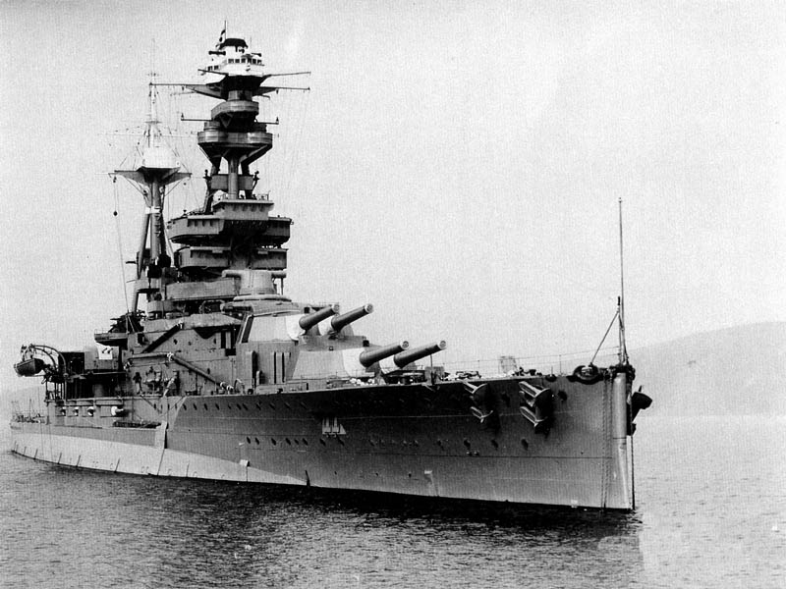

**HMS *Royal Oak*** was one of five [*Revenge*-class](https://en.wikipedia.org/wiki/Revenge-class_battleship) [battleships](https://en.wikipedia.org/wiki/Battleship) built for the [Royal Navy](https://en.wikipedia.org/wiki/Royal_Navy) during the [First World War](https://en.wikipedia.org/wiki/First_World_War). Completed in 1916, the ship first saw combat at the [Battle of Jutland](https://en.wikipedia.org/wiki/Battle_of_Jutland) as part of the [Grand Fleet](https://en.wikipedia.org/wiki/Grand_Fleet). In peacetime, she served in the [Atlantic](https://en.wikipedia.org/wiki/Atlantic_Fleet_(United_Kingdom)), [Home](https://en.wikipedia.org/wiki/Home_Fleet) and [Mediterranean](https://en.wikipedia.org/wiki/Mediterranean_Fleet_(United_Kingdom)) fleets, more than once coming under accidental attack. *Royal Oak* drew worldwide attention in 1928 when her senior officers were controversially [court-martialled](https://en.wikipedia.org/wiki/Court-martial), an event that brought considerable embarrassment to what was then the world's largest navy. Attempts to modernise *Royal Oak* throughout her 25-year career could not fix her fundamental lack of speed and, by the start of the [Second World War](https://en.wikipedia.org/wiki/Second_World_War), she was no longer suitable for front-line duty.

On 14 October 1939, *Royal Oak* was anchored at [Scapa Flow](https://en.wikipedia.org/wiki/Scapa_Flow) in [Orkney](https://en.wikipedia.org/wiki/Orkney), Scotland, when she was torpedoed by the German [submarine](https://en.wikipedia.org/wiki/Submarine) [*U-47*](https://en.wikipedia.org/wiki/German_submarine_U-47_(1938)). Of *Royal Oak*'s complement of 1,234 men and boys, 835 were killed that night or died later of their wounds. The loss of the outdated ship—the first of five Royal Navy battleships and [battlecruisers](https://en.wikipedia.org/wiki/Battlecruiser) sunk in the Second World War—did little to affect the numerical superiority enjoyed by the British navy and its [Allies](https://en.wikipedia.org/wiki/Allies_of_World_War_II), but it had a considerable effect on wartime morale. The raid made an immediate celebrity and [war hero](https://en.wikipedia.org/wiki/War_hero) out of the U-boat commander, [Günther Prien](https://en.wikipedia.org/wiki/G%C3%BCnther_Prien), who became the first German submarine officer to be awarded the [Knight's Cross of the Iron Cross](https://en.wikipedia.org/wiki/Knight%27s_Cross_of_the_Iron_Cross).

Before the sinking of *Royal Oak*, the Royal Navy had considered the naval base at Scapa Flow impregnable to submarine attack, but *U-47*’s raid demonstrated that the German navy was capable of bringing the war to British home waters. The shock resulted in rapid changes to dockland security and the construction of the [Churchill Barriers](https://en.wikipedia.org/wiki/Churchill_Barriers) around Scapa Flow, with the added advantage of being topped by roads running between the islands.

The wreck of *Royal Oak*, a designated [war grave](https://en.wikipedia.org/wiki/War_grave), lies almost upside down in 100 feet (30 m) of water with her hull 16 feet (4.9 m) beneath the surface. In an annual ceremony marking the loss of the ship, Royal Navy divers place a [White Ensign](https://en.wikipedia.org/wiki/White_Ensign) underwater at her stern. Unauthorised divers are prohibited from approaching the wreck under the [Protection of Military Remains Act 1986](https://en.wikipedia.org/wiki/Protection_of_Military_Remains_Act_1986).

**\*\*\*\*\*\*\*\*\*\*\*\*\*\*\*\*\*\*\*\*\*\*\*\*\*\*\*\*\*\***

**HAVE A LAUGH**

Lost words that we all knew:

Murgatroyd!

 Do you remember that word? Would you believe the spell-checker did not recognize the word Murgatroyd? Heavens to Murgatroyd!

The other day a not so elderly (I say 75) lady said something to her son about driving a Jalopy; and he looked at her quizzically and said “What the heck is a Jalopy?" He never heard of the word jalopy!! She knew she was old.... But not that old.

We were in like Flynn and living the life of Riley; and even a regular guy couldn't accuse us of being a knucklehead, a nincompoop or a pill.  Not for all the tea in China!

We wake up from what surely has been just a short nap, and before we can say, “Well, I'll be a monkey's uncle!” Or, “This is a fine kettle of fish!” We discover that the words we grew up with, the words that seemed omnipresent, as oxygen, have vanished with scarcely a notice from our tongues and our pens and our keyboards.

Long gone: Pshaw, the milkman did it. Hey! It's your nickel. Don’t forget to pull the chain. Knee high to a grasshopper. Well, Fiddlesticks! Going like sixty. I'll see you in the funny papers. Don't take any wooden nickels. Wake up and smell the roses.

We of a certain age have been blessed to live in changeable times. For a child each new word is like a shiny toy, a toy that has no age. We  at the other end of the chronological arc have the advantage of  remembering there are words that once did not exist and there were  words that once strutted their hour upon the earthly stage and now are  heard no more, except in our collective memory.  It's one of the greatest advantages of aging.

WE ARE THE CHILDREN OF THE FABULOUS 50'S..NO ONE WILL EVER HAVE THAT OPPORTUNITY AGAIN...WE WERE GIVEN ONE OF OUR MOST PRECIOUS GIFTS:  LIVING IN THE PEACEFUL AND COMFORTABLE TIMES, CREATED FOR US BY THE “GREATEST GENERATION!”

**\*\*\*\*\*\*\*\*\*\*\*\*\*\*\*\*\*\*\*\*\*\*\*\*\*\*\*\*\*\*\*\*\*\***

**ROYAL AUSTRALIAN NAVY – Ship History**

**HMAS J5:**

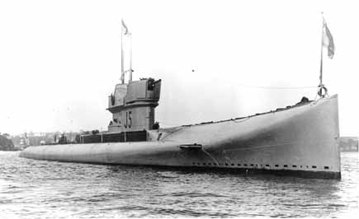

|  |  |  |  |
| --- | --- | --- | --- |
| Class | J Class | Length | 275ft 8in |
| Type | Submarine | Beam | 23ft 1in |
| Builder | Devonport Naval Dockyard UK | Draught | 16ft |
| Launched | 9 September 1915 | Speed | 9.5 knots |
| Commissioned | 25 March 1919 | Crew | 5 officers and 40 sailors |
| Displacement | 1,820 tons | Machinery | 3 x 12 cyl. Diesel engines (surface)  2 x electric motors ( submerged) |
| Torpedoes | 6 x 18in torpedoes | Guns | 1 x 4in |

Towards the end of 1914, early in World War I, disturbing rumours began to circulate that the newest German submarines were capable of a much higher surface speed than British boats, one report giving their speed at about 22 knots. The rumours were sufficiently strong to force serious consideration of the matter by the Admiralty, and at the same time consideration was given to the idea that submarines should have a high enough surface speed to be able to work with the fleet. The reports concerning the speed of the German submarines proved to be spurious, but the idea of a British submarine with a high surface speed gained ground. The immediate result of this concern was the development of the J Class, which were unique with their three shafts. Originally eight boats were planned but this was reduced to six and then increased to seven. As a result of these changes the boats originally intended to be *J7* and *J8* were renumbered in April 1915 as *J3* and *J4* respectively.

HMS *J5* commissioned in the Royal Navy on 6 May 1916 under the command of Commander CP Talbot RN and was allocated to the 11th Submarine Flotilla based at Blyth, Northumberland.

*J5* sailed from Devonport on 5 June 1916 having carried out initial trials locally, had two steering breakdowns en route to Portsmouth, spent two weeks in Portsmouth for more trials and finally arrived in Blyth on 24 June. There were more days of workup and modification before sailing for a patrol off the Dogger Bank on 10 July. During this patrol she had great trouble with depth keeping and on one occasion hit the bottom at 140 feet. On return she was docked at Wallsend-on-Tyne. Leaving dock on 31 July she was in collision with HMS *Vixen* and had to be redocked at Blyth for repairs to the stem and bow shutters to No. 1 tube.

On 18 August 1916 a German signal was intercepted which made it clear that the German High Seas Fleet would be putting to sea that night. Again, the several submarine flotillas were involved in the British counter measures. By midnight 26 submarines were on the move including *J1*, *J3*, *J5* and *J6* sent to patrol areas off the Tyne. In the event only *E23* saw anything of the Germans.

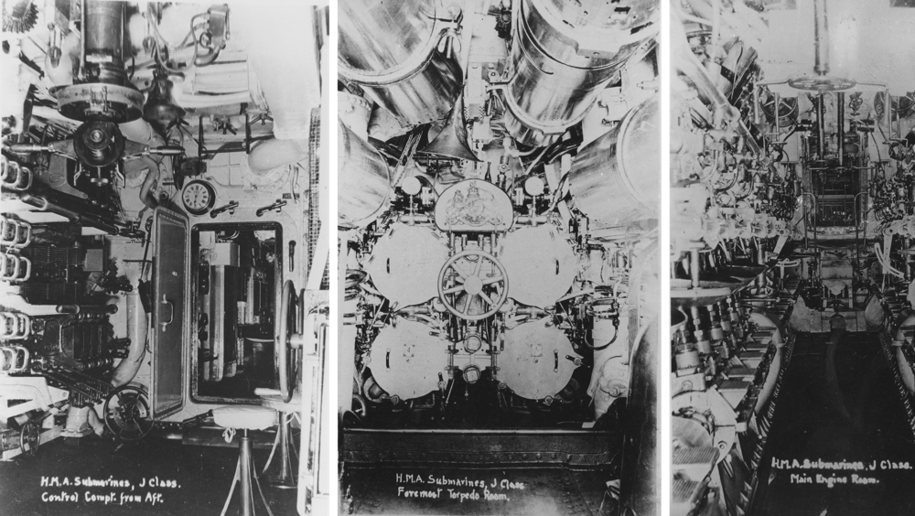

Before the end of 1916 *J5* was in dock on three more occasions. During the last, in October, she had the forward hydroplanes enlarged and a telescopic signal mast was fitted. During the latter half of the year Commander EC Boyle VC, RN assumed command of the submarine.

On 13 March 1917 while on the surface in position 56°10´N, 05°55´E, *J5* sighted an enemy submarine also on the surface. *J5* dived but no attack was made. On 18 May in the same year a small vessel, possibly a submarine, opened fire on *J5* from about 600 yards on the port quarter. All the shots fell short though changed in deflection from aft to forward. At the time *J5* was silhouetted against a clear horizon which still retained some light from the setting sun while the enemy could not be seen. *J5* dived, during which operation the hydroplanes jammed with a 10-degree rise. On the following day while on the surface *J5* sighted an enemy submarine also on the surface. Before attack could be made the enemy dived and although *J5* altered course towards her nothing more was seen of her.

In June 1917 it was decided to conduct a large-scale operation using both destroyers and submarines to flush out enemy submarines either leaving for patrol or returning to their bases from the Atlantic. Known as Operation BB, it was planned to force enemy submarines to dive through certain areas heavily patrolled by destroyers so that they would be on the surface while passing through adjacent areas patrolled by British submarines. The British submarines employed included *J1*, *J2*, *J4* and *J5*. During the ten days, 15 to 24 June, 19 German submarines passed in or out of the North Sea; 12 homeward bound and seven outwards bound. There were 26 sightings and 11 attacks made, eight by destroyers and three by submarines.

*J5* sailed from Blyth on 18 June to take part in the operation. At 03:12 on 25 June while surfaced, *J5* sighted the conning tower of an enemy submarine about 6000 yards distant on the port bow. She dived to attack but at 04:00 surfaced and gave chase at full speed. Four torpedoes were fired all of which missed. At 05:00 the enemy opened fire with a gun whereupon *J5* dived.

On 9 July *J5* was submerged with moderate visibility, strong winds and rough seas prevailing above. Through her periscope she sighted an enemy submarine on her port beam. Two torpedoes were fired at about 2000 yards range which Commander Boyle recorded in his log as having missed. The intended victim, *U-86*, however, reported torpedo hit the fore part of the ship but did not explode.

Between 28 July and 21 August 1917, enemy submarines were sighted on three occasions; 28 July, 4 August and 21 August. On 4 August four torpedoes were fired at the enemy from a range of 1500 yards but all appeared to miss. On 21 August the enemy submarine opened fire and as the shots immediately fell close to *J5* she dived and broke off the action.

The submarine was in dockyard hands at Newcastle from 9 January to 26 March 1918.

While on the surface on 9 April 1918, *J5* sighted a large force of ships which appeared to include six battleships or battlecruisers, three light cruisers and ten destroyers.

They were recognised as 'friendly' and the appropriate recognition signals were displayed. Nevertheless, one destroyer closed rapidly and fired three rounds which fell 50 yards astern before identities were exchanged.

On 26 May 1918 when in position 56°01´N, 06°E, and while proceeding on the surface in a south westerly direction at 15 knots, *J5* sighted a submarine conning tower to the south. Course was altered towards the other boat, speed was increased and the gun was manned. On closing to 8000 yards the target was identified as the enemy and fire was opened. After firing eight rounds, two of which may have been hits, the gun jammed and the submarine dived. She had been running with ventilators open, however, and these were not shut on diving. Surfacing again with a large bow up angle and only 500 yards from the U-boat she was quite unmanageable. There was an estimated 40 tons of water in the engine room, chlorine was being given off from the batteries and a calcium flare had been triggered off. Luckily the U-boat made off after firing a few more desultory and inaccurate rounds, perhaps also damaged. On return to Blyth the damaged battery cells had to be replaced and *J5* was not ready for sea again until 10 June.

On 11 June and again on 12 July, *J5* was forced to dive due to the presence of a Zeppelin in her area. Gun action stations were ordered on 12 June but before fire the target was identified as the submarine HMS *E44*.

The last submarine to be sighted by *J5* during the war was at 07:00 on 30 September 1918 while dived in position 57°28´N, 06°01´E. Four torpedoes were fired but although they appeared to run correctly the enemy was probably out of range.

Lieutenant E Starling RN assumed command during October 1918 and *J5* returned from her last war patrol to Blyth on 6 November.

Following the conclusion of hostilities in World War I, the Admiralty in 1918 presented the six remaining boats of the J Class to the Australian Government - *J6* had been sunk in error in 1918 by a British ship. All the submarines commissioned into the Royal Australian Navy at Portsmouth on 25 March 1919, as tenders to the submarine depot ship HMAS *Platypus*, *J7* being the senior boat. The Commanding Officer of *J5* was Lieutenant John JA Peirson DSO, RN.

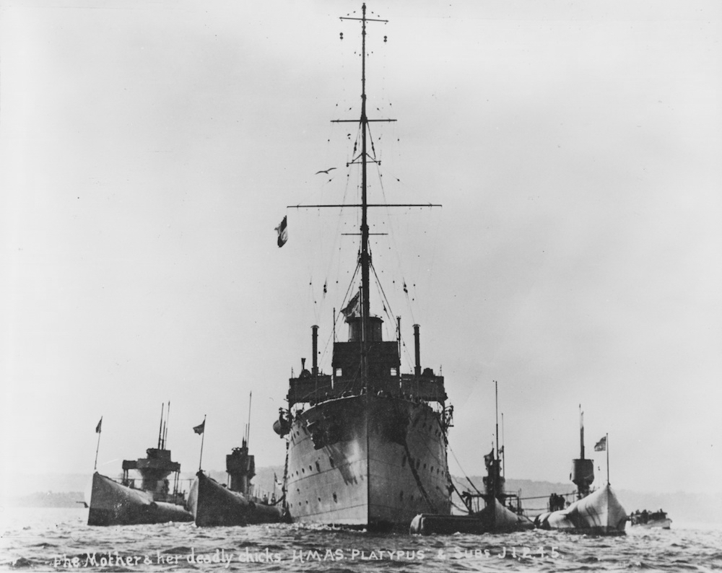

*The mother and her deadly chicks. HMAS Platypus and subs*

The beam tubes were removed from all six J Class submarines before they sailed for Australia. The tubes were despatched separately to Garden Island. The reasons given for the removal were that the beam tubes were not a success and that increased accommodation was required.

On 9 April 1919 *Platypus* and the submarines, escorted by the light cruiser HMAS *Sydney*, sailed from Portsmouth for Australia, their first two ports of call being Gibraltar and Valetta.

On the night of 28 April, the night before the vessels arrived at Port Said, *J3*'s starboard main engine shaft snapped. Thus handicapped she could not keep up with the others and consequently on departure for Aden on 30 April, *J3* was in tow of *Sydney*.

The vessels arrived at Aden on 5 May. On the same day the light cruiser HMAS *Brisbane*, which had left Portsmouth on 17 April, also arrived. On 7 May all the vessels sailed for Colombo. *Brisbane* took over the tow of *J3* while *Sydney* took *J5* in tow as that boat had also developed engine trouble. Three days after arrival at Colombo on 15 May, *Brisbane* sailed with*J5* in tow. From Singapore they sailed for Thursday Island, which *Brisbane* and*J5* reached on 14 June. After calls at Townsville and Brisbane they arrived in Sydney on 27 June. *J5* was the first boat of the flotilla to reach Australia.

*J3* was taken in hand at Colombo for repairs. On 31 May *Sydney*, *J1*, *J2*, *J4* and *J7* sailed for Singapore, followed on 2 June by *Platypus* and *J3*. The vessels were reunited at Singapore from where all except *Sydney* sailed on 18 June. *Sydney* sailed for Australia a few days later but did not rejoin the other vessels. On 29 June *Platypus* and the five submarines arrived at Thursday Island, although *J7* was three hours late because of trouble with her engine lubricating system. The last call before Sydney was Brisbane, Sydney being reached on 15 July.

Having arrived in poor condition, the submarines were taken in hand at Garden Island Dockyard for refitting. After her refit was completed*J5*, in company with *J2*, sailed on 3 May 1920 for the submarine base at Geelong, Victoria.

After uneventful service, little of which was spent at sea,J5 and her five sisters paid off into Reserve at Westernport on 12 July 1922. The boats had become victims of the worsening economic conditions of the time, coupled with their high cost of maintenance.

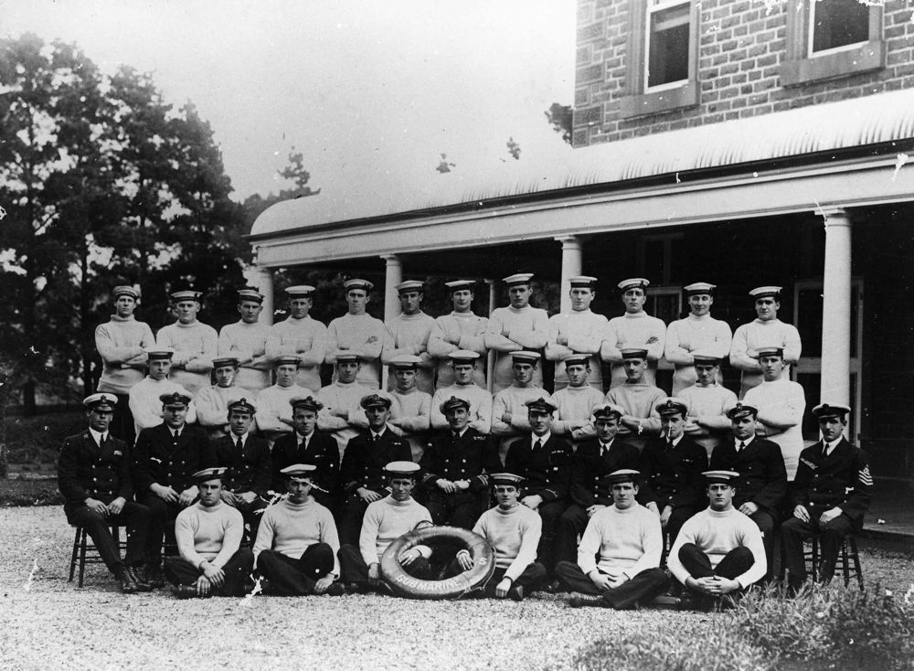

On 26 February 1924J5 was sold to the Melbourne Salvage Syndicate. The hull was sunk three miles off Barwon Heads on 4 June 1926.

*************************************

**ROYAL AUSTRALIAN NAVY – Active Fleet Ships**

**HMAS HUON and GASCOYNE**

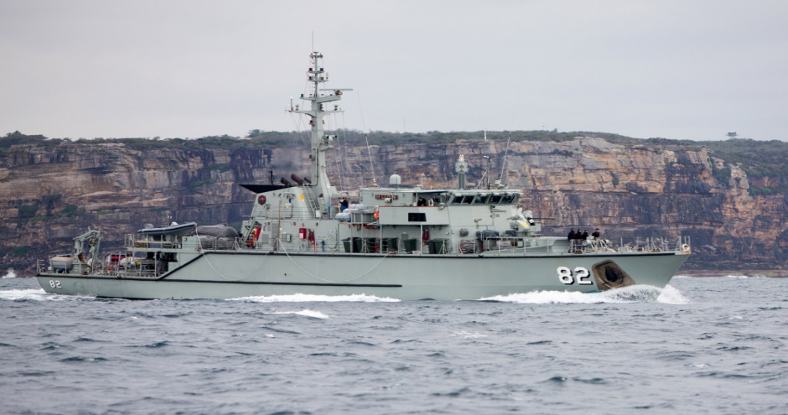HMAS Huon: (11)

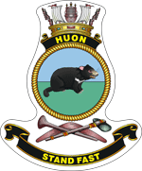

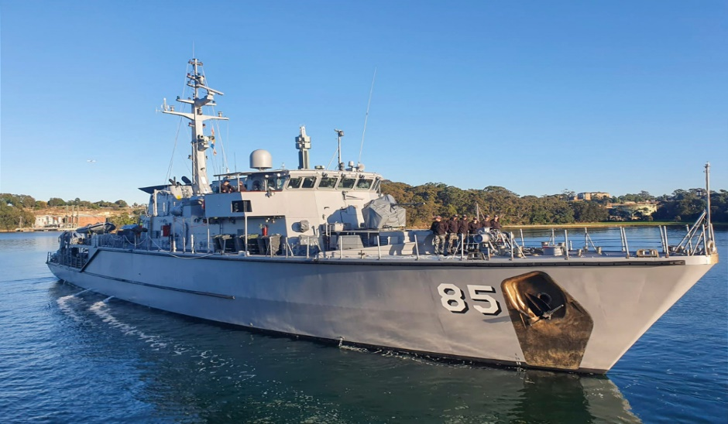HMAS Gascoyne (11)

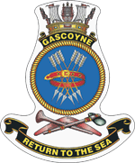

Huon Class Minehunters built for the Royal Australian Navy by Australian Defence Industries, Newcastle, NSW.

The ship is the most advanced of its type in the world. These ships, Huon and Gascoyne are made of fibre reinforced plastic and have a unique single skin solid hull that has no ribs or frames and provides high underwater shock resistance and very low magnetic and noise levels. This hull is designed to flex inwards if an undersea explosion occurs nearby. All machinery/equipment is mounted on cradles or suspended from bulkheads to further enhance resistance to shock damage and protect ship systems.

The Huon Class Minehunters are all named after Australian rivers.

****************************

**PICTURE FUNNIES**

 

 

 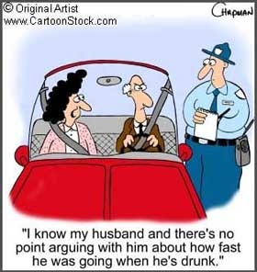

**NAVAL TRADITIONS – TERMS – SLANG**

**Official Badge and Design:**

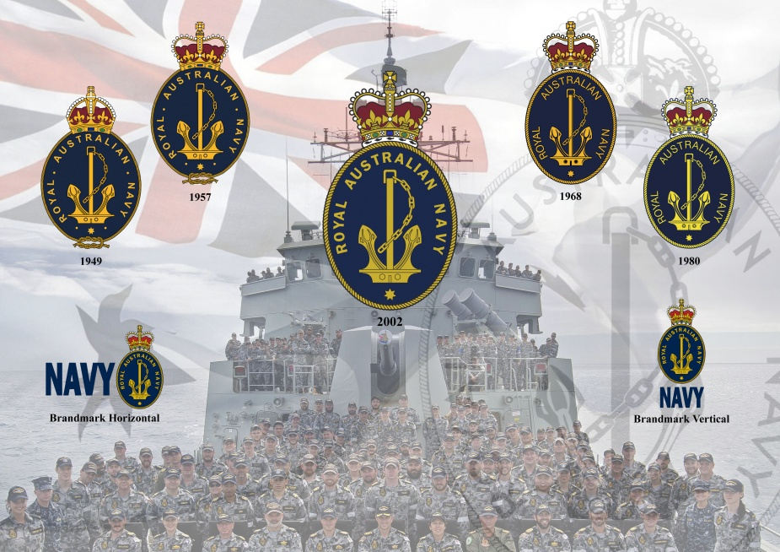

The official badge of the Royal Australian Navy (RAN), pictured right, was adopted on 23 August 1949 as a result of an inquiry by the Building Surveyor, Hobart, Tasmania, who wished to incorporate a naval symbol in a design for the Hobart Cenotaph. The badge was derived from a Navy office, booklet 'Advice to Personnel', 'The Navy List' and a rubbing from the badge displayed on the glass doors on the ground floor of the Coventry Street entrance to 'N' Block.

The description of the officially approved design was promulgated in Navy Order 262/1949. It contained within a left-handed rope surround, which displayed a knotted section in its base, a stockless chain cabled anchor, and four dots which were placed between a federation star and the words 'Royal Australian Navy'. Placed on top of the rope surround was the Tudor (Kings) Crown.

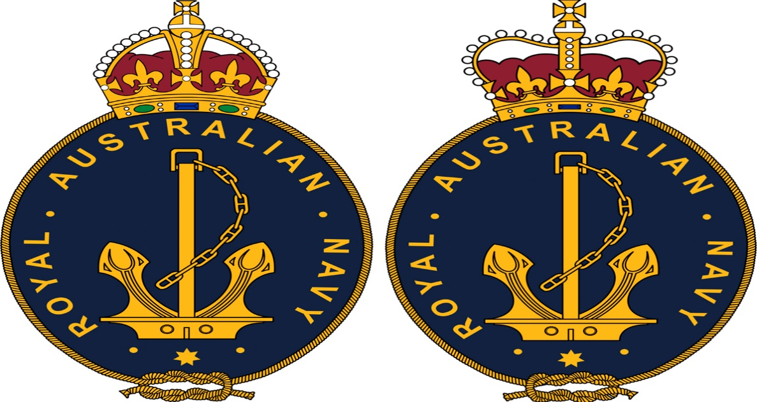

Left: *The official badge of the RAN instituted on 23 August 1949 per CNO 262/49. Right: The official badge of the RAN displaying the St Edward's crown, instituted on 3 December 1957 as per CNO 1149/57.*

## 1957

## The 1949 badge was then amended on 3 December 1957 (NO 1149/1957) by substituting the St Edwards (Queens) Crown for the Tudor Crown and right hand in place of left-hand roping.

On 16 July 1968 the badge was again revised by eliminating the knotted rope surround in favour of a plain oval rope surround and the four dots which appeared between the words, Royal Australian Navy and Federation Star. Some thoughts are that the four dots from the original rubbing were duplicated in the original draft designs by mistake as they could have been the mounting screw holes that secured the badge to the door.

Certainly this gives the badge even further mystery about its origins because no record exists about the designers or original designs that lead to the existence of the 1949 badge. Again speculation but with some sound knowledge suggests that the origins came from the Royal Navy (RN) as so many other RAN badge designs are derived from the RN.

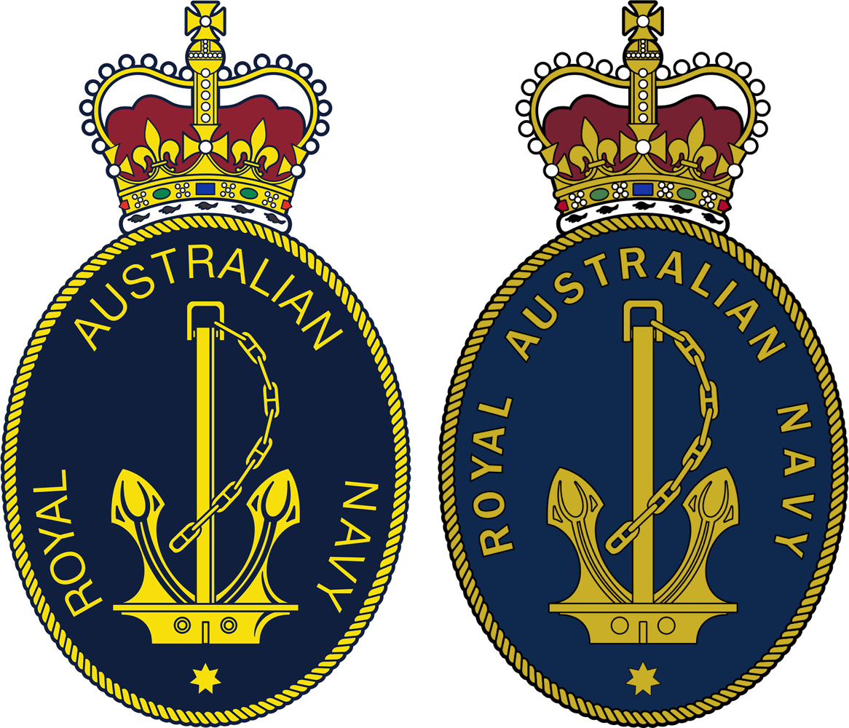

Left: *The official badge of the RAN 1980. Right: The official badge of the RAN 2002, note the closer spacing within the words.*

## 2002

## The current 2002 official badge (right) has had a slight change since the development of the 1968 badge. The change being in spacing the words 'Royal Australian Navy' closer together.

The Brand Navy Master Identity and all navy badges and badge designs are protected by both international and domestic law - in Australia by the Defence Act of 1903 and various forms of trademark and intellectual property legislation, and overseas by international agreements and conventions protecting trademarks and intellectual property.