

GREENBANK NAA NEWSLETTER

Grey Funnel Dits

*Disclaimer: The material contained in this publication is in the nature of entertainment for the members. Contributions are acknowledged with thanks from service organisations. The editor disclaims all and any liability to any person, whether an association member or not. Views expressed may not necessary be held by the executive or the members.*

A close up of a sign

Description generated with very high confidence

*Editor: Tony Holliday* [*tonyholliday13@gmail.com*](mailto:tonyholliday13@gmail.com) *0403026916*

**GREENBANK NAVAL ASSOCIATION – Subsection**

**Events for July & August.**

**July2022 Sunday10 1000-1200 Normal Meeting RSL Rooms**

**Wednesday 27 1000-1030 Executive Meeting RSL Rooms**

**August2022 Sunday 07 1000-1200 Normal Meeting RSL Rooms**

**Wednesday 31 1000-1030 Executive Meeting RSL Rooms**

**\*\*\*\*\*\*\*\*\*\*\*\*\*\*\*\*\*\*\*\*\*\*\*\*\*\*\*\*\*\*\*\*\*\*\*\*\*\*\*\*\*\*\*\*\*\*\*\*\*\*\*\*\*\*\*\*\*\*\*\*\*\***

**JACK’S MEMORIAL**

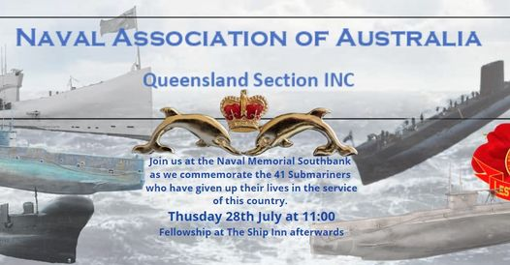

**ROYAL AUSTRALIAN NAVY – PERSONALITY**

**Third Officer F B Provan:**

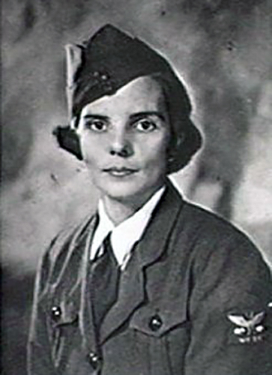**Frances Betty Provan** (1911-1963), naval officer and businesswoman, was born on 17 November 1911 at Spring Hill, Brisbane, second daughter of Queensland-born parents Donald McCallum Provan, bookseller, and his wife Frances Mary Walpole, née Boyd. Her mother was descended from the Walpole family in England. Frances was educated at Toowoomba, at the Glennie Preparatory School, Fairholme Presbyterian Girls' College, and the Glennie Memorial School. Margaret Brown, the headmistress of GMS, stressed moral behaviour and told her pupils: 'Remember, you are a Glennie Girl, and there is nothing a Glennie Girl cannot do'. After Frances' father died during her final year at school, she worked in turn as a trainee-teacher, nurse and governess. About 1939 she moved to Sydney. Five foot 6 1/2 inches (169 cm) tall, with brown hair, large brown eyes, a fair complexion and classical features, she was a smart, slightly built, well-groomed young woman - a 'darling' and 'tremendous fun' according to her younger sister.

Believing war to be imminent, Provan began training with the Women's Emergency Signalling Corps which had been founded in Sydney by Florence McKenzie. By 1941 the RAN needed more wireless telegraphists. The availability of women who had learned these skills in the Women's Emergency Signalling Corps led to a decision to recruit twelve female telegraphists as the initial members of the Women's Royal Australian Naval Service (WRANS). Enlisting as a telegraphist on 28 April 1941, Provan was given the official number WR/1 and posted to HMAS *Harman*, the communications station in Canberra. She and her colleagues relayed messages to the fleet and maintained contact with many wireless-stations around the world. The number of female telegraphists increased rapidly, and women were recruited to serve in other branches of the Navy. By 1945 there were 2590 WRANS working in shore establishments throughout Australia.

Promoted Leading Telegraphist (September 1941) and Petty Officer Telegraphist (December 1942), Provan attended the first WRANS officers' training course at Flinders Naval Depot, Westernport, Victoria. She was appointed Third Officer on 15 February 1943 and returned to *Harman* in August. In June 1945 she was posted as officer-in-charge of the only draft of WRANS to serve in an operational zone, in Darwin: her standards of behaviour and appearance led her contingent to be referred to as 'Miss Provan's Academy for Young Ladies'. She served briefly at bases in New South Wales and Queensland before being demobilised from the Navy in October 1946 in Melbourne.

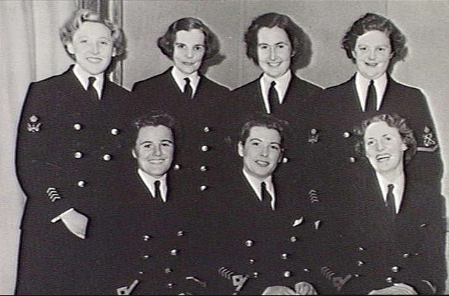Miss Provan travelled to England where she was employed by a meat-importing firm. In the late 1950s her ability and competence won her the post of manager of the London office of Jackson's United Meat Co Pty Ltd, a business based at Footscray, Melbourne. In 1963 she returned to Melbourne, met the firm's Australian directors and flew to Brisbane, planning to visit her mother. She died suddenly of heart disease on 21 June that year in a taxi en route from Eagle Farm to Camp Hill and was cremated with Presbyterian forms.

*Senior WRANS from HMAS Harman Naval Wireless Station at the fourth birthday of the service. Left to right, back row: Daphne Wright, Frances Provan (WRAN No. 1), Shirley Drew, Joan Cade; Front row: Third Officers Joan Hodges, Billee Thompson, Jess Prain. Canberra, ACT, circa 1945. (Australian War Memorial Collection)*

**\*\*\*\*\*\*\*\*\*\*\*\*\*\*\*\*\*\*\*\*\*\*\*\*\*\*\*\*\*\*\***

**ROYAL AUSTRALIAN NAVY – Admirals**

**Adm. Sir J G Crace:**

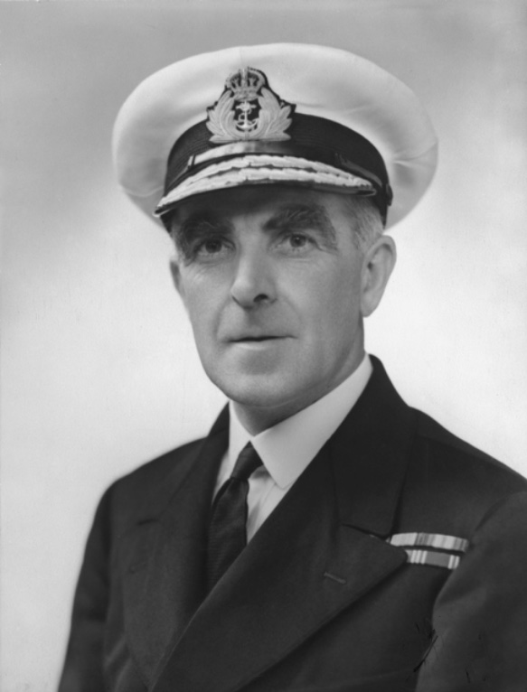**John ‘Jack’ Gregory Crace** was born on 6 February 1887 at Gungahleen, New South Wales (Gungahlin, Australian Capital Territory) the eighth child of Edward Kendall Crace, an English-born grazier, and his Queensland born wife Kate Marion (née Mort). After attending The King's School at Parramatta, Jack sailed for England in October 1899 for further private schooling. In May 1902 he joined the Royal Navy's training ship HMS *Britannia* on a colonial cadetship.

Accepting a career with the Royal Navy he served in various ships and was promoted Lieutenant in September 1908.  Crace served in Australia with the Royal Navy Squadron, based on the Australia Station, during 1908-1910 and after returning to the United Kingdom he commanded HM Torpedo Boat 105 (October 1910-July 1911) before specialising as a Torpedo Officer in 1911. He had an active mind and invented a torpedo change of bearing instrument and the Crace enemy torpedo calculator.

In January 1913, he was loaned to the fledgling Royal Australian Navy for service in the battle cruiser HMAS *Australia* which was commissioned on 21 June 1913. Crace was to serve in her for the next four years including war-time operations including the capture of German New Guinea in September 1914, the hunt for the German East Asia Squadron in the Pacific Ocean later that year and operations in the North Sea from 1915 onwards.

Crace was promoted Lieutenant Commander in September 1916 and reverted to Royal Navy service in March 1917. He was then appointed to the torpedo school, at HMS *Vernon*, as an instructor where he served until appointed to the new battle cruiser HMS *Hood* as her Torpedo Officer in October 1918.

On 13 April 1920 Jack Crace married Carola Helen Baird, with Episcopalian rites, in St Mary's Cathedral, Glasgow, Scotland. He was promoted to Commander in December 1920 and in early 1921 was appointed to the Directorate of Torpedos and Mining in the Admiralty. During his service here it was noted he invented a protractor to help analyse tactical plotting.He served as the Commanding Officer of the anti-submarine training establishment (HMS *Osprey*) at Portland during 1924-26 followed by service as the Fleet Torpedo Officer, in the Home Fleet during 1927 followed by a year as the Fleet Torpedo Officer in the Mediterranean Fleet. Crace was promoted Captain in June 1928 and commanded the V Class destroyer HMS *Valhalla* during April 1929 -April 1930. He then returned to *Osprey* as the Captain Anti- Submarine Warfare.

During June 1934-January 1937 he commanded the light cruiser HMS *Emerald*, part of the 4th Cruiser Squadron based in Singapore. On completion of this command, he became the Naval Assistant to the 2nd Sea Lord in the Admiralty who was responsible for personnel and shore establishments. Promoted Rear Admiral on 1 August 1939, he was appointed Rear Admiral Commanding the Australian Squadron (RACAS) in mid-September and soon after sailed for Australia in RMS *Orontes*.

After arriving in Australia, in late October 1939, he found that the government had committed most of his ships to theatres outside Australia. The few vessels remaining in home waters performed convoy escort and counter-raider operations for the next two years.

Although Crace was appointed as a Commander of the Order of the Bath (CB) in July 1941, he was frustrated by the low level of activity on the Australia Station, and by the Naval Board's frequent interference in operational matters. He sought to be replaced and in October 1941 tried to resign from his position as RACAS.

This was soon to change with the action involving the light cruiser HMAS *Sydney* with the German raider *Kormoran* off the Western Australian coast on 19/20 November 1941 in which both ships were sunk, with *Sydney* lost with her entire crew of 645 men.

Following the Japanese entry into the war, Crace became commander of the Allied naval squadron, Anzac Force, in February 1942. During operations in New Guinea waters with a carrier task force of the United States Navy, he was dissatisfied with the minor supporting role given to his ships. In April command arrangements in the Pacific were reorganised and Crace's squadron was renamed Task Force 44, but, despite his seniority, he was made subordinate to the US Navy tactical commander.

On 1 May 1942 Crace's force sailed from Sydney to join two US Navy carrier groups that were deployed to the Coral Sea in anticipation of a major Japanese move southwards. His force consisting of the heavy cruiser HMAS *Australia* (II), in which Crace was embarked, the heavy cruiser USS *Chicago*, the light cruiser HMAS *Hobart* and three US destroyers. His force was detached on 7 May to intercept enemy troop ships heading for Port Moresby. Lacking air cover, it came under heavy enemy attack and *Australia* narrowly escaped being hit on several occasions.

Crace received no further orders and knew little of the crucial carrier battle which was fought next day, east of his position. He withdrew on 10 May when fuel was running low and it was obvious that the enemy's advance had been checked and the Port Moresby invasion force had turned back. The battle of the Coral Sea marked the end of Japanese expansion in South Pacific waters.

After handing over his command, on 13 June 1942, to Rear Admiral Sir Victor Crutchley, VC, RN, Crace returned to England. He was placed on the Retired List and promoted to Vice Admiral on 29 October 1942 and then appointed as the Superintendent of Chatham Naval Dockyard. Crace was promoted to Admiral 25 September 1945 and finally retired in July 1946. Crace was appointed as a Knight of the Order of the British Empire (KBE) in 1947 and resided in Hampshire.

Admiral Sir John Crace, KBE, CB, RN died on 11 May 1968 at Liss, East Hampshire and was cremated. He was survived by his wife and three sons.

**\*\*\*\*\*\*\*\*\*\*\*\*\*\*\*\*\*\*\*\*\*\*\*\*\*\*\*\*\*\*\*\*\*\*\***

**GREAT WARSHIPS of 19th / 20th Century**

**HMS Belfast:**

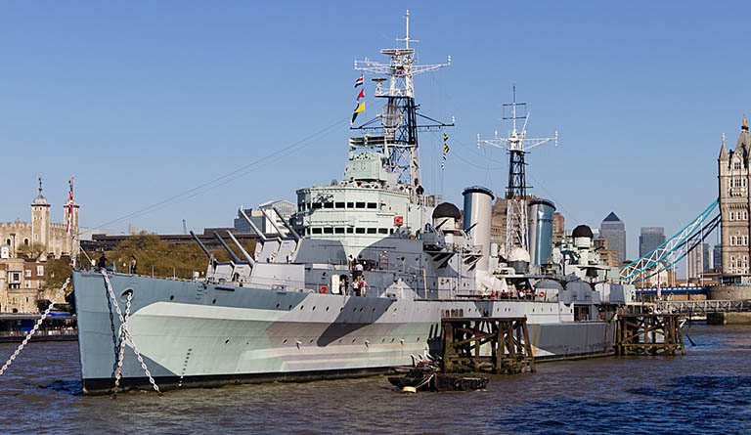

In the early 1930s, a concerned British Admiralty discovered that the Imperial Japanese Navy had started construction of the new *Mogami*-class light cruisers, which were superior in specifications to their Royal Navy counterparts. In order to present a worthy adversary for the *Mogamis*, it became necessary to operate uncomfortably near the limits of the restrictions imposed by the existing international naval treaties.

Thus, in 1934, construction of what would become the *Town*-class light cruisers began at British shipyards. Further development of this project down the line led to the creation of the two most advanced ships of the class—Belfast and Edinburgh. They surpassed earlier ‘*Towns’* in terms of their superior weaponry and improved armour layout. However, Belfast still wasn’t able to match the number of Mogami’s main battery guns.

The Admiralty tried to make up for this by developing new artillery systems for her main battery. As a result, a choice was made to equip her with triple turrets, keeping one original feature of the original system. The middle barrel was set slightly further back in the turret to prevent the powder gases from disrupting the trajectory of the shells when firing a simultaneous salvo from all guns. The cruiser was very well armed, and her extensive artillery constituted a solid percentage of her total displacement.

Belfast entered service just prior to the outbreak of World War Two, on August 3, 1939. On the morning of November 21, 1939, His Majesty’s newest cruiser, having served less than four months, was hit by a German magnetic mine a few kilometers from Rosyth. The ship was lucky enough to stay afloat and was hastily towed back to base. At the dry dock, it was found that the cruiser’s hull had taken serious damage—part of the keel was distorted and pushed in, half of the frames were deformed, and the turbines had been torn from their foundations. However, the plating luckily had only one small hole in it. The ship underwent an extensive overhaul that lasted 3 years with the aim of both repairing and improving the design to better withstand such shockwaves.

While undergoing repairs, Belfast was significantly modernized; in particular, the layouts of the hull and armour were modified, her AA weaponry was strengthened, and radar stations were mounted. The upgraded cruiser re-entered service in November 1942. She served as a protector of Arctic convoys; distinguished herself in the Battle of the North Cape, during which German battleship Scharnhorst was sunk; and provided fire support for the Normandy landings in June 1944.

After the German surrender in May 1945, Belfast—having received an upgrade to her radar and anti-aircraft armament, as well as being prepped for fighting in tropical conditions—sailed for the Far East on the 17th of June to be part of the operations against the last Axis power continuing the war—Japan. HMS Belfast arrived in Sydney in the beginning of August, just in time to see the end of World War II.

Having already made the trip, Belfast remained serving in East Asia for the rest of the 1940s. Therefore, when the Korean War broke out in 1950, she was close at hand to support the United Nations forces. Operating out of Japan, she conducted a number of coastal bombardments until the end of 1952, when she sailed back to Britain to enter the reserve.

In 1955, she returned to the site of her first refit in the early 40s for a new modernization intended to catch her up with the developing Cold War naval doctrine. On completion in 1959, she was recommissioned and once again deployed to the Pacific. In 1962, she finally made her final voyage home to be shortly thereafter placed in reserve and subsequently decommissioned in 1963.

Currently, Belfast is the largest surviving Royal Navy surface combatant of World War II and can be visited at its mooring on the Thames in London.

Since 8th July 2021, coinciding with the grand re-opening of this landmark museum ship, visitors are able to explore the [World of Warships Command Centre](https://www.iwm.org.uk/events/world-of-warships-command-center)—a first-rate gaming room complete with four PCs and two consoles. Visitors can command the HMS Belfast and its variation HMS Belfast ’43 in battle, as well as watch documentary footage showcasing films from the Naval Legends video series, available also on YouTube of Warships.

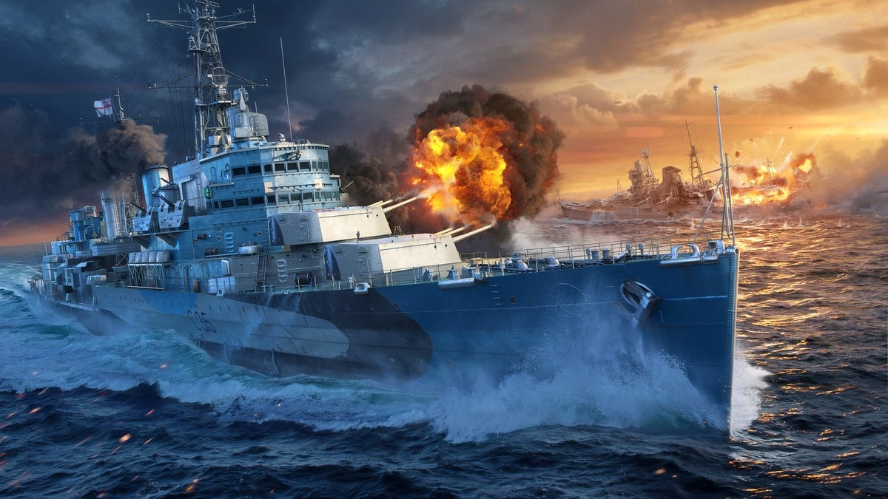

**\*\*\*\*\*\*\*\*\*\*\*\*\*\*\*\*\*\*\*\*\*\*\*\*\*\*\*\*\*\*\*\*\*\*\*\***

**HAVE A LAUGH**

## A man and a giraffe walk into a bar.

## After a few drinks, the giraffe falls over and dies. The man begins to walk out when the bartender stops him. “Hey, you can’t leave that lying’ there!” The bartender yells out.

## The man turns around: “It’s not a lion. It’s a giraffe.”

Two factory workers are talking. The woman says, "I can make the boss give me the day off." The man replies, "And how would you do that?" The woman says, "Just wait and see." She then hangs upside down from the ceiling. The boss comes in and says, "What are you doing?" The woman replies, "I'm a light bulb." The boss then says, "You've been working so much that you've gone crazy. I think you need to take the day off." The man starts to follow her and the boss says, "Where are you going?" The man says, "I'm going home, too. I can't work in the dark."

I got pulled over today and the cop asked if I knew why he pulled me over…

I replied, “Is it because you want to see how tall I am?”

He said, “Step out of the car, sir.”

See, I knew it…

Dave walks into a magic shop.

He walks up to the man at the counter and asks, “What magic can you do?”

The man at the counter replies, “Voodoo, magic reversal, time travel, and …”

Dave interrupts him and says, “Wait, go back.”

Dave walks into a magic shop, and the man at the counter says to him, “That’ll be $30.75.”

I saw a woman drop her purse in the high street this morning, so I quickly followed her.

As I was just about to tap her on the shoulder she started running for a bus.

So I ran after her shouting, “You dropped your purse! You dropped your purse!”

She didn’t hear me and proceeded to get onto the bus, so I got on the bus too.

As I walked to the back of the bus I breathlessly said, “You dropped your purse on the floor outside McDonald’s.”

“Thank you so much,” she said, “Where is it?”

I said, “I’ve just told you, on the floor outside McDonald’s.”

*************************************

**ROYAL AUSTRALIAN NAVY – Ship History**

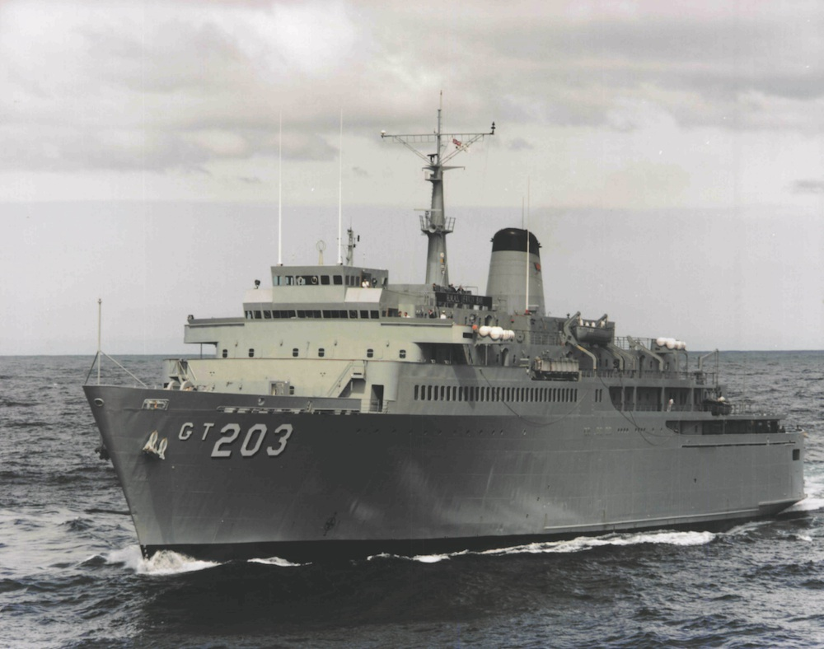**HMAS Jervis Bay (1)**

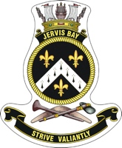

|  |  |  |  |
| --- | --- | --- | --- |
| Builder | NSW Dockyard Newcastle | Displacement | 8,910 tonnes |
| Laid down | 27 September 1967 | Length | 135.7Mtrs |
| Launched | 17 February 1969 | Beam | 21.5Mtrs |
| Commissioned | 25 August 1977 | Draught | 6.1Mtrs |
| Speed | 17 knots | Machinery | Twin 16cyl PC2V400  Pielstick turbo diesel engines |
| Crew | 108 | Horsepower | 5,500 bhp |

HMAS Jervis Bay was laid down at the Newcastle State Dockyard as the merchant ship Australian Trader on 27 September 1967. She was built for the Australian Shipping Commission (later the Australian National Line) as a roll-on roll-off vehicle ferry to service the Bass Strait run. She was launched on 17 February 1969. On completion of her merchant service in 1977 Australian Trader was acquired by the Royal Australian Navy (RAN) as a replacement for the training ship HMAS Duchess which decommissioned on 23 October 1977.

Australian Trader was commissioned into the RAN as HMAS Jervis Bay at Garden Island, Sydney, under the command of Commander Joe Morrice on 25 August 1977, the 38th anniversary of the commissioning of HMS Jervis Bay. Her primary role was to train junior officers in seamanship and navigation. She was equipped with classrooms and a purpose-built training bridge for that purpose, and conducted up to six training cruises per year. Her secondary role was that of military sea lift which went some way in addressing the capability lost when the fast troop transport and former aircraft carrier HMAS Sydney (III) decommissioned.

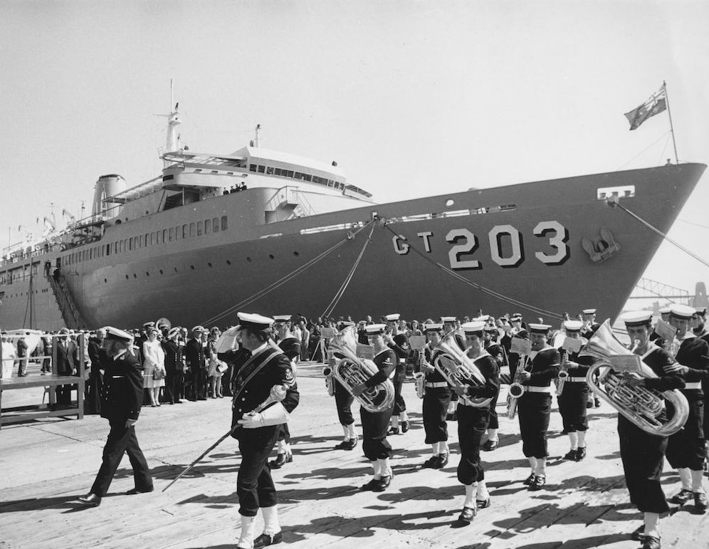

Following her commissioning, Jervis Bay underwent a dockyard conversion and a period of sea trials before embarking on her first training cruise in February 1978 during which she visited Hobart and Port Arthur for the first time as an RAN vessel. Her second cruise took her overseas visiting New Zealand in March and April where members of the Royal New Zealand Navy (RNZN) were embarked for sea training. Jervis Bay often provided training to officers and sailors of the RNZN and on occasion provided training for members of other Commonwealth navies, including the Royal Navy. She was a regular visitor to Australia's neighbours over the years of her commission including New Zealand, Fiji, Papua New Guinea, Indonesia, New Caledonia, the Solomon Islands, Singapore, Malaysia, Vanuatu, the Philippines and Samoa.

As well as serving in her training role, Jervis Bay was also involved in regular fleet exercises and humanitarian tasks. She participated in Exercise GOLDEN SAND TWO in November and December 1980, Exercise KANGAROO 81 in October 1981, Exercise KANGAROO 83 in September 1983, Exercise KANGAROO 86 in October and November 1986, Exercise DIAMOND DOLLAR 87 in October 1987, Exercise TASMAN LINK in May 1988, Exercise SWIFT EAGLE 90 in August 1990, Exercise KANGAROO 92 in March and April 1992, and the Fleet Concentration Periods in February 1984, February and September 1985 and November 1991.

In 1980 she became the first RAN ship to embark females when six midshipmen of the Women’s Royal Australian Navy Service (WRANS) embarked on 28 April for a three-week training cruise. The only distinction made between the RAN and WRANS members was that the WRANS were assigned their own sleeping and ensuite facilities.

Unfortunately the WRANS's cruise was cut short when Jervis Bay, along with HMAS Vampire (II), was retasked to observe the re-entry of two Chinese inter-continental ballistic missiles which splashed down in the South Pacific Ocean. As females, at that time, could not yet undertake overseas deployments, the WRANS were disembarked at Cairns on 10 May while Jervis Bay and Vampire proceeded into the South Pacific. The two ships observed the re-entry of the first missile on 18 May and the second three days later some 750 nautical miles north north west of Fiji. Eighteen ships of the People’s Liberation Army-Navy were present in the recovery area. ([Navy News - 30 May 1980](http://www.navy.gov.au/sites/default/files/documents/Navy_News-May-30-1980.pdf))

In March 1983 Jervis Bay, with 20 soldiers from 30 Terminal Squadron Detachment embarked, assisted in the relocation of 75 Squadron Royal Australian Air Force (RAAF) from RAAF Base Butterworth, Malaysia, to Darwin. She conducted normal sea training concurrently with the sea-lift task. Some 600 tonnes of RAAF cargo were embarked at both Singapore and Butterworth, and Jervis Bay arrived in Darwin on 4 April.

In January 1984, a film crew embarked to shoot scenes for the 'Bodyline' television mini-series. Jervis Bay was cast as the merchant vessel SS Orantes which had transported Douglas Jardine’s England cricket team to Australia for the infamous ‘Bodyline’ Ashes test series of 1932-33. Some members of the ship’s company made their film debuts as extras in the production. ([Navy News - 27 January 1984](http://www.navy.gov.au/sites/default/files/documents/Navy_News-January-27-1984.pdf))

In October 1986 Jervis Bay participated in the RAN 75th Anniversary Fleet Review which included some 40 naval vessels from seven countries. She was host ship to RFA Olmeda for the period of the review which involved a number of professional and social exchanges between the two crews. Jervis Bay was the first vessel to take up her review position at the No 2 Point Piper buoy on the morning of 2 October and the next day she hosted some 40 guests on board for the start of the Sydney-Montagu Island Yacht Race. With 290 midshipmen from the Australian Defence Force Academy embarked, the ship dressed overall for inspection by the Admiral of the Fleet, His Royal Highness Prince Philip, Duke of Edinburgh, on 4 October. She later departed Sydney on 13 October to participate in Exercise KANGAROO 86 in Queensland waters.

Following a coup in Fiji on 14 May 1987, Jervis Bay was ordered to make all necessary preparations to sail while other RAN vessels headed for the South Pacific nation under the auspices of Operation MORRIS DANCE. Jervis Bay underwent emergency modifications at Cockatoo Island Dockyard having a flight deck fitted to enable her to conduct helicopter operations.

Jervis Bay departed Sydney to relieve HMAS Success (II) in Fiji on 1 June and conducted flight trials on her new flight deck that morning. A Sea King helicopter from 817 Squadron was the first aircraft to land aboard Jervis Bay at 11:15. The following day, while off the Queensland coast, the ship was notified that Operation MORRIS DANCE had been suspended and that her presence in Fiji was no longer required.

The ship was placed at four hours’ notice for sea and the ship's company recalled on 25 September when a second military coup occurred in Fiji. A contingency plan was put in place, involving Jervis Bay, for the evacuation of Australian nationals from Fiji if the situation deteriorated further. However, as it transpired that Jervis Bay was not required and she instead proceeded to Queensland waters to participate in Exercise DIAMOND DOLLAR 87 providing sea-lift for Army equipment and personnel.

The ship and her crew started 1988 in fine style when she was awarded the [Duke of Gloucester's Cup](http://www.navy.gov.au/history/tradition/duke-gloucester%E2%80%99s-cup) as the RAN unit displaying the highest level of overall proficiency through the previous year. The cup was presented by His Excellency the Governor-General The Right Honourable Sir Ninian Stephen, AK, GCMG, GCVO, KBE, on the ship's flight deck on 5 January.In the evening of 21 February, having just completed pilotage training in Queen Charlotte Sound, New Zealand, Jervis Bay intercepted a distress call indicating that a Korean fishing trawler, Dong Chang No. 3, was sinking some 35 nautical miles north of Cape Jackson. The ship proceeded to the area in heavy and worsening seas and began a systematic search in company with MV Ficus and one aircraft. After little more than five minutes of searching, Leading Seaman Andy Skinner spotted an overturned life raft with 12 survivors clinging to it. In a five-metre swell, with winds in excess of 40 knots, Jervis Bay created a lee for the life raft and lowered a sea boat to rescue the survivors. With three sailors still missing the search continued joined by MV James Cook later in the evening and a helicopter the following morning. However, no trace could be found of the missing sailors. The survivors held a traditional Taoist memorial service for their lost crew mates on the ship's flight deck before setting course for Wellington. ([Navy News - 4 March 1988](http://www.navy.gov.au/sites/default/files/documents/Navy_News-March-4-1988.pdf))

On 22 April 1988, *Jervis Bay* paid her first visit, as a RAN vessel, to the Tasmanian town of Burnie. The following day Burnie formally adopted the ship, building on the strong ties developed between the town and the ship when she was employed as a car ferry before commissioning into the RAN. A scheduled march through the streets of Burnie by the ship's company was cancelled due to poor weather so the adoption ceremony was instead held on board. A contingent from the crew participated in Burnie's annual Anzac Day Dawn Service while some were present to witness Her Majesty Queen Elizabeth II proclaim Burnie a city the following day. *Jervis Bay* returned to Burnie in February 1991 when the ship's company conducted a Freedom of Entry March through the city on 16 February.

On 20 May 1988 *Jervis Bay*, along with *Stalwart*, was once again diverted from training in preparation to assist Australian nationals in a south pacific nation; on this occasion it was Vanuatu where rioting had swept through the capital, Port Vila, the previous week. The two ships arrived on station in the early morning of 23 May under the auspices of Operation SAILCLOTH. Thankfully local police were restoring order ashore and SAILCLOTH was suspended on the morning of 26 May. Both ships departed that morning for Brisbane.

On 11 July *Jervis Bay* embarked the Flag Officer Naval Support Command, Rear Admiral Tony Horton, AO, RAN, as well members of the Australian Bicentennial Authority and 78 media personnel for the media launch of the Bicentennial Naval Salute scheduled for September 1988. Ironically, *Jervis Bay* did not participate in the Naval Salute on 26 September; she was in Townsville embarking 121 members of the Bicentennial Military Tattoo Regiment. She spent the next ten weeks circumnavigating Australia transporting the regiment and providing alongside support on its national tour. Her commitment came to an end on 30 November in Melbourne. In stark contrast to what was a very busy 1988, much of 1989 was spent at Garden Island and Cockatoo Island Dockyards in Sydney, spending some 252 days in refit beginning on 22 February. Material shortages, the discovery of asbestos on board and industrial unrest all combined to blow out the refit's schedule making a routine period of maintenance anything but that. She was returned to service on 1 November.

On 25 January 1990 while visiting Auckland, New Zealand, *Jervis Bay* was assigned to Operation DEFERENCE and ordered to North Queensland waters with instructions to standby to evacuate Australian nationals from Bougainville should political tensions there continue to rise. It was the fourth occasion during her commission that *Jervis Bay* had been diverted from her normal duties due to political unrest in the South Pacific. She arrived in Townsville on 30 January and continued training in North Queensland waters until DEFERENCE was cancelled in April.

On 19 December 1992, *Jervis Bay* departed Sydney for Mogadishu, Somalia, to provide strategic sea-lift for Operation SOLACE, the Australian Defence Force's contribution to the US-led operation to bring peace and humanitarian relief to the war-torn African nation. Her operations, in concert with those of HMAS *Tobruk* (II), amounted to Australia's largest military sea-lift operation since the end of the Vietnam War.

*Jervis Bay* arrived in Townsville on 22 December where she embarked a detachment of troops from 1RAR and some 800 tonnes of cargo bound for Mogadishu. She entered the SOLACE Area of Operations on 12 January 1993 having refuelled at Darwin and Diego Garcia en route. On arrival *Jervis Bay* was assigned an anchorage some five and half miles from the port due to the large amount of shipping in the area. Ships from the navies of the USA, Canada, India, France, Turkey and Spain were present while port operations were controlled by US Marines. She was allowed into the port two days later to disembark her troops and cargo. *Jervis Bay*'s Commanding Officer, Commander Errol Morgan, RAN later related the scene that evening: "The darkened city of Mogadishu, little more than a collection of remains with all buildings stripped of rooves, windows and fittings, took on an eerie appearance at night. Sporadic gun fire was clearly audible/visible in the near vicinity but fortunately no action was directed against *Jervis Bay*".There were also reports of stray sniper fire into the port.She departed Mogadishu the following day rendezvousing with Tobruk on 17 January to provide Tobruk's command team with a comprehensive brief on the situation in Mogadishu. She reverted to her role as a training ship when she arrived in Diego Garcia on 21 January.

Jervis Bay deployed to Somalia for a second time in May arriving in Mogadishu on the 17 May where she embarked troops and equipment for passage back home to Australia. She departed Mogadishu three days later arriving in Townsville on 16 June. ([Operation SOLACE - RAN Relief Somalia](http://www.navy.gov.au/history/feature-histories/operation-solace-ran-relief-somalia-1993))

*Jervis Bay* made her final overseas visit in September 1993 visiting Port Vila in Vanuatu during a training cruise. She arrived back in Sydney on 3 October following the complete failure of the starboard main engine. On 17 December, the Minister for Defence, Senator the Hon. Robert Ray announced that *Jervis Bay* and *Tobruk* were to be decommissioned in 1994. Members of the ship's company travelled to Little Creek Naval Amphibious Base, Norfolk, Virginia, USA, to begin preparations to commission the two ships' replacements; the amphibious vessels HMA Ships *Kanimbla* (II) and *Manoora* (II). HMAS *Jervis Bay* was decommissioned on 18 April 1994. She was subsequently sold to Voyager Marine Ltd and renamed *Agios Andreas* (Saint Andrew).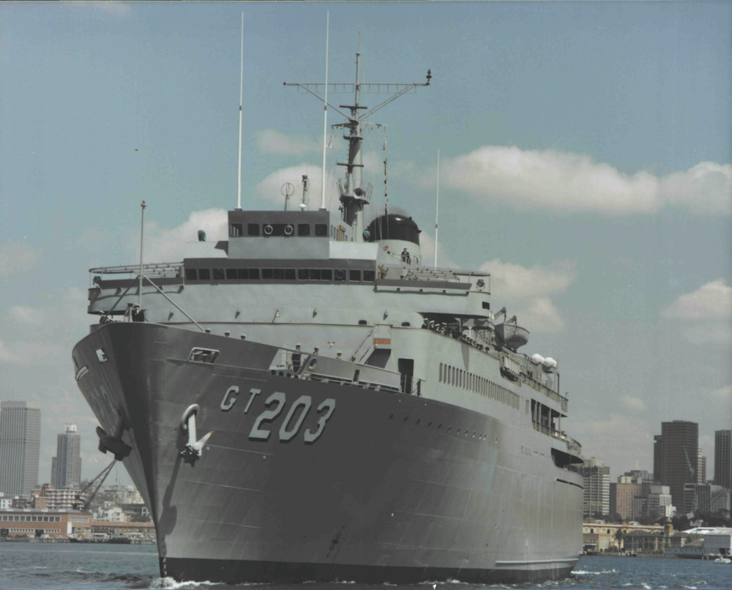

**ROYAL AUSTRALIAN NAVY – Active Fleet Ships**

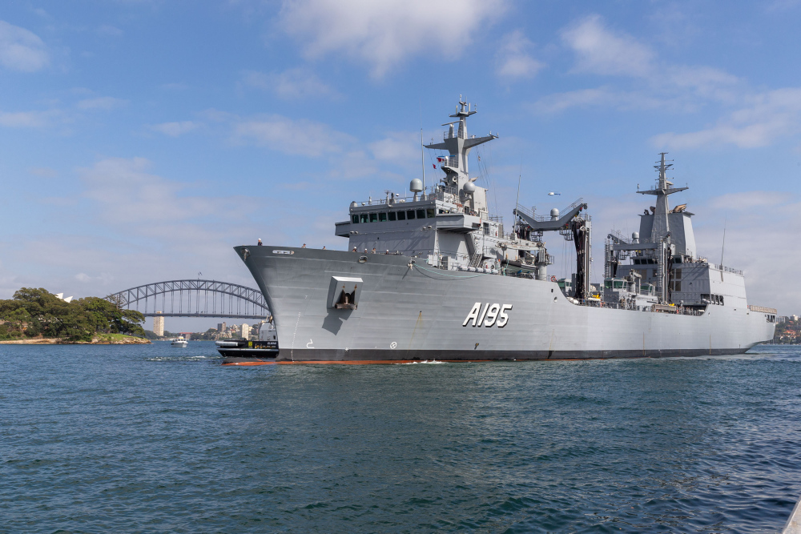**HMAS Supply (11)**

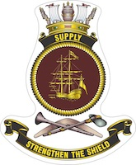

\

HMAS *Supply* (II) and HMAS Stalwart (lll) are two Supply Class Auxiliary Oiler Replenishment (AOR) ships currently being built for the Royal Australian Navy by Spanish shipbuilder, Navantia. The Australian Supply Class ships are based on the Spanish Navy’s Cantabria Class design.

The ships are intended to carry fuel, dry cargo, water, food, ammunition, equipment and spare parts to provide operational support for the deployed naval or combat forces operating far from the port on the high seas for longer periods.

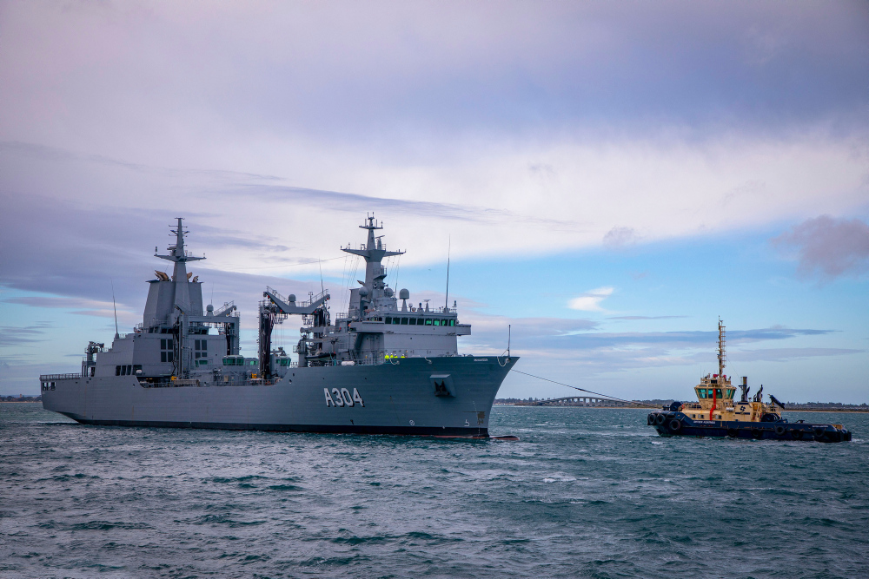**HMAS Stalwart (111)**

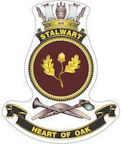

**************************

**PICTURE FUNNIES**

 

 

 

**NAVAL TRADITIONS / TERMS / SLANG**

**Naval Slang / Nicknames:**

**Navy Slang:**

**Adrift:** Absent or late for a muster  
**Ahoy:** A seaman's call for attention  
**All nighters in:** All night in one’s bed/night without going on watch               
**Aloft:** Anything above the main deck of the ship  
**Alongside:** Against the side of the ship, such as the wharf  
**Amidships:** The centre part of a ship or boat  
**As you were:** A warning to return to your original position  
**Avast:** Stop what you are doing  
**Badges:** Short name for continuous service badges  
**Bait Layer:** A member of the cookery branch  
**Bandy:** A musician  
**Banyan:** A beach BBQ  
**Beagle:** A steward  
**Below there:** A call to a person below  
**Bight:** A loop or slack in a length of rope  
**Birdie:** A member of the aviation branch  
**Black Cat:** A person with more impressive stories than you  
**Bravo Zulu:** Well done (BZ)  
**Brew:** A coffee or tea  
**Bright Work:** Polished metal fittings  
**Buffer:** Sailor in charge of the boatswain branch  
**Burgoo:** Porridge  
**Buzz:** A rumour

**Navy Nicknames:**

**Bell:** Daisey

**Bennett:** Wiggy

**Beresford:** Charlie

**Grey:** Dolly

**Green:** Jimmy

**Harris:** Chats

**Henderson:** Granny

**Hewitt:** Nobby

**Hughes:** Flapper

**Knight:** Bogie

**Long:** Dodger

**Martin:** Pincher

**Gale:** Windy

**Murphy:** Spud

**Noble:** Charlie

**Payne:** Whacker

**Parker:** Nosey

**\*\*\*\*\*\*\*\*\*\*\*\*\*\*\*\*\*\*\*\*\*\*\*\*\*\*\*\*\*\***