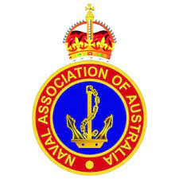
Naval Association of Australia, Victoria Section Incorporated.
ABN: 86 973 753 106. INC No: A0047633A

Secretary’s Postal Address (for General Correspondence):
Naval Association of Australia Victorian Secretary: 36 Barretts Road LANGWARRIN SOUTH. VIC. 3911

