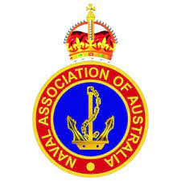
Naval Association of Australia, Victoria Section Incorporated.
ABN: 86 973 753 106. INC No: A0047633A

Secretary’s Postal Address (for General Correspondence):
Naval Association of Australia Victorian Secretary: 36 Barretts Road LANGWARRIN SOUTH. VIC. 3911

AGENDA
VICTORIAN SECTION EXECUTIVE MEETING
COMMENCING (Insert time and date)
ONLINE

Meeting Opening and welcome:
Housekeeping. Conflict of Interest. Emergency Brief (if required)
Recording of the virtual meeting using Zoom
Item A. Tribute to our shipmates. Vales: Chair

- Apologies: Secretary
- Attendees: Secretary

Item B. Confirmation of Previous Meeting Minutes. Secretary

Item C. Business Arising from the Previous Meeting Minutes Secretary

Item D. Correspondence and Associated Actions.
Documents of Significance:

Item E. Treasurer’s Statement and Accounts for Payment CFO

Item F. Reports. Secretary
Sub-section Reports.

Membership

DVA Report.

ESO Report.

Item G. Notice of Motion. Nil

Item H. Election of Officers

Item I. General Business Secretary

Other:
- Calendar (Including Commemoration Services_

- Periods of absence
Next meeting.

Closure.

