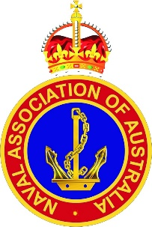
Always Navy

Principal objectives of the Association are to:

a. unite and develop comradeship among all former and serving Naval personnel; and

b. promote and assist activities in the wider Naval community in order to improve the health and wellbeing of that community.

Actions to support the Four Pillars & Corporate for 2018

- Determine the status of NAA advocates.
- Scope the level of support available from NAA to Veterans.
- Encourage members to have at least one person in each Sub-section undertaken L1 ATDP training.
cARE:
Supporting Navy and ex-Navy men and women.

Communications: NAA to be top of mind within the Navy community.
- Standardise mast head, letter head and proforma layout.
- Increase NAA Face book to 1,000 followers.
- White Ensign Magazine to be revenue neutral.
Administration: Institute an efficient and effective way of communicating with Members.
- review the sustainability of the Association.
- Identify changes that will reduce unnecessary delays in achieving the goals of the Association.
- Actively pursue like minded organisations with the aim of affiliation.
CORPORATE
We seek to unite like-minded folk for the purpose of mutual benefit.

COMMEMORATION:
Maintaining the legacy of past service and sacrifice.

- Identify the appropriate milestone events that highlight past service and sacrifice.
- Sections to make appropriate arrangements to support milestone commemoration services.
- Identify resourcing opportunities with Navy and like minded organisations, such as ANC, for each milestone event.
- Determine which Sub-sections have a Cadet TS in their area and promote collaboration.
- Promote membership of the NAA to ANC.
- Invite local Cadet Training Units to all commemoration services.
CADETS:
Assisting youths become better citizens - Australian Navy Cadets.

- Record all low level welfare activities undertaken by members.
- Determine the wellbeing of each and every member in the Sub-section.
- Review social programs with the view of attracting younger families.
CAMARADERIE
Meet & socialise with like-minded Navy & ex-Navy men & women.

